
ATSB Transport Safety Report
Aviation Occurrence Investigation
AO-2011-102
Final – 14 November 2013

VFR flight into dark night conditions involving Aérospatiale AS355F2, VH-NTV
145 km north of Marree, South Australia, 18 August 2011

Released in accordance with section 25 of the Transport Safety Investigation Act 2003

Publishing information

Published by: Australian Transport Safety Bureau
Postal address: PO Box 967, Civic Square ACT 2608
Office: 62 Northbourne Avenue Canberra, Australian Capital Territory 2601
Telephone: 1800 020 616, from overseas +61 2 6257 4150 (24 hours)
Accident and incident notification: 1800 011 034 (24 hours)
Facsimile: 02 6247 3117, from overseas +61 2 6247 3117
Email: atsbinfo@atsb.gov.au
Internet: www.atsb.gov.au

© Commonwealth of Australia 2013



Ownership of intellectual property rights in this publication
Unless otherwise noted, copyright (and any other intellectual property rights, if any) in this publication is owned by the Commonwealth of Australia.

Creative Commons licence
With the exception of the Coat of Arms, ATSB logo, and photos and graphics in which a third party holds copyright, this publication is licensed under a Creative Commons Attribution 3.0 Australia licence.

Creative Commons Attribution 3.0 Australia Licence is a standard form license agreement that allows you to copy, distribute, transmit and adapt this publication provided that you attribute the work.

The ATSB’s preference is that you attribute this publication (and any material sourced from it) using the following wording: Source: Australian Transport Safety Bureau

Copyright in material obtained from other agencies, private individuals or organisations, belongs to those agencies, individuals or organisations. Where you want to use their material you will need to contact them directly.

Addendum
Page | Change | Date
3 | Table 1, correct bank angles for seconds: 131, 133, 148 and 161 | 16 Jun 2015
32 | Clarification of charter flight, adding ‘at night’ | 16 Jun 2015
39 | Footnote clarification, adding ‘user defined waypoint’ | 16 Jun 2015
50 | Paragraph formatting and charter clarification to include ‘helicopter’ | 16 Jun 2015
55 | Amend recommendation number (replace ‘01’ with ‘59’) | 13 Nov 2013
62 | Add missing reference source | 16 Jun 2015
71 | Add footnote for clarification of Figure A12 | 16 Jun 2015
83 | Correction of roll direction for Kenya Airways accident | 16 Jun 2015

Safety summary
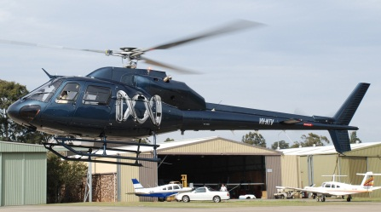
What happened
VH-NTV
Source: ABC
On 18 August 2011, an Aérospatiale AS355F2 (Twin Squirrel) helicopter, registered VH-NTV, was being operated under the visual flight rules (VFR) in an area east of Lake Eyre, South Australia. At about 1900 Central Standard Time, the pilot departed an island in the Cooper Creek inlet with two film crew on board for a 30-minute flight to a station for a planned overnight stay. It was after last light and, although there was no low cloud or rain, it was a dark night.
The helicopter levelled at 1,500 ft above mean sea level, and shortly after entered a gentle right turn and then began descending. The turn tightened and the descent rate increased until, 38 seconds after the descent began, the helicopter impacted terrain at high speed with a bank angle of about 90°. The pilot and the two passengers were fatally injured, and the helicopter was destroyed.
What the ATSB found
The ATSB found that the pilot probably selected an incorrect destination on one or both of the helicopter's global positioning system (GPS) units prior to departure. The ATSB concluded that, after initiating the right turn at 1,500 ft, the pilot probably became spatially disoriented. Factors contributing to the disorientation included dark night conditions, high pilot workload associated with establishing the helicopter in cruise flight and probably attempting to correct the fly-to point in a GPS unit, the pilot’s limited recent night flying and instrument flying experience, and the helicopter not being equipped with an autopilot.
Although some of the operator’s risk controls for the conduct of night VFR were in excess of the regulatory requirements, the operator did not effectively manage the risk associated with operations in dark night conditions. The ATSB also identified safety issues with the existing regulatory requirements in that flights for some types of operations were permitted under the VFR in dark night conditions that are effectively the same as instrument meteorological conditions, but without the same level of safety assurance that is provided by the requirements for flight under the instrument flight rules (IFR).
What's been done as a result
The Civil Aviation Safety Authority (CASA) has advised of safety actions in progress to clarify the nature of what is meant by the term ‘visibility’ in dark night conditions, provide enhanced guidance on night VFR flight planning, and provide enhanced guidance on other aspects of night VFR operations. The ATSB has issued a recommendation to CASA to prioritise its efforts in this area. In addition, CASA advised that it will require that helicopter air transport operations with passengers at night use either a helicopter fitted with an autopilot or a two-pilot crew.
Safety message
The ATSB advises all operators and pilots considering night flights under the VFR to systematically assess the potential for the flight to encounter dark night conditions by reviewing weather conditions, celestial illumination and available terrain lighting. If there is a likelihood of dark night conditions, the flight should be conducted as an IFR operation, or conducted by a pilot who has an IFR-equivalent level of instrument flying proficiency and in an aircraft that is equipped to a standard similar to that required under the IFR.
Contents

The occurrence 1
Context 5
Pilot information 5
Qualifications and experience 5
Recent history 6
Medical information 6
Aircraft information 7
General information 7
Airworthiness and maintenance 8
Flight controls 8
Avionics 8
Landing lights 13
Fuel 13
Weight and balance 13
Meteorological information 13
Weather conditions 13
Illumination 14
Landing site information 15
Wreckage and impact information 15
Overview of the accident site 15
Fire damage 17
Airframe damage 17
Engines 18
Drive train and rotor systems 18
Flight controls 19
Instruments, avionics and light globes 20
Emergency locator transmitter 21
Feathers examination 22
Recorded information 22
Flight recorders 22
Garmin GPSMAP 495 22
Media camera P2 memory cards examination 22
Simulator trials 22
Spatial disorientation 23
Overview 23
Nature of spatial disorientation accidents 23
Misperceptions associated with a gradually increasing bank angle 24
Accidents associated with a gradually increasing bank angle 27
Spatial orientation modelling 27
Organisational and management information 29
Overview 29
Classification of operations 29
Pilot checking and training 30
Safety management 30
Regulatory surveillance 31
Requirements and guidance for night operations 31
Night visual flight rules 31
Pilot qualifications 32
Recency requirements 32
Helicopter landing sites for night operations 33
Aircraft equipment 33
Guidance for conducting night operations 33
Previous ATSB recommendations related to night operations 35
Requirements in other countries 36
Night VFR accidents 37
Safety analysis 38
Introduction 38
Purpose of the right turn after reaching 1,500 ft 38
Potential explanations for the descent with increasing bank 39
Factors associated with spatial disorientation 40
Activities involved in recognition and recovery 40
Salience of perceptual cues 41
Workload and distraction 42
Expectancy 44
Instrument flying proficiency 45
Automatic flight control systems 45
Interpretation of flight instruments 46
Unusual attitude training 47
Fatigue and physiological factors 47
Summary 48
Factors associated with planning the flight 48
Operator’s processes for managing risk of night flights 49
Minimum requirements for night operations 49
Other efforts to reduce the risk of night operations 51
Findings 52
Contributing factors 52
Other factors that increase risk 52
Other findings 52
Safety issues and actions 54
Operator’s processes for managing operations 54
Safety issue description: 54
Current status of the safety issue: 54
Requirements for visual flight rule flights in dark night conditions 54
Safety issue description: 54
Requirements for autopilots in dark night conditions 56
Safety issue description: 56
Current status of the safety issue: 57
General details 58
Occurrence details 58
Aircraft details 58
Sources and submissions 59
Sources of information 59
References 59
Submissions 62
Appendices 63
Appendix A – Garmin GPSMAP 495 examination 63
Introduction 63
Garmin GPSMAP 495 63
Physical examination 64
Memory chip removal and rework 66
Memory chip download 67
Overview of recorded flight data 67
Accident flight data 67
GPS data error sources 73
Additional data points 75
Appendix B – P2 memory cards examination 76
Introduction 76
Panasonic P2 cards 76
Physical examination 76
Data recovery 77
Data analysis 77
Appendix C – Engines examination 78
Appendix D – Accidents involving gradually increasing bank angle 81
Air India Boeing 747, 1 January 1978 81
Korean Air B747, 22 December 1999 81
Crossair Saab 340B, 10 January 2000 82
Flash Air B737, 3 January 2004 82
Adam Airlines B737, 1 January 2007 83
Kenya Airways B737, 5 May 2007 83
Aeroflot-Nord B737, 13 September 2008 84
United States military helicopter accident 84
Appendix E – Spatial orientation modelling 85
Appendix F – Accidents involving night VFR operations 86
Australian Transport Safety Bureau 88
Purpose of safety investigations 88
Developing safety action 88

The occurrence
On 17 August 2011, an Aérospatiale AS355F2 (Twin Squirrel) helicopter, registered VH-NTV, departed Sydney, New South Wales, for the Lake Eyre region of South Australia (SA) (Figure 1). The pilot and two film crew were travelling to various locations for the purposes of filming and gathering information for the production of a television documentary. At about 1637 Central Standard Time, the pilot landed the helicopter at Parachilna, SA, where they stayed the night.
Figure 1: Accident site location
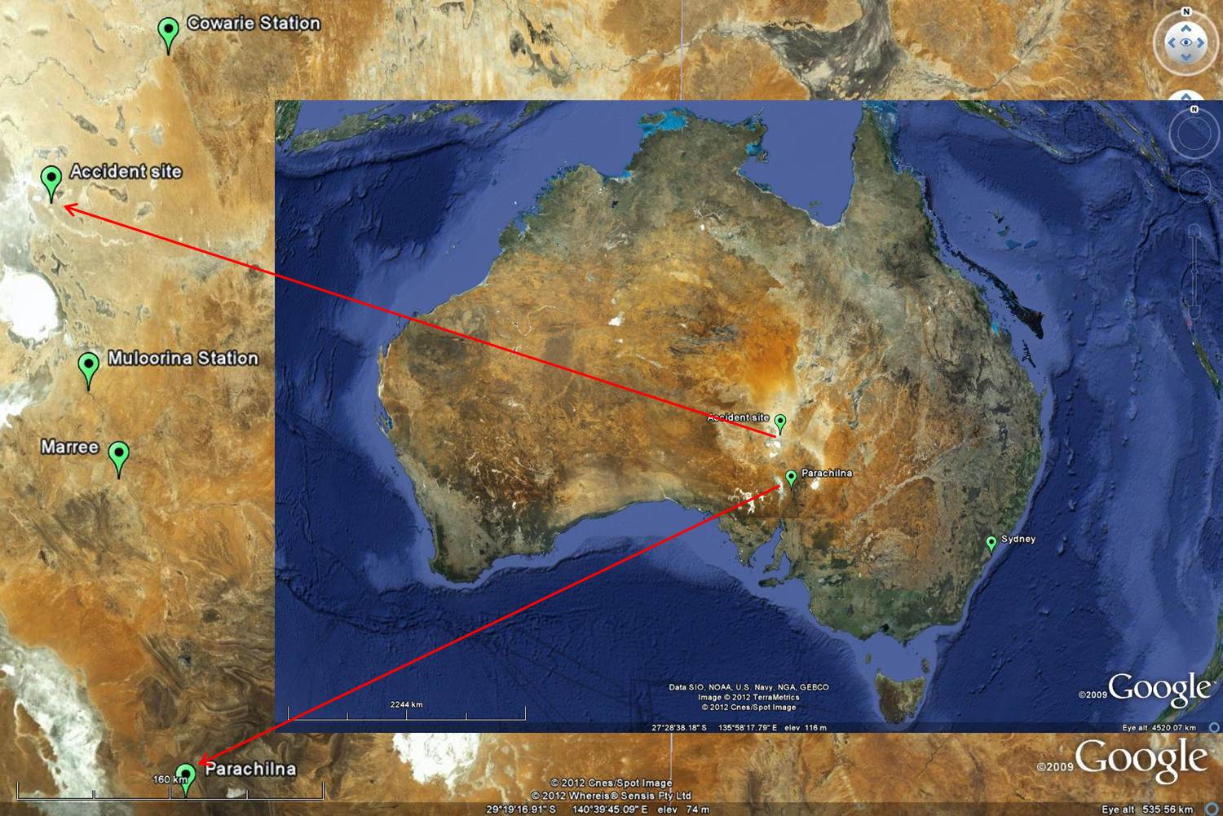
Source: Google Earth (modified by the ATSB)
On the next day (18 August), the pilot and film crew departed at 0716 for a filming flight. They returned to Parachilna for breakfast, then later that morning departed for flights and visits in the Lake Eyre region. At 1340, the pilot stopped at Muloorina Station, about 48 km north of Marree, SA, to offload luggage and to refuel the helicopter. It was planned to return to the property later that day for the evening meal and to stay the night.
At 1418, the helicopter departed Muloorina Station for the Cooper Creek crossing of the Birdsville Track. The helicopter departed the crossing at about 1607 and arrived at an island in the Cooper Creek inlet (Figure 2), about 145 km north of Marree, at about 1715. The film crew stopped there to meet and interview a tour group. Tour group personnel had been in contact with the crew during the day by two-way radio to discuss the crew’s arrival time. The tour group personnel later reported that they had expected the helicopter to arrive mid-afternoon.
Figure 2: Image of VH-NTV at the Cooper Creek inlet taken at 1821
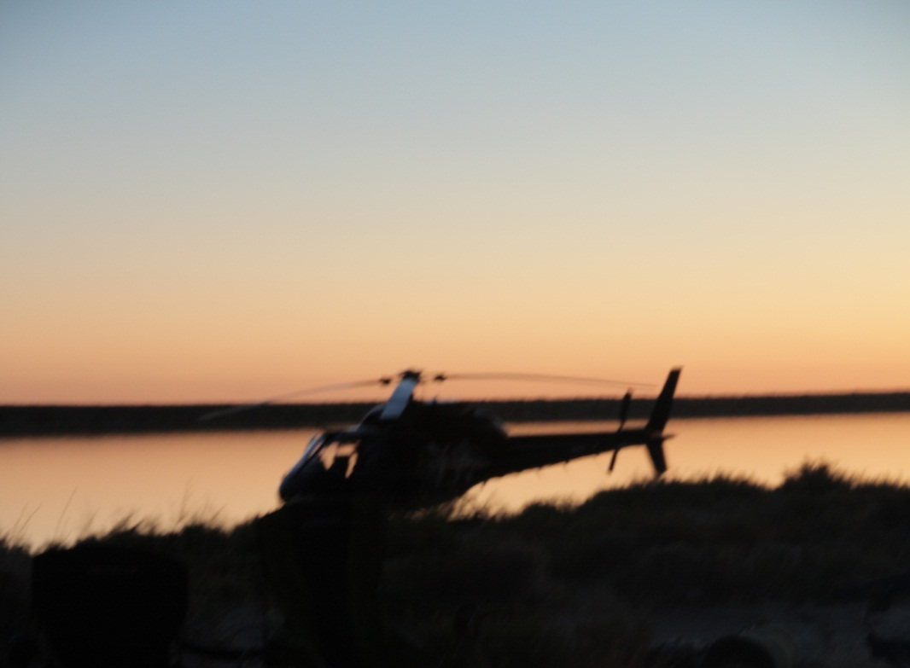
Source: John Bean
The pilot and film crew departed the island at about 1900. It was after last light and, while there was no low cloud or rain, it was a dark night. Witness reports indicated that the helicopter initially climbed vertically while moving rearwards. This was most likely to maintain a visual reference to the camp fire, which was the only available ground light source. The witnesses then observed the helicopter depart in an easterly then north-easterly direction. This was contrary to what they expected as they understood that the crew were returning to their accommodation at Muloorina Station (96 km away on a southerly bearing of about 160° M). One witness tried contacting the helicopter by radio to query their north-easterly flight path rather than the expected southerly heading, but no response was received.
Data was recovered from a global positioning system (GPS) unit on board the helicopter (see appendix A). The unit provided data on the helicopter’s position and altitude, as well as the time. Based on these parameters, the Australian Transport Safety Bureau (ATSB) was able to estimate other flight path characteristics such as groundspeed, track, rate of descent and bank angle (see appendix A).
The GPS data indicated that the helicopter took off at about 1859, climbed and levelled off at an altitude of 1,500 ft above mean sea level on a heading of 035° before commencing a turn to the right. Twelve seconds after initiation of the turn, the helicopter started descending with the bank angle increasing. Based on the GPS data and flight path estimations, it was calculated that the helicopter impacted terrain at about 1902, about 38 seconds after it started descending. Wreckage examination indicated that the helicopter impacted terrain in a 90° right-side low attitude. Table 1 provides a list of key events derived from the GPS data, and Figure 3 and Figure 4 provide an overview of the helicopter’s flight path.
No radio communications with air traffic services from the helicopter were expected, and none were received or recorded. A review of the helicopter’s satellite phone records indicated that the phone was not in use around the time of the accident and there was no ground-based mobile phone coverage in the area. The ATSB could not determine if the two-way radio was turned on in the helicopter at the time of the accident.
A number of witnesses at the departure site saw the helicopter descending and turning, followed by a fireball and an orange glow. After advising authorities of the situation, the tour group initiated a search, and at about 2040 they located the wreckage of the helicopter about 3 km east-north-east of the departure point. The pilot and the two passengers were fatally injured. The helicopter was destroyed by impact forces and a fuel-fed fire.
Table 1: Summary of key events obtained or derived from GPS data
Time since take-off (seconds) | Events
0 | started to climb (142 seconds after the GPS unit was powered on)
32 | altitude about 100 ft, transitioned into forward flight in an easterly direction
61 | altitude about 500 ft, turned left and continued to climb
103 | rolled out onto a heading of about 035° and continued to climb
108 | levelled off at about 1,500 ft with speed still increasing
121 | commenced right turn with speed still increasing
131 | established at cruise speed of about 105 kt  bank angle about 19° right and increasing
133 | started descending, heading 075°  bank angle about 23° and increasing
148 | altitude about 1,310 ft, rate of descent over 1,000 ft per minute, heading 162°  bank angle increase briefly ceased at about 42° before again increasing
161 | altitude about 800 ft, rate of descent 4,000 ft per minute, heading 307°, bank angle about 53°  groundspeed 116 kt and increasing
165 | last recorded GPS data point  altitude 731 ft but considered unreliable (see appendix A)
171 | estimated time of impact (based on extrapolated data and simulations), easterly heading, bank angle 90° (based on wreckage information)

Figure 3: Flight path derived from recovered GPS data-plan view
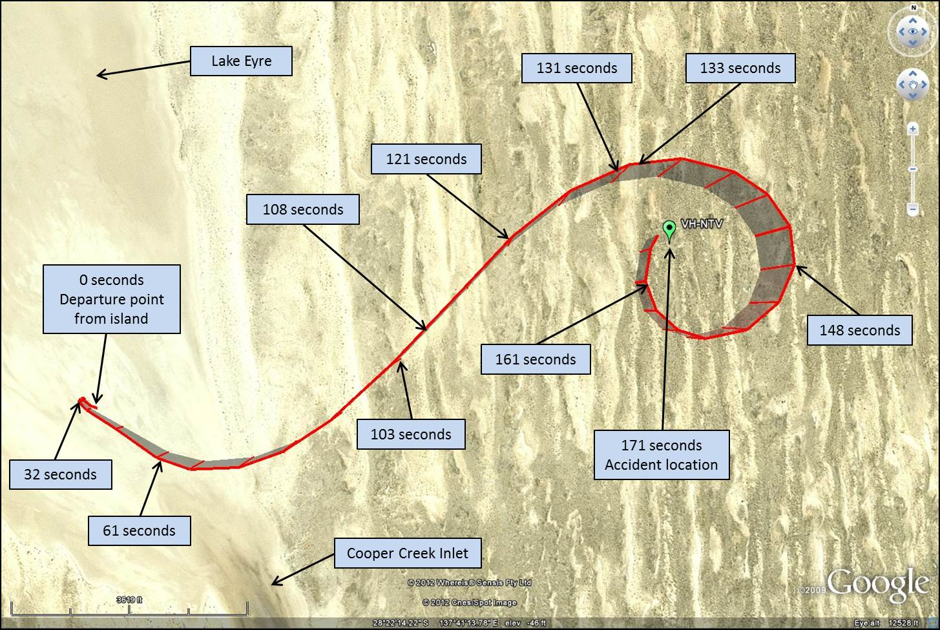
Source: Google Earth (modified by the ATSB)
Figure 4: Flight path derived from recovered GPS data-elevation view
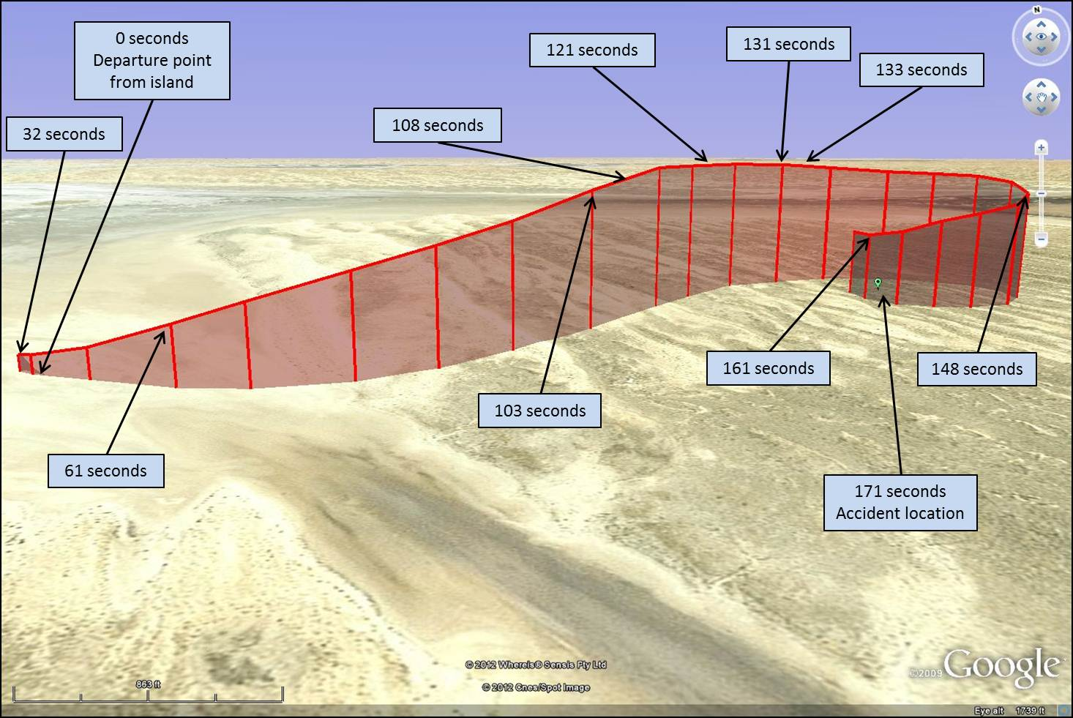
Source: Google Earth (modified by the ATSB)

Context

Pilot information

Qualifications and experience
From 1973 to 1979, the pilot flew for the Australian Army, mostly in helicopters, and he obtained a military instrument rating and logged 90 hours instrument flying time during this period. He obtained a Commercial Pilot Licence (Helicopter) in 1977, and attained a night visual flight rules (VFR) helicopter rating in 1979, which included an approval to use NDB and VOR navigation aids. The pilot never held a civil command instrument rating (CIR) or a global positioning system (GPS) navigation approval. He was endorsed on the AS355 and several other helicopter types.
The last recorded entry in the pilot’s logbook, dated 27 June 2011, indicated that he had attained 16,352.6 hours flying experience, the majority being on helicopters. This entry was on the last line in that logbook, and no subsequent logbooks were located. According to the helicopter’s flight record, the pilot had logged a further 3.5 hours in VH-NTV in July 2011. The pilot sometimes flew other helicopters and it is possible that he conducted other flights between 27 June and 17 August 2011, but no relevant records for the operator were available. Family members and colleagues could not recall whether the pilot had conducted any other flights during this period.
Of the pilot’s total recorded flight time, 483.8 hours were conducted at night. He recorded a total of 3.4 hours night flying within the previous 12 months and about 30 hours over the last 4 years. To carry passengers at night, the pilot was required to have conducted 3 night take-offs and landings in the previous 90 days (see Requirements and guidance for night operations). The only recorded night flight in the preceding 90 days was in VH-NTV on 24 June 2011. This was a 1.3 hour flight, which consisted of a night departure from Cooma, New South Wales, and a night landing at the helicopter’s base in Sydney. The two previous recorded night flights were 0.6 hours on 4 April 2011 and 1.5 hours on 7 September 2010.
To maintain the validity of a commercial licence, a pilot was required to undergo a biennial flight review (BFR). The operator’s proficiency checks were conducted more regularly than every 2 years, with the pilot’s last six proficiency checks occurring in November 2004, May 2005, March 2006, July 2007, May 2009 and April 2010. The May 2009 check was the last recorded BFR. Although not conducted for the purposes of a BFR, the April 2010 check was conducted to the same standard and by the same approved testing officer as the May 2009 check.
The pilot reached 60 years of age in October 2010 and was therefore subject to additional check requirements. Civil Aviation Regulation (CAR) 5.126 required that a commercial helicopter pilot not undertake a commercial flight as pilot in command with passengers if the pilot was 60 years old unless they had completed a proficiency check or flight review in the previous year. The pilot reached 60 years of age in October 2010, and his last proficiency check was conducted on 27 April 2010. Therefore, he was not permitted to undertake any commercial flights with passengers after 27 April 2011.
The 27 April 2010 proficiency check was conducted over 2.2 flight hours, with 0.7 hours conducted at night. According to the check pilot, this flight did not highlight any problems or deficiencies with the pilot’s performance. The check flight assessed the pilot’s ability to fly on instruments, but he was not assessed to the same extent as would have been required for a CIR renewal. The check pilot stated that the check was not conducted in dark night conditions and the notes for the check flight stated that the pilot’s next check ‘should address night flight in marginal VMC to revise instrument scan skills’. Notes from other check flights in recent years indicated no significant concerns about the pilot’s ability to fly on instruments.
Due to the operator’s flights being conducted with a single pilot, there was very limited opportunity for other pilots to have observed the pilot’s performance during normal operations. Media personnel who had flown with the pilot reported that they rarely flew at night due to the nature of their tasks. The pilot had operated in the Lake Eyre region in 2009 and 2010, and also other remote locations in recent years, and no night flying was recorded on these trips. One media worker who had flown with the pilot on a previous Lake Eyre trip reported that on one occasion they departed at dusk and flew for about 30 minutes in the dark without any problems. Overall, it was considered likely that most of the pilot’s night flying in recent years would have been near built-up areas with a significant amount of terrestrial lighting.

Recent history
During the week prior to the accident, the pilot had been on an overseas holiday, and was considered to be well rested upon return. There was a time-zone difference of 3 hours between the holiday location and Sydney. The pilot had 5 days to readjust to the time zone change before commencing flying duty on 17 August 2011, therefore the pilot’s risk of circadian dysrhythmia was minimal.
Prior to 17 August 2011, the pilot’s last recorded flight was on 25 July 2011.The pilot flew 7.5 hours on 17 August, with the last landing at about 1637. On 18 August 2011, the pilot conducted 8 flights and 4.3 hours flying prior to the accident flight.
On the evening of 17 August, the pilot retired to his accommodation at about 2030, and commenced flying at 0716 the following morning. Allowing for 1 hour of pre-sleep activity and 1 hour of post-wake activity before commencing duty, that period afforded an 8-hour sleep opportunity. During the previous 24-hour period (48 hours prior to accident), the pilot was reported to have slept from about 2200 to 0515.
People who met with the pilot and passengers on 17 and 18 August did not note any problems with the health or behaviour of the pilot. Several witnesses from the tour group reported that the pilot and passengers had a light meal but did not consume any alcohol during their visit on the afternoon of 18 August.

Medical information
The pilot held a current Class 1 Aviation Medical Certificate that was issued by the Civil Aviation Safety Authority (CASA). He underwent his most recent annual aviation medical assessment in November 2010, and no problems were identified. The only restriction on his medical certificate was that reading glasses were to be available during flight.
The pilot’s most recent aviation medical included a stress electrocardiogram (ECG) test, with a pass result. The requirement to carry out the ECG was based on the pilot’s age (60 years). Apart from his age, there were no cardiac risk factors or prior cardiac events that would have required the pilot to undertake an ECG.
The pilot had a history of the formation of kidney stones with documented hospitalisations in 2006 and 2009. He had recorded on his 2009 aviation medical form that the pain associated with the kidney stones was severe enough to be disabling, although the 2006 incident was not disclosed as part of his aviation medical assessments. Medical advice was sought from the CASA aviation medicine section and an independent aviation medical expert regarding kidney stone pain (or renal colic). They advised that a person who had dealt with kidney stones before would be aware of the signs of onset. They also advised that a pilot would most likely be able to maintain a level of control of an aircraft for sufficient time to initiate recovery action if the pain onset commenced during flight. Previous reviews of medically-related aviation occurrences did not identify any accidents associated with kidney stones.
No other issues of note were found during a review of the pilot’s aviation and general medical histories.
Due to the nature of the accident, a conclusive autopsy and toxicology assessment could not be conducted. The post-mortem examination found no useful evidence regarding any medical condition that may have affected the pilot’s performance. The test sample used for toxicological testing was unsuitable for analysis of cannabinoids and alcohol, and no other drugs were detected.

Aircraft information

General information
The helicopter (Figure 5) was manufactured in France in 1988 (serial number 5380). It was first registered in Australia on 22 February 1989, and had accumulated about 11,920 hours total time in service at the time of the accident.
Figure 5: VH-NTV
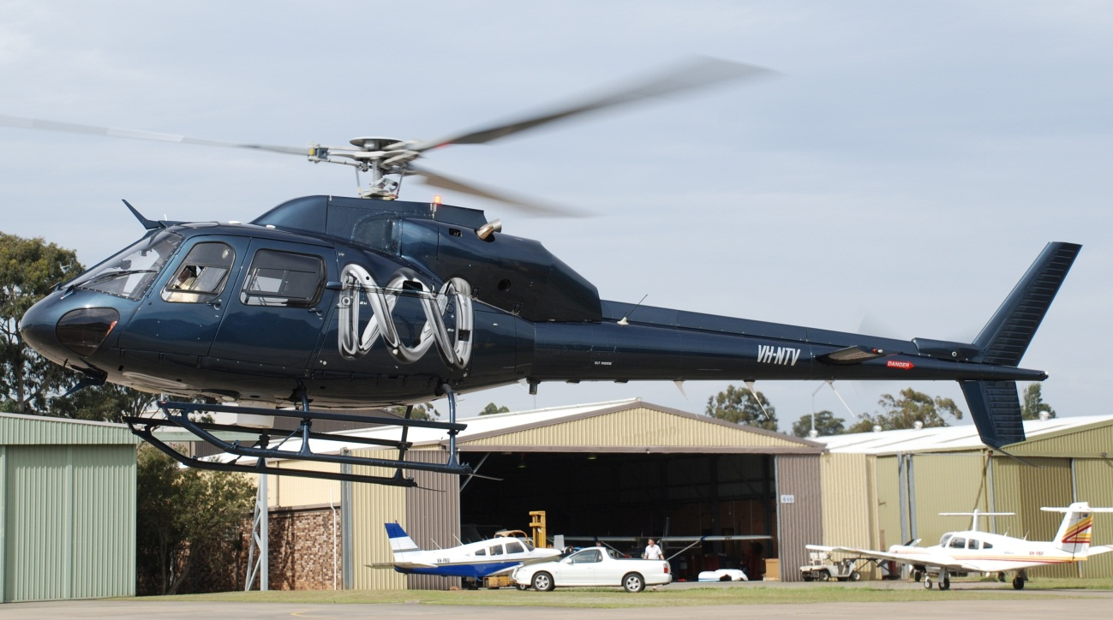
Source: Australian Broadcasting Corporation
In its role as a media helicopter, VH-NTV had seating for a pilot and three passengers, and a camera mount located at the rear right sliding door. It was certified for day and night charter operations under the night visual flight rules (VFR). The helicopter was powered by two Rolls-Royce 250-C20F turboshaft engines.
The accident was the first fatal accident in Australia involving a twin-engine helicopter since 1986, and the first involving an AS355. At the time of the accident, there were 10 other AS355 helicopters on the Australian register.

Airworthiness and maintenance
Examination of the helicopter’s maintenance records indicated that it was maintained in accordance with the requirements of the airframe and engine manufacturers, and with CASA Schedule 5 for instrument, electrical and radio inspections. It was maintained to a night VFR standard, and had a current Certificate of Registration and Certificate of Airworthiness.
The helicopter’s last scheduled maintenance was a 100-hourly service, which was completed on 9 August 2011. As part of this maintenance activity, both engines were removed for inspection. The left engine was removed to facilitate a compressor module change, as the compressor was due for overhaul. The left engine compressor was replaced with an overhauled module. The right engine was removed due to metal contamination identified in the oil system. The right engine compressor module and accessory gearbox were sent to an engine overhaul facility for metal contamination assessment and repair. Because there was metal contamination of the right engine, the turbine module was also sent for a serviceability inspection, with no problems identified.
Between 9 and 16 August 2011, the helicopter was operated for about 9 flight hours. A pilot who flew it during this period stated that there were no problems with its performance and operation. While en route to the Lake Eyre region, the pilot of the accident flight was in contact with the maintainer of the helicopter and indicated that the helicopter was operating normally.

Flight controls
The helicopter was equipped with a dual hydraulic-powered main rotor flight control system to assist with reducing the flight control operating loads. This system incorporated two independent hydraulic systems, allowing continued hydraulic power assistance to the main rotor should one system fail. The tail rotor flight control system was powered by a single hydraulic system. In the event of a failure, an accumulator was incorporated into the tail rotor control system to provide limited hydraulic power assistance. In the event of both hydraulic systems failing, the helicopter could be controlled, but this would require an increased level of control input forces by the pilot.
The main rotor flight controls were equipped with pilot-adjustable friction mechanisms. These allowed the pilot to adjust the apparent control operating load, or to assist with holding the controls in position when on the ground. The investigation was unable to determine the amount of friction normally applied by the pilot.
The helicopter was not equipped with an autopilot or automatic stabilisation system, nor were such systems required by Civil Aviation Order (CAO) 20.18 for night VFR flight (see Requirements and guidance for night operations).

Avionics
Figure 6 provides an overview of the flight instruments located in VH-NTV at the time of the accident.
Figure 6: Schematic of the instrument panel (pilot seated front right)
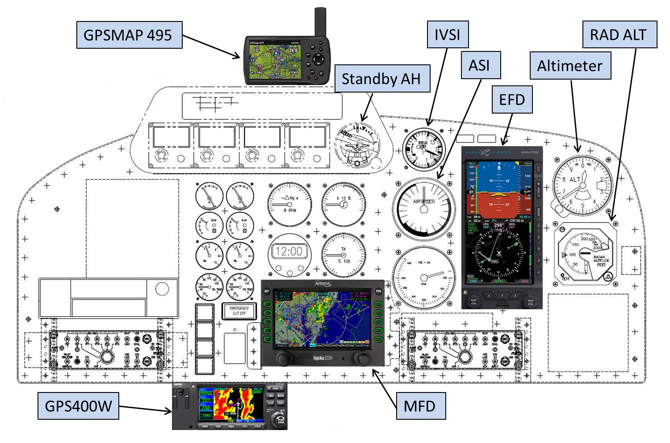
Source: Auto Avia Design Pty Ltd, Aspen Avionics Inc, Avidyne Corp, and Garmin International Inc.

Electronic flight display
In August 2010, the aircraft was fitted with an Aspen Avionics EFD1000H electronic flight display (EFD) to replace the existing primary artificial horizon (AH) and horizontal situation indicator on the pilot’s instrument panel (Figure 7). The unit was capable of providing a large amount of information to the pilot at a single location on the instrument panel, including an electronic attitude director indicator (EADI) and an electronic horizontal situation indicator (EHSI). The original airspeed indicator (ASI), altimeter, instantaneous vertical speed indicator (IVSI) and radar altimeter (RAD ALT) remained in place and were functional.
The EFD had an internal battery that was kept charged by the aircraft electrical system. This battery was capable of providing about 30–60 minutes of power to the EFD in the event of an aircraft electrical failure. In the event of a system error, a red cross would be placed over the unreliable information (Figure 8), and a text note displayed describing the issue.
The EFD had an aid to assist the pilot in the event of some types of unusual attitudes. This consisted of a series of red chevrons that would indicate the recovery direction to the nearest horizon, and would appear on the EADI display when the aircraft was in a nose-up attitude of 15° or greater, or a nose-down attitude of 10° or greater (Figure 9). The display was also set up to always have a portion of either the background sky (blue) or ground (brown) visible in the screen showing the horizon, regardless of the aircraft’s attitude.

Standby artificial horizon
In addition to the EFD, the aircraft was fitted with a standby AH, which was available for attitude information as a cross-reference or back-up to the EFD.

Figure 7: Typical screen display on the EFD
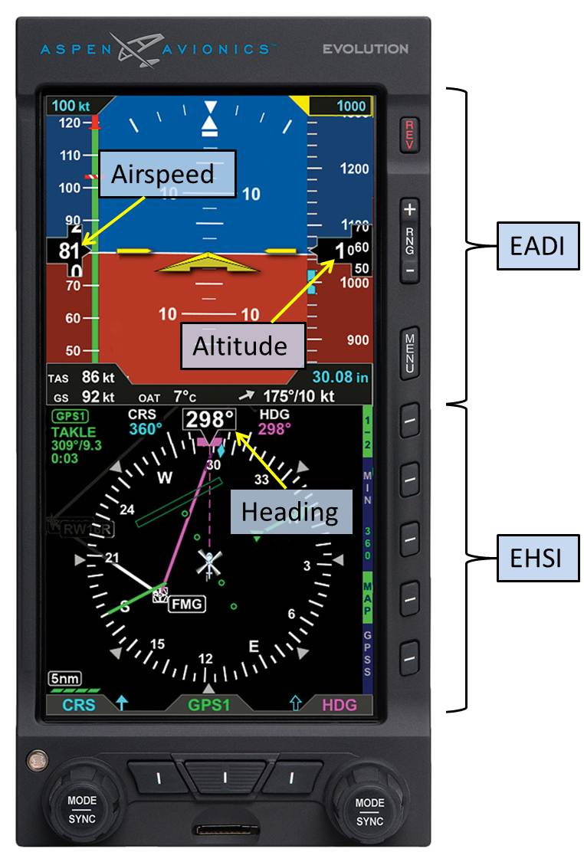
Source: Aspen Avionics Inc.
Figure 8: Example of a failure warning on the EFD
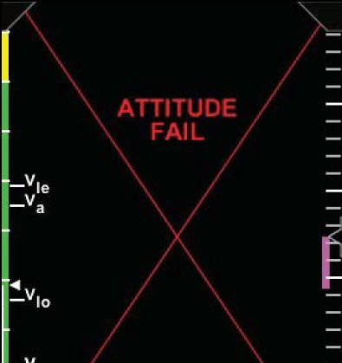
Source: Aspen Avionics Inc.
Figure 9: Example of chevron markers on the EFD for pitch down and up guidance
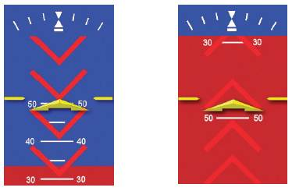
Source: Aspen Avionics Inc.

Radar altimeter
The RADALT system was used to indicate an accurate height above ground level, up to the maximum indicated altitude of 2,000 ft. The accuracy was dependant on the aircraft bank not exceeding about 30° and the pitch angle not exceeding about 20°. If these limits were exceeded the indicator would display an altitude greater than the actual height above ground level.
A ground proximity warning system was not fitted to the helicopter, nor was it required by CAO 20.18.

Navigation equipment
Two GPS units were fitted to the aircraft. A Garmin GPS400W was mounted in the centre pedestal just below the instrument panel. The data from this GPS unit allowed GPS tracking information to be displayed on the lower portion of the EFD screen, as well as on an Avidyne FlightMax EX500 multifunction display (MFD) mounted in the pilot’s instrument panel (Figure 10). The GPS400W used volatile memory, and therefore did not store any flight data.
The MFD could display a moving map, designed to improve situational awareness and safety. A compass rose was overlayed on the moving map, and various information sources were able to be overlayed onto the moving map, including flight plan track information from the GPS400W.
Figure 10: Typical screen display on the MFD
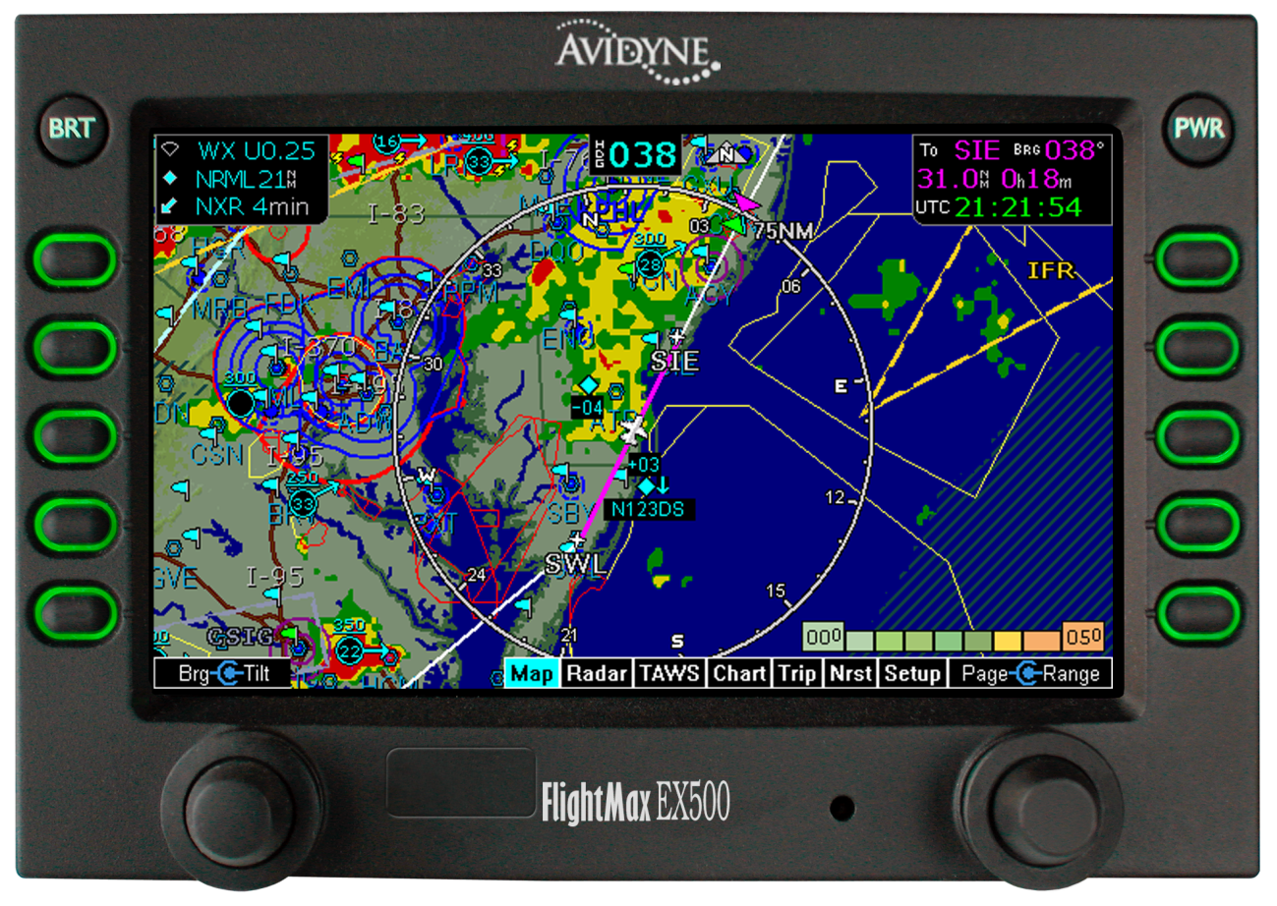
Source: Avidyne Corp.
The second GPS unit, a portable Garmin GPSMAP 495, was mounted above the instrument panel on the windscreen centre pillar. This unit was equipped with its own battery, which was kept charged by the aircraft electrical system. The flight data from this GPS unit was stored internally in non-volatile memory. The unit was not integrated into the helicopter’s avionics systems.

Active noise reduction headsets
Active noise reduction headsets were available for use by the pilot and passengers. These headsets would electronically cancel the majority of environmental noise inside the helicopter for the person wearing the headset, thereby reducing the noise level effects from sources such as the airflow, engines, gearbox and the rotor system.

Landing lights
The helicopter had a fixed landing light and an electrically-steerable searchlight, both located on the lower surface of the helicopter. In accordance with CAO 20.18, two functional landing lights were required for night VFR flight.
While the helicopter was on the ground at Cooper Crossing, two witnesses reported that they assisted the pilot in identifying a fault with the steerable searchlight. The light would not illuminate, although it was able to be steered. The fixed landing light located to the right of the steerable searchlight was observed to be illuminating correctly. The investigation could not determine if the pilot was able to rectify the problem with the searchlight.
Witnesses who observed the accident flight departure noted that a landing light was illuminated during the take-off. It was not observed to be on later in the flight. It is normal practice for a helicopter pilot to turn off the landing light during the climb on departure.

Fuel
The helicopter had two fuel tanks with a combined maximum fuel capacity of 730 L, and a typical fuel burn of 225 L/hour. The pilot had organised for three 200 L sealed drums of aviation turbine fuel (Jet A1) to be positioned at Muloorina Station, where the crew were intending to stay on the night of 18 August. At about 1340 that day, the pilot landed at Muloorina Station to refuel, and two of the three drums were nearly emptied during the refuelling. The helicopter departed the property at about 1418, and it was operated for about 1.7 hours after refuelling.
No refuelling records were recovered from the accident site, and it was not possible to determine the exact quantity on board at the time of the accident. If the helicopter had been refuelled to full capacity at the last fuel stop prior to adding the two drums of fuel at Muloorina Station, it would have had about 40 per cent of its fuel capacity at the time of the accident. Evidence at the accident site indicated there was a significant quantity of fuel on board at the time of impact.
Due to the post-impact fire, a fuel sample could not be taken from the aircraft; however, two fuel samples were taken from the fuel drums that the helicopter had last refuelled from. Those samples were tested at a laboratory and found to meet the specifications for Jet A1. Particulates were identified in the fuel samples; however, the report provided by the laboratory stated that ‘…from our experience these should not adversely effect engine operation. Filters are usually employed to remove these particulates.’ Each of the helicopter’s two fuel systems had a fuel filter, as well as a filter in the engine-driven fuel pump on each of the two engines.

Weight and balance
Calculations of weight and balance were conducted with 40 per cent fuel capacity. In this circumstance, the helicopter’s take-off weight was well below the maximum take-off weight (2,540 kg) and the centre of gravity was well within acceptable limits.

Meteorological information

Weather conditions
There were no automatic recorded observations of the weather conditions in the vicinity of the accident site. A Bureau of Meteorology (BoM) analysis described the general prevailing weather conditions on the evening of the accident as including scattered cloud with a base of about 4,000 ft and light to moderate wind from the south to south-west. The BoM analysis further stated that no rain or thunderstorms were present near the accident site that evening.
Witnesses from the tour group reported that the weather conditions during the period when the helicopter was at the island were fine, with no cloud and minimal wind. Video footage taken by a witness prior to the helicopter’s departure was consistent with these reports (see also Figure 2).

Illumination
Sunset in the area of the take-off was at 1758 and the end of evening civil twilight, which was the start of night for aviation purposes, was at 1822. The end of nautical twilight was at 1850, the end of astronomical twilight was at 1917, and moonrise was at 2158. Apart from the tour group’s camp fire on the island, there were no other known sources of terrestrial lighting cues available in the vicinity of the helicopter’s flight path. As the accident happened at about 1902, there would have been very little ambient illumination available from any sources other than stars.
The human eyes require 30 minutes or longer to be fully adapted from bright conditions to dark conditions (Federal Aviation Administration 2008, Kalloniatis and Luu 2007). The time required depends on the starting level of illumination, how long a person was exposed to that level of illumination, and any exposure to light sources during the adaptation period. With increasing age, a person’s ability to detect light is reduced and the time required for dark adaptation increases (Wynn and others 2010).
The presence of cockpit and instrument lighting reduces available external cues due to windscreen reflections. It is generally recommended that a pilot reduces the cockpit and instrument lighting at night to the lowest possible level to assist dark adaptation. Because the pilot’s eyes are not fully adapted at the beginning of a flight, the normal process is to set a higher instrument lighting level, and reduce it as their eyes adapt. In this case, the helicopter’s landing light on the light-coloured terrain would have also provided a bright source of illumination during the take-off. Overall, it is very unlikely that the occupants’ eyes would have fully adapted to the dark night conditions by the time the helicopter started descending.
Witnesses from the tour group reported that the ambient illumination level was dark at the time the helicopter departed. A few witnesses reported that they could discern some terrain features, which may have been possible due to starlight and if their eyes were fully adapted. A few witnesses also reported being able to see a horizon. This would seem unlikely given the time and conditions. Even if a horizon was faintly visible outside the helicopter due to starlight, it would have been difficult to detect from within the helicopter.
A pilot reported flying around the Lake Eyre region in an Aérospatiale AS350BA (Single Squirrel) from the same media organisation several years prior to the accident. He departed Muloorina Station after last light for a flight to Marree. The stars were not visible as there was instrument lighting glare on the inside of the windshield and there was no visible horizon at all during the flight. The pilot said the darkness was ‘frightening’, and he had to fly the helicopter by flight instruments for the flight to Marree.
In summary, the occupants of VH-NTV would have been able to see very little, if anything, outside the helicopter after they had reached their cruising height.

Landing site information
The helicopter landing site at the Cooper Creek inlet was on a sand island, with an undulating surface of small sand hills and low scrub. The only available ground lighting on the island was from a camp fire at the tour group camp site.
The closest helicopter landing sites to the accident site, as detailed on the film crew’s itinerary, were Muloorina Station and Cowarie Station, South Australia (SA). Muloorina Station was about 96 km to the south on a bearing of 160°, and Cowarie Station was about 97 km to the north-east, on a bearing of 034°. Assuming a cruise speed of 110 kt, the calculated flight time from the island at Cooper Creek inlet to Muloorina Station was 28 minutes.
The runway at Muloorina Station was located adjacent to the station complex, and there was a concrete helipad next to the taxiway, on the apron. No helipad lighting was available. Kerosene lanterns were available for runway lighting with prior notice; however, the owners of the station discouraged night arrivals. The runway at Cowarie Station was located to the west of the station, a short drive from the station homestead. Runway lighting flares were available with prior notice. Both runway owners confirmed that there had been no prior arrangements made to organise runway lighting for a night arrival of the helicopter.
The nearest navigation aids in the general direction of Muloorina Station were an NDB and VOR at Leigh Creek, SA, which was located about 255 km to the south of the accident site. The pilot was most likely using GPS as his primary means of navigation for the accident flight.

Wreckage and impact information

Overview of the accident site
The wreckage was located on sandy, undulating terrain at about sea level (Figure 11). All of the helicopter’s major components were identified at the accident site.
Figure 11: Helicopter wreckage
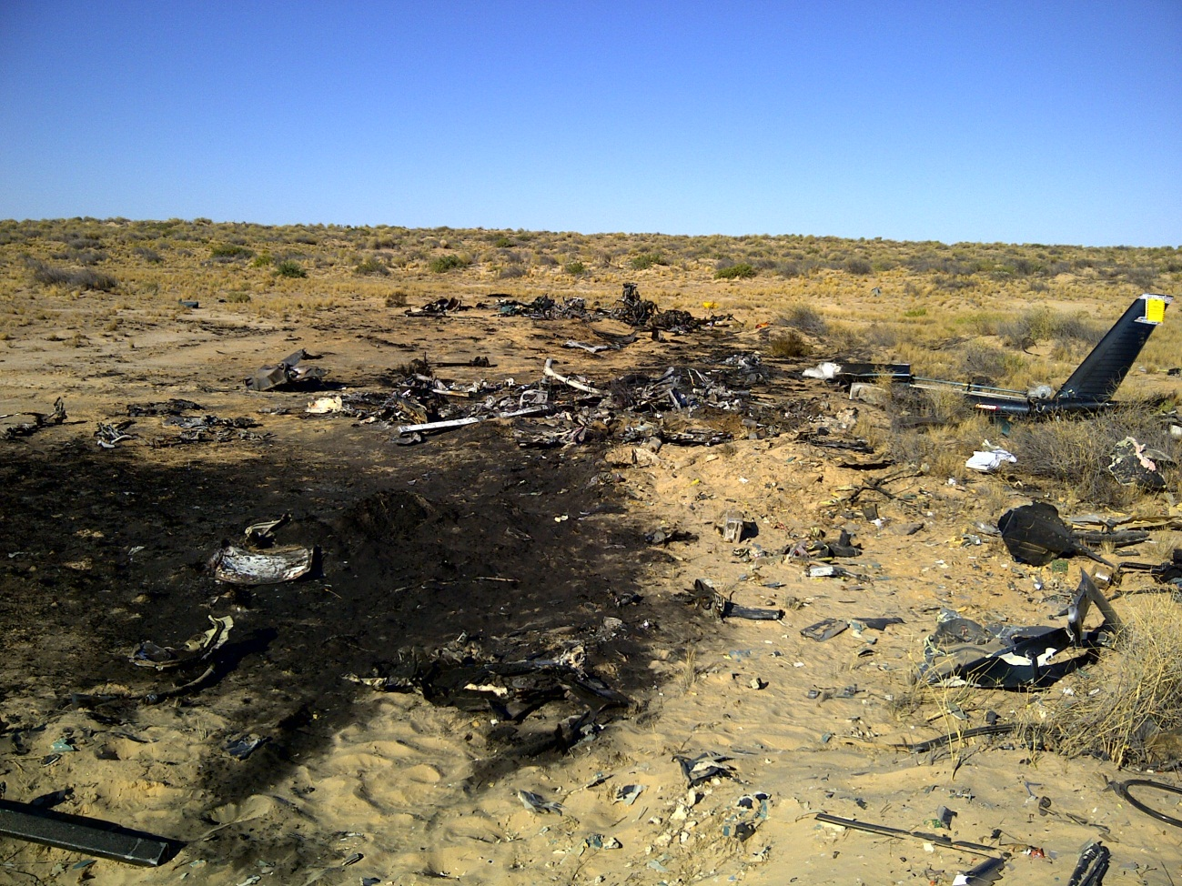Source: ATSB
The wreckage trail was about 60 m long and indicated that the helicopter was travelling in an easterly direction at the time of impact (Figure 12). The majority of the cabin and tail boom were near the beginning of the wreckage trail at the western end. The heavier components, consisting primarily of the engines, main rotor gearbox, main rotor head and main rotor blades, were to the eastern end of the wreckage trail.
Figure 12: Wreckage trail
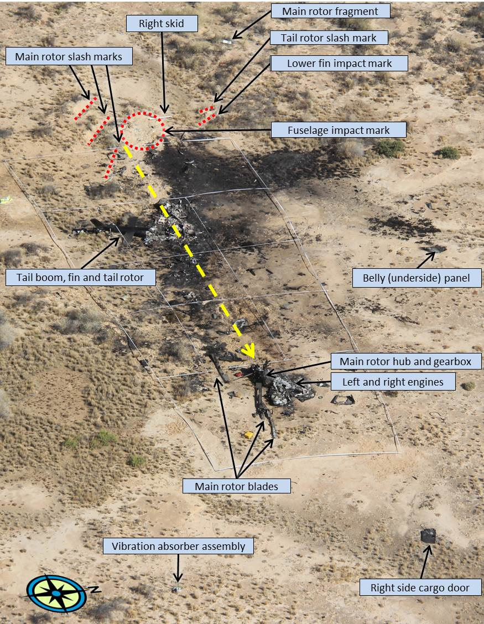Source: ATSB
Ground strike marks from the helicopter’s three main rotor blades were identified at the beginning of the wreckage trail. The marks, and the orientation of two main rotor blade tips found embedded in two of the strike marks, indicated that the helicopter impacted the ground at about a 90°, right-side-low attitude (Figure 13). The third main rotor blade tip remained attached to its blade.
Figure 13: Main rotor blade tip
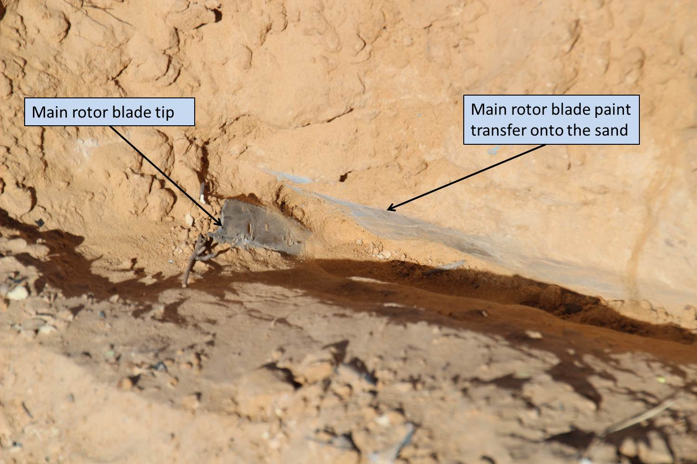Source: ATSB

Fire damage
Much of the wreckage and localised ground foliage was destroyed by a fuel-fed fire. There was no evidence of fire along the flight path, or on airframe components, prior to or at the initial fuselage impact marks (Figure 12). The fire damage had a ‘burst’ pattern, consistent with a post-impact fire.
Nine witnesses reported seeing the very last part of the flight and all of those witnesses saw a fireball and/or an orange or similar-coloured glow. There were a number of sand dunes between the accident site and the witnesses at the camp site. Seven witnesses reported a fireball or glow after or at the same time that the helicopter disappeared from view behind the terrain. Two witnesses recalled seeing a glow before the helicopter disappeared from view.
Overall, the physical evidence and the majority of the witness evidence indicated that it was very unlikely that there was any fire prior to the helicopter impacting terrain.

Airframe damage
The main airframe was significantly disrupted by the initial impact, with pieces of the structure identified from the initial impact point through to the end of the wreckage trail. Almost all of the airframe had been consumed by the post-impact fire (Figure 14). Due to the level of disruption to the cabin area, the accident was not considered survivable.
Figure 14: Main airframe
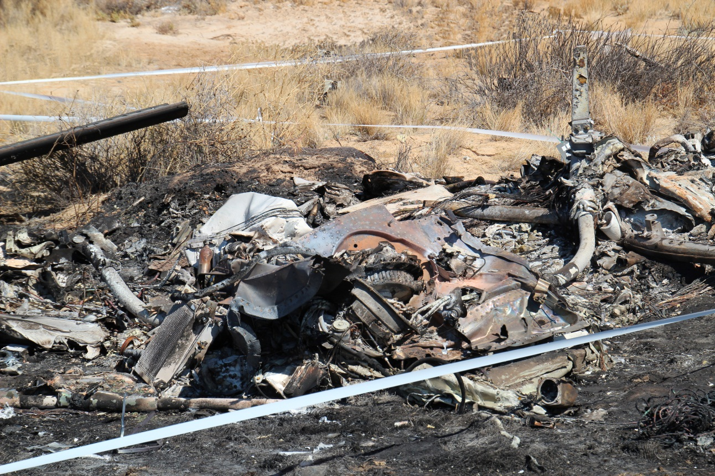Source: ATSB

Engines
Both engines were located at the end of the main wreckage trail, including the overhead engine controls from the cockpit, and the associated control cables. The left engine had been affected by the fire, while the right engine had no significant fire damage.
The engines were removed from the accident site and taken to a Rolls-Royce-approved workshop for detailed examination under the supervision of the ATSB (appendix C). From the evidence available at the examination, it was likely that at the time of the impact both engines were operating at a level of power, although the exact level could not be determined. An examination of the fuel components also identified no problems (see appendix C).

Drive train and rotor systems
The main rotor head was severely damaged, consistent with a main rotor strike under a level of power. All three main rotor blades had been severely disrupted, consistent with contact with the terrain. Drive continuity was confirmed from the main gearbox through to the main rotor head, then through to the tail rotor gearbox. One of the blades on the tail rotor assembly had separated at the beginning of the wreckage trail when the tail rotor contacted the ground. The other blade on the assembly had indications of rearwards bending, consistent with a ground strike under a level of power (Figure 15).
Figure 15: Tail rotor
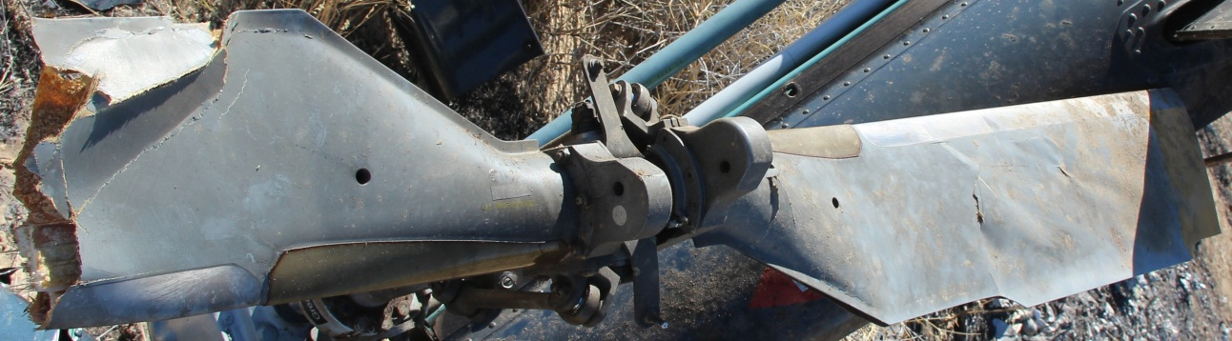Source: ATSB

Flight controls
Continuity of the tail rotor pitch control rod was confirmed along the remaining portion of the tail boom, and the rod was able to be moved. Continuity of the flight controls from the main hydraulic actuators on the main gearbox to the main rotor head was also confirmed. The majority of the flight control tubes in the cabin area had been consumed by the post-impact fire. The majority of the control tube ends and bellcranks were identified and all associated attaching hardware was intact. Unidentified flight control items were also confirmed to have attaching hardware installed (Figure 16).
Figure 16: Flight controls set out on-site
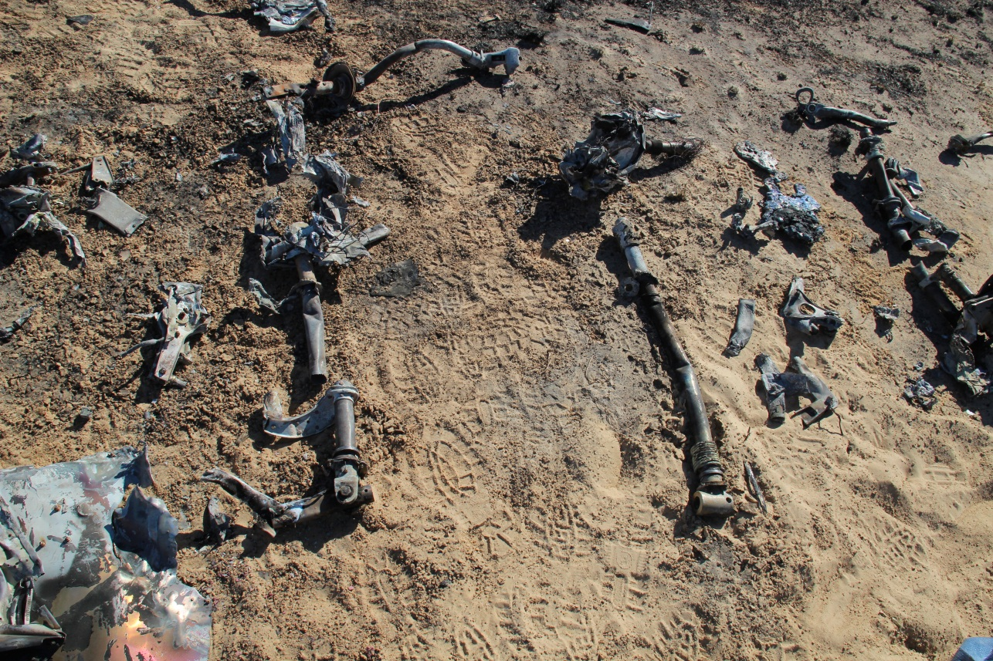Source: ATSB
The three main hydraulic actuators and the tail rotor hydraulic actuator were taken for detailed examination under the supervision of the ATSB. The actuators were damaged by the impact and fire and were not able to be operationally tested on a hydraulic rig. The actuators were disassembled and no internal defects were identified.

Instruments, avionics and light globes
A number of instruments, avionics components and light globes were recovered from the accident site and subsequently examined by the ATSB.
The EFD and MFD were both examined. No flight information was available from either unit.
Examination of the standby AH confirmed that the roll attitude indication on the instrument was captured at about 90° right-side low (Figure 17). The pitch attitude in the instrument had some movement, and therefore its relative position at the time of impact could not be determined. The standby AH was disassembled for a detailed examination, and it was confirmed that its internal gyro was rotating at the time of impact (Figure 18), and therefore capable of providing aircraft attitude information.
Figure 17: On-site image of the standby AH
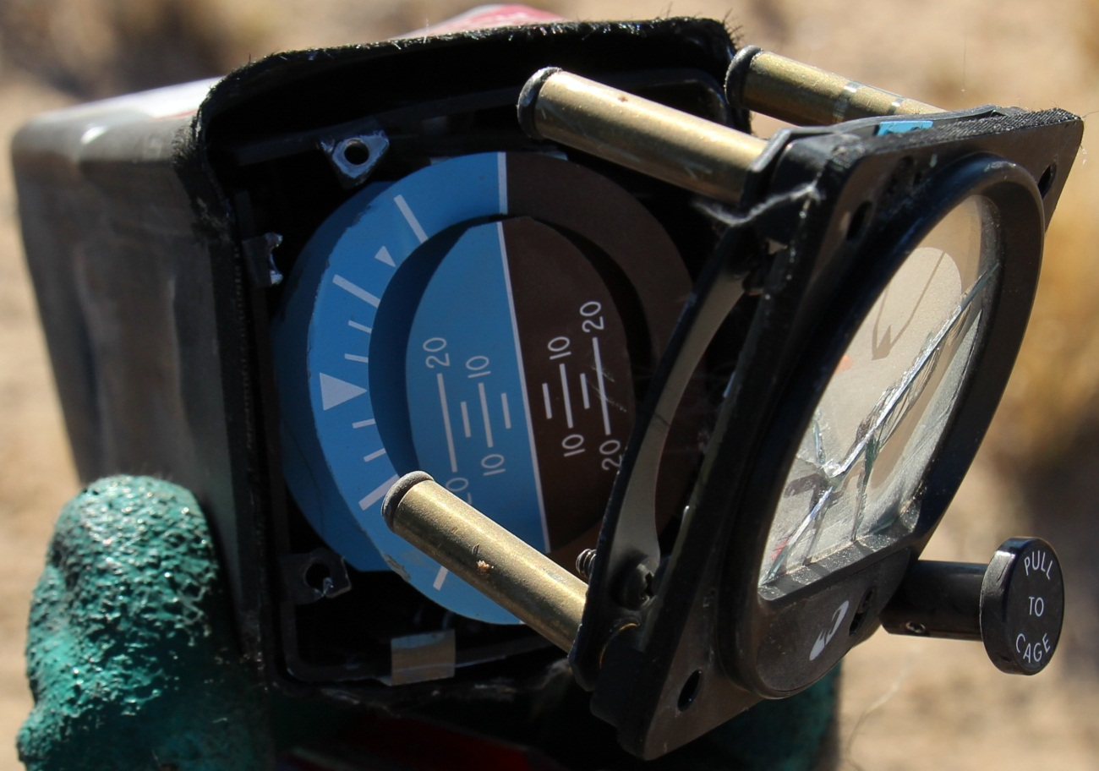Source: ATSB
Both the instantaneous vertical speed indicator (IVSI) and the gas generator (Ng) gauge faces had evidence of contact from their pointers. Although the contact marks provided some indication regarding the flight profile and engine operation, the actual information provided by the instruments immediately prior to the impact could not be determined due to the nature of the impact sequence. The IVSI had evidence of paint transfer on the instrument face at about 4,800 ft per minute rate of descent, which was broadly consistent with the data retrieved from the GPS unit. The Ng gauge had scratching on its face from both of the pointers starting in the area of the 105 per cent mark and continuing past the 110 per cent mark, which was consistent with both engines operating at impact.
The RAD ALT was impact- and fire-damaged. The decision height bug on the instrument face could not be identified and therefore its setting could not be determined.
Figure 18: Standby AH displaying rotational scoring from the gyro rotor (removed)
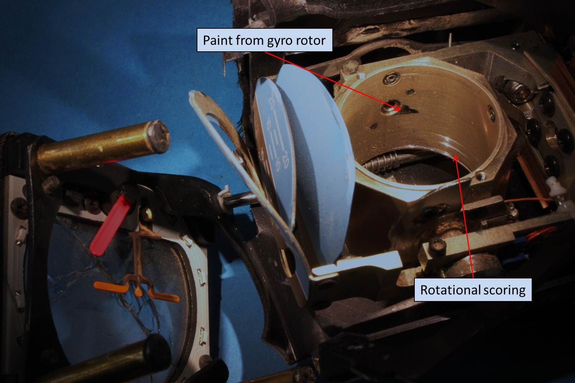Source: ATSB
The light globes in the caution-warning panel and three switch panels were examined with the aid of a stereo microscope. Light globe filament stretch can be an indication of illumination of the light globe at impact. Many factors need to be considered during examination of light globe filaments, such as the magnitude and direction of impact, aircraft crumple characteristics, the age of the light globe, illumination time at the time of impact and total illumination time since new, and the filament’s cold stretch characteristics.
Evidence of some minimal filament stretch was identified in the right engine fire warning light globe; however, the examination of the right engine found no evidence of fire damage. Minimal filament stretch was also found in the limit, pilot pitot and door warning light globes. As the right side of the helicopter initially impacted terrain, it was possible that the disruption to the airframe, right engine and the electrical system momentarily resulted in multiple caution and warning lights illuminating before further disruption resulted in electrical power being removed. Overall, the evidence from the warning light globes was not considered reliable.

Emergency locator transmitter
The helicopter was fitted with a 406 MHz, fixed installation, emergency locator transmitter (ELT). No ELT transmissions were received by the Cospas Sarsat distress beacon system, and there were no overflying aircraft in the area to monitor the distress frequency. The ELT was mounted in the forward section of the tail boom. Due to the level of fire damage to the forward section of the tail boom, the ELT could not be identified.
In addition to the fixed ELT installation, there were two portable, manually activated 406 MHz emergency position-indicating radio beacons (EPIRB) mounted in the forward cabin. Neither of these units had been activated.

Feathers examination
Down feathers were identified at the accident site. To confirm the source of the feathers, they were sent to the Australian Museum in Sydney, and then onto the Smithsonian Institution’s Feather Identification Laboratory in the United States. Microscopic examination determined that the down feathers were most likely from a domesticated or commercial waterfowl, a species that was not native to Australia. The lack of bird DNA indicated their source would be more consistent with treated down feathers used in sleeping bag or jacket stuffing. Photographs taken at the Cooper Creek inlet showed evidence of the pilot wearing a down-filled vest.

Recorded information

Flight recorders
The helicopter was not fitted with a flight data recorder or a cockpit voice recorder, nor was either required by CAO 20.18.

Garmin GPSMAP 495
The Garmin GPSMAP 495 GPS was recovered from the accident site and the ATSB subsequently downloaded data from the accident flight and previous flights. Basic data is provided in The Occurrence and further details of the data downloading and interpretation process are provided in appendix A.

Media camera P2 memory cards examination
To ascertain if the crew of the helicopter were filming at the time of the accident, several P2 media cards from the Panasonic video camera located on-site were recovered and sent to the media card manufacturer for detailed examination. No evidence of filming after the accident flight departure was identified (appendix B). Other camera operators reported that the camera type was not effective in low light, so filming away from a light source after dusk would be ineffective. Overall, it was considered very unlikely that any filming was occurring during the accident flight.

Simulator trials
The ATSB conducted simulator trials in an ELITE TH-100 AS350B, Cat B, FSD2 procedural fixed-base simulator. The main purpose was to examine the control inputs required to replicate the flight path of the accident flight.
A series of trials were carried out attempting to match speed, bank angle, rate of descent and turn rate. These trials were able to match the accident flight profile if the simulator pilot made continual control adjustments. A series of trials with the controls in a fixed position produced flight profiles that were significantly different to that of the accident flight, and none of them produced a sustained spiral descent.
On the trials where the flight profile was matched, flight was continued past the last reliable GPS data point at about 800 ft above mean sea level with continued control inputs and an increasing bank angle from a northerly heading. These trials resulted in the aircraft turning through about another 90°, striking the ground in a 75° to 90° right-side low attitude and generally on an east to south-easterly heading, which was consistent with the accident site information. The time interval from the last reliable GPS data point (163 seconds after the start of the flight) to the time of impact was estimated to be about 8 seconds.
The ATSB also asked the helicopter manufacturer to conduct similar trials, which were done using the American Eurocopter’s AS350B2/B3, Level B full motion flight simulator. Unfortunately the simulator was not able to record flight control inputs or flight data. The manufacturer reported that its pilots could replicate the accident flight profile with continual control adjustments. The test pilots also commented on the difficulty of maintaining control of the helicopter when there were no external visual references.
The flight models used in each simulator did not necessarily represent helicopter flight characteristics accurately at or near extremes of the flight envelope. However, the models were considered to provide reasonable approximations of flight characteristics during normal flight. Overall, the consistent result over both sets of trials was that continual control adjustments were required to recreate the profile of the accident flight.

Spatial disorientation

Overview
Spatial disorientation (SD) occurs when a pilot does not correctly sense the position, motion and attitude of an aircraft relative to the surface of the Earth. It is often simply described as the inability to determine ‘which way is up’, although the effects of disorientation can be considerably more subtle than that description.
Pilots obtain information about their orientation from:
- The visual system (eyes), which can obtain information from a range of cues outside the aircraft and relevant flight instruments inside the aircraft.
- The vestibular system, which consists of the balance organs located in the inner ears. The semicircular canals provide information about angular or rotational accelerations in the vertical (yaw), horizontal (pitch) and longitudinal (roll) axes, and the otolith organs provide information about linear accelerations.
- The somatosensory system, which includes a range of receptors in the muscles, tendons, joints and skin that sense gravity and other pressures on the body. Such perceptions are often known as the ‘seat of the pants’ aspect of flying.
The visual system generally provides about 80 per cent of a person’s raw orientation information, with the remainder provided by the vestibular and somatosensory systems, both of which are prone to misinterpretation and illusions during flight (Newman 2007). Although the visual system can overcome these limitations, the risk of SD is significantly increased if the relevant visual cues are absent, ambiguous or not attended to.

Nature of spatial disorientation accidents
Almost all pilots will experience SD events at some time, but the events are usually recognised and do not result in adverse consequences. Nevertheless, SD has always been involved in a significant proportion of aviation accidents, particularly those with more serious consequences. Statistics from the United States show that SD was involved in:
- 11 per cent of fatal general aviation accidents during 1976–1992 (Collins and Dollar 1996)
- 2 per cent of general aviation accidents during 1983–1992, with 92 per cent resulting in fatalities (Mortimer 1995)
- 1.2 per cent of civil helicopter accidents during 1983–1996, with 61 per cent resulting in fatalities (Mortimer 1997)
- 11 per cent of United States Air Force accidents during 1990–2006, with 69 per cent resulting in fatalities (Lyons and others 2006)
- 11 per cent of helicopter accidents and 31 per cent of fatal helicopter accidents in the United States Army during 2002–2011 (Gaydos and others 2012).
Many authors have indicated that accident statistics often underestimate the proportion of accidents that are associated with SD due to the difficulty in establishing the contributing factors in some accidents and differences in the use of definitions (Gibbs and others 2012, Mortimer 1997, Newman 2007).
When SD does result in an accident, it is usually in the form of a controlled flight into terrain or in-flight loss of control, resulting in a collision with terrain or in-flight break-up. With most SD accidents, the pilot does not recognise the problem, or at least does not recognise it in time to effectively recover the situation. This unrecognised SD, often known as Type I, can occur for an extended period of time lasting up to tens of seconds or even longer (Previc and Ecoline 2004).
Recognised SD, or Type II, is a more common event and occurs when the pilot is aware that their perception is incorrect, aware there is inconsistency in the information from the different sensory systems, or aware that the sensory information does not agree with the aircraft’s flight instruments. Usually the situation is able to be recovered before an accident. When Type II SD accidents do occur, they generally involve erratic flight paths resulting from the pilot having difficulty maintaining control of the aircraft’s flight path.
A range of factors can influence the extent to which a pilot may experience SD or be able to recover from SD. Common factors include limited or ambiguous visual cues outside the cockpit, not directing sufficient attention to the flight instruments due to workload or distraction, and not being proficient in instrument flying skills. McGrath and others (2003) stated:
The typical SD mishap occurs when visual attention is directed away from the aircraft's orientation instruments and/or the horizon (due to, for example, temporary distraction, increased workload, cockpit emergencies, transitions between visual and meteorological conditions, reduced visibility, or boredom). Most SD mishaps are not due to radical maneuvers. When a pilot looks away from the horizon (loss of focal and peripheral visual cues), or looks away from his artificial horizon in instrument weather (loss of focal visual cues), the central nervous system computes spatial orientation with the remaining information at its disposal, vestibular and somatosensory. The vestibular and somatosensory information are concordant, but frequently incorrect. In such circumstances, it is physiologically normal to experience spatial disorientation.

Misperceptions associated with a gradually increasing bank angle
There are many misperceptions and illusions that can occur during flight, and these are discussed by many reference sources (such as Benson 1999b, Gillingham and Previc 1993, Newman 2007a). This section briefly reviews some misperceptions that can be associated with a gradually increasing bank angle.

Movement below the detection threshold
If a roll movement occurs gradually, it may be below the level that a pilot can detect. The threshold for the detection of short-duration roll movements (5 seconds or less) is usually reported as an angular or rotational velocity of about 2° per second. For longer durations the threshold is usually reported as an angular acceleration of about 0.5° per second² (Cheung 2004). In operational settings these types of sensory thresholds are often higher, particularly when a pilot’s attention is directed elsewhere (Benson 1999a, Gillingham and Previc 1993).

The ‘leans’
Sometimes a pilot either intentionally or unintentionally initiates a roll at a rate below the detection threshold, and then notices the problem and initiates a roll in the opposite direction at a rate above the threshold in order to get the aircraft back level. The semicircular canals detect the acceleration of the corrective roll but not that of the original roll. As a result, a pilot can perceive that the aircraft is actually banking in the direction of the corrective roll even though it is level.
This is one of the most common forms of SD, and usually results only in a pilot leaning their body in the direction of the initial roll. However, it can also result in a pilot rolling the aircraft back in the direction of the original roll if they are not monitoring their instruments (Benson 1999b).

Somatogyral illusion
During the entry into a turn, the semicircular canals will detect the initial angular acceleration. If the rotation is continued at a constant rate the canals will soon no longer be stimulated (or ‘wash out’). This can occur after 10 to 20 seconds (Cheung 2004). If the pilot then attempts to roll out of the turn, they can falsely perceive an undesired, ongoing turn in the opposite direction. This illusion is usually discussed in terms of aircraft spinning in the yaw axis, but it also is relevant to movement in the roll axis. As described by Gillingham and Previc (1993):
…when trying to stop the turn by rolling back to a wings-level attitude, the pilot feels not only a turn in the direction opposite to that of the original turn, but also a bank in the direction opposite to that of the original bank. Unwilling to accept this sensation of making the wrong control input, the hapless pilot rolls back into the direction of the original banked turn. Now the pilot's sensation is compatible with a desired mode of flight, but the flight instruments indicate a loss of altitude (because the banked turn is wasting lift) and a continuing turn. So the pilot pulls back on the stick and perhaps adds power to arrest the unwanted descent and regain the lost altitude. This action would be successful if the aircraft were flying wings-level, but with the aircraft in a steeply banked attitude it tightens the turn, serving only to make matters worse. Unless the pilot eventually recognizes what is occurring and rolls out of the unperceived banked turn, the aircraft will continue to descend in an ever-tightening spiral toward the ground, hence the name graveyard spiral.
In summary, for the somatogyral illusion to occur, there has to be sustained rotation above the detection threshold.

Somatogravic illusion
During some aspects of a flight, a pilot is exposed to linear accelerations in various directions in addition to the normal gravitational force (g). The resultant total force vector is known as the gravito-inertial force (GIF). When a pilot misinterprets the GIF vector to indicate that they are tilted at a different attitude than they actually are, the pilot is experiencing the somatogravic illusion. Although the somatogravic illusion is usually discussed in terms of false pitch illusions that can occur when an aircraft accelerates during a take-off, it can also occur during turns.
During a constant airspeed turn, a pilot feels a centrifugal force as well as the gravitational force. If an aircraft yaws or turns without banking, the pilot will feel a sideways force because the resultant GIF vector points towards the outside of the turn. During a coordinated or balanced turn, the pilot manipulates the aircraft’s controls to minimise any such sideways forces. Consequently, the resultant GIF vector points towards the floor of the aircraft (or from the pilot’s head to feet), which is a similar perception to when the aircraft is in straight and level flight (Figure 19).
Figure 19: Gravito-inertial force during turn and potential misperception
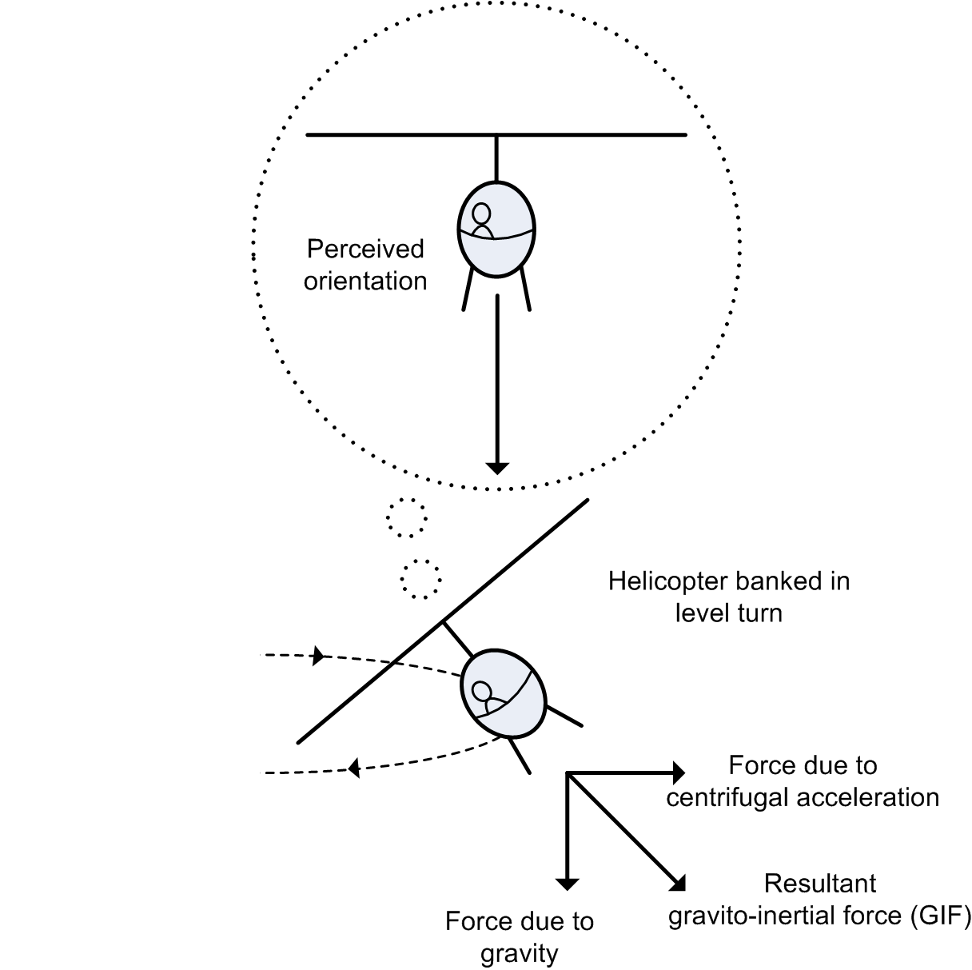
Source: ATSB
As previously discussed, in a gradual or prolonged turn, the semicircular canals do not contribute to the pilot’s perception of bank. In the absence of visual cues, the pilot may then interpret the direction of the resultant GIF vector during a coordinated turn as being the same as that during straight-and-level flight.
In addition to level turns, misperceptions of the GIF vector can occur during a descending turn and result in a spiral descent. As described by Gillingham and Previc (1993):
A pilot who is flying "by the seat of the pants" applies the necessary control inputs to create a resultant G-force [GIF] vector having the same magnitude and direction as that which the desired flight path would create. Unfortunately, any particular G vector is not unique to one particular condition of aircraft attitude and motion, and the likelihood that the G vector created by a pilot flying without reference to instruments is that of the flight condition desired is remote indeed. Specifically, once an aircraft has departed a desired wings-level attitude [or other desired bank angle] because of an unperceived roll, and the pilot does not correct the resulting bank, the only way he can create a G vector which matches that of the straight and level condition is with a descending spiral… a skilful pilot can easily manipulate the [flight controls] to cancel all vestibular and other nonvisual sensory indications that the aircraft is turning and diving.
In terms of the ability to detect changes in the angle of the GIF vector, Benson 1999a stated:
Typically, an individual can set or determine bodily attitude with respect to the gravitational vertical with an accuracy of ±2°, but if the rate of movement is very slow (0.1°/s) body tilt of 10° or more can take place before deviation from verticality is detected.
In terms of the magnitude of the GIF vector, a level turn at a 60° bank angle would result in a GIF magnitude of 2 g, which would be easily detectable to a pilot. However, a 30° bank angle would result in a GIF magnitude of only about 1.15 g. In addition, when the aircraft is also accelerating downward the resultant force is decreased, which may lead a pilot to believe the aircraft is in a bank of less magnitude than it actually is. An increase in the magnitude of the GIF vector would also be harder to detect if it was gradual.
As previously noted, detection thresholds can be higher in operational settings. In particular, helicopter flights involve continual small variations in movement.
In summary, an undetected increasing bank angle can result in a somatogravic illusion, which can result in a descending, spiral turn. A pilot can easily and automatically manipulate the flight controls to cancel any non-visual sensory indications that the aircraft is turning or descending, which will maintain a GIF vector oriented close to the pilot’s head-to-feet axis.

Accidents associated with a gradually increasing bank angle
A significant number of aircraft accidents have been associated with a gradually increasing bank angle for an extended period until the aircraft was at an attitude from which the flight crew could not recover. These have included several accidents involving civil air transport aircraft, which each had two pilots with instrument ratings. Appendix D provides details on seven such accidents. In most cases the flight crew took a significant time to both recognise the problem and attempt recovery actions, which were generally incorrect. The crews were not using autopilots and their attention was diverted to other tasks. In reviewing a series of related air transport accidents and incidents, Bramble (2008) concluded:
All occurred in reduced visibility conditions (either instrument meteorological or dark night visual meteorological conditions). Operational distractions preceded initial deviations from desired flight parameters. Most of the events occurred while the airplane was turning and climbing, during departure, go-around or missed approach. The flying pilot was unaware of the initial deviations, and became confused when alerted to the change. While confused, the flying pilot was slow to make needed corrections, and made inappropriate control inputs. In each of the episodes that resulted in an accident, the captain served as the flying pilot. In several of those accidents, the first officer appeared to have a correct understanding of the airplane’s attitude and motion early in the sequence, but did not intervene assertively, if at all, until long after the captain had rolled the aircraft beyond 90 degrees.
The ATSB did not identify any civil helicopter accidents in Australia that involved SD and a gradually increasing bank angle over an extended time period. The ATSB contacted specialists in the United States Army Aeromedical Research Laboratory (USAARL) to determine if the United States military had experienced any such events. The USAARL advised that:
In both the Navy and Army mishap reports there are literally dozens of Controlled Flight Into Terrain (CFIT) mishaps in which the pilot and co-pilot at night make no [corrective] inputs to the controls and impact the terrain. This type I (unrecognised) spatial disorientation may be slow descent until impact, level flight into a rising terrain, or a slowly increasing turn until impact. All reflect a lack of attention to the aircraft instruments by both pilots.
These accidents generally occurred with two pilots, each with instrument ratings and usually wearing night vision goggles. The USAARL advised of several accidents that shared a similar flight profile to the accident involving VH-NTV. Further details of one accident with a very similar profile are provided in appendix D.

Spatial orientation modelling
In recent years, researchers have developed models of human spatial orientation mechanisms, and such models have been used in several aircraft accident investigations (see appendix D and appendix E). The ATSB asked the USAARL to conduct spatial orientation modelling work and provide its assessment for the accident involving VH-NTV.
The basic method was to use the GPS data, and estimated data for other parameters derived from the GPS data by the ATSB, as inputs into two spatial orientation models. The models then provided estimated values of how a pilot would perceive certain parameters. Further details of the method are provided in appendix E.
Modelling could only be conducted regarding the perceived roll. There was insufficient data to model either perceived yaw or pitch movements, but analysis of the helicopter’s flight path suggested that such movements were probably minimal during the accident flight (appendix A). The data used in the modelling were mathematical estimates based on the recorded data, and therefore may have contained a degree of error. However, the estimates were considered to be a reasonable representation of the accident flight.
Figure 20 provides details of the helicopter’s bank angle estimated by the ATSB (appendix A), and the two models’ estimates of the pilot’s perceived roll. As indicated in the graph, the perceived roll during most of the right turn was very low in comparison with the actual roll. The specialists advised:
The angular roll rates are in the range of 1.0 – 2.0 deg/sec. This magnitude is below the range of thresholds for detection of angular motion published in the literature. This indicates possible undetected attitude changes – especially the roll because of the resultant [roll-related] GIF angle also remains approximately zero. The average threshold for detection of roll rotation with an approximately 10 second stimulus is 2.0 – 3.3 degree/sec (Benson, 1989). However, this average threshold range was measured in the laboratory. Anecdotal evidence from other mishaps investigated by the author suggests that the threshold value is higher in a vibrating, high workload environment. Therefore, it is concluded that the pilot would not perceive a change in roll attitude, or more importantly, would under-estimate his roll attitude from his vestibular angular sensors.
The estimation of parameters such as bank angle assumed that the flight was in coordinated flight, which meant that the GIF vector angle would be relatively low. Figure 20 also provides the estimated GIF magnitude based on accelerations estimated by the ATSB. As can be seen in the figure, during the period of descent (from 133 seconds) the magnitude increased gradually.
In summary, if it is assumed that the helicopter was in or close to coordinated flight, the orientation modelling shows that the pilot would have had very limited nonvisual cues of the increasing bank angle and descent.
Figure 20: Estimated bank angle and perceived roll
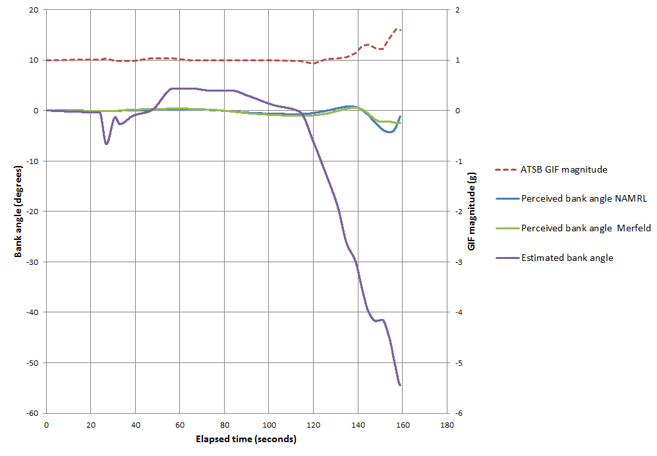Source: ATSB

Organisational and management information

Overview
The helicopter was owned by a media organisation based in Sydney, New South Wales, and the two media personnel on the flight were employed by that organisation. The media organisation also owned another helicopter, which was a single-engine AS350BA based in Melbourne, Victoria.
For about the last 14 years, operational management of the media organisation’s helicopter operations was contracted to a third-party operator. Prior to that, it had been managed in-house. The pilot of the accident flight was the owner, managing director and chief pilot of the operator and had been providing services to the media organisation in excess of 20 years. He was one of two pilots who did the majority of flying for the operator’s Sydney-based operations, with another permanent pilot based in Melbourne. Several other pilots were brought in by the operator on an as-required basis.
The operator provided services to other parties as well as the media organisation. It used VH-NTV for the majority of its Sydney-based operations and hired other helicopters when VH-NTV was undergoing maintenance or if it was conducting operations away from its Sydney base for extended periods of time.

Classification of operations
The operator held an Air Operator’s Certificate (AOC) issued by CASA in July 2011 that authorised the conduct of passenger charter and aerial work operations, including aerial photography. The operator had held this type of AOC for several years.
Under the civil aviation regulatory framework, charter operations had higher requirements on some matters than aerial work operations. In September 2004, CASA issued Ruling 3/2004, titled ‘Classification of aerial work operations carrying passengers’. The ruling was an advisory document that set out CASA’s policy on this issue, and clarified various charter versus aerial work scenarios, including media operations. According to the document, a positioning flight was considered to be charter, and a flight for the purpose of aerial photography was considered aerial work. The document stated:
An operation classified for more than 1 of the purposes in CAR 206 must comply with the requirements applicable to both classifications. Generally, a person who complies with the higher level classification (e.g. charter) will also comply with the lower level classification (e.g. aerial work)…
An example of this type of operation is the hire of an aircraft to carry a media employee (a passenger) for the purposes of conducting aerial photography (an aerial work purpose) and the stopping en route to carry out an interview related to the photography (a non-aerial work purpose). Even though the interview may relate to the aerial photography activity for media purposes, the interview is not one of the operational aspects of the aerial photography purpose. The carriage of the passenger for the conduct of interviews is therefore a charter purpose, and the operation will therefore be conducted for multiple purposes…
It was very unlikely the film crew were filming on the accident flight (see Recorded information). That being the case, the classification of the accident flight was consistent with a charter flight in accordance with the CASA ruling.
The operator’s operations manual provided no guidance on what flights were charter or aerial work. It also contained no specific requirements for charter operations. An experienced pilot with the operator stated that it was a common understanding with the chief pilot and himself that the operator conducted all of its media and film-related operations as aerial work. An experienced media work pilot for another operator advised that they were unaware of the CASA ruling. CASA advised that it had no record of discussions or correspondence with the operator of VH-NTV about ruling 3/2004, or about the possible classification of some of its media work flights as charter rather than aerial work.

Pilot checking and training
The operator’s operations manual stated that pilots were required to complete a proficiency check every 2 years. The manual also stated that in order to conduct night flights, a pilot had to conduct a proficiency check at night within the previous 12 months (see Recency requirements). The operator also had a CASA approval to conduct low-flying operations, which required the pilots conducting such operations to complete a proficiency check on low-flying emergencies every 12 months. The chief pilot did not hold a check or training approval, and all of the operator’s proficiency checks were conducted by other approved pilots.
For the pilot of the accident flight, proficiency checks were often carried out at periods exceeding 12 months in recent years (see Pilot information). Most of the operator’s other pilots flew with other operators, and therefore were subject to additional proficiency checks by those operators. Some of the operator’s pilots had command instrument ratings and therefore completed annual proficiency checks to renew these ratings.
The operator maintained a ‘pilot currency schedule’ that listed the date when various items occurred or were due, including the biennial flight review, recency in terms of three take-offs and landings at night, and the ‘last simulated IMC flight’. The chief pilot produced the schedule based on data provided by the other pilots. A hard copy of the most current schedule, for July 2011, showed that the night recency item was listed as ‘current’ for each pilot but no actual dates were specified. A review of the accident pilot’s flight records indicated that he had probably not met the night recency standard in July 2011.

Safety management
A review of the ATSB occurrence database identified that the operator had had no previous accidents. There were two serious incidents in the 10 years prior to August 2011 relating to operational aspects:
- September 2003: the Bell 206 helicopter’s skid came into contact with a 4-wheel drive vehicle during a commercial film shoot near Leigh Creek, SA.
- July 2010: the AS350 contacted trees at low speed while manouvering to avoid cloud near Healesville, Victoria, resulting in damage to one of the tail rotor blades.
The operator had a Quality and Occupational Health & Safety Management System. According to the relevant manual, the operator was required to identify hazards, assess the risk associated with those hazards, and identify the controls to be used to manage the hazards so that the risk was at an acceptable level. The July 2011 hazard register included 22 occupational and aviation-related hazards. One of the hazards was ‘visibility impaired through dust or fog at HLS’ and the documented risk controls included ‘Pre-flight weather and site assessment’. None of the identified hazards related to night operations.
The media organisation reported that the operator’s risk management processes were developed in consultation with the organisation. In terms of the trip to the Lake Eyre region in 2011 that encompassed the accident flight, the media organisation did not require a specific written risk assessment. It noted that the operator had conducted three similar trips in recent years and was aware of the relevant hazards, and that the operator had also planned and reviewed the itinerary, travel logistics and considered a number of general risks with the media organisation on this occasion. The media organisation also considered that the normal flight planning and risk assessment processes used by the operator would manage any specific hazards as they arose.
The media organisation arranged for independent operational and maintenance audits to be conducted of the operator every 12–18 months. The last audit was conducted in August 2010. No issues relating to night operations were considered in the audit. The audit report noted that the chief pilot advised that the operator had implemented pilot checks every 180 days.

Regulatory surveillance
CASA’s last audit of the operator was conducted in September 2009. CASA issued requests for corrective action relating to inconsistency in how pilots recorded flight time and some aspects of fuel management procedures, and the operator made rectifications that were accepted as satisfactory by CASA. The surveillance report noted that the recording of flight crew qualifications and recency was compliant with AOC obligations. It also noted advice from the chief pilot that the operator’s pilots were subject to 6-monthly proficiency assessments.
CASA personnel completed four safety trend indicator (STI) assessments on the operator between September 2009 and August 2011. Each STI involved a CASA inspector contacting the chief pilot and completing a 30-item questionnaire about the operator. None of the STI assessments indicated any concerns regarding the operator, although they generally noted that they had minimal information available to make an assessment on some issues. The STIs noted the operator’s primary type of operations as ‘aerial work with participating passengers’. The last STI assessment was conducted in May 2011, prior to the operator’s AOC being renewed. It noted that the chief pilot was advised to adopt a formal safety management system and consider a fatigue risk management system, even though neither was mandatory.
There was no discussion of night operations in any of CASA’s surveillance documentation from 2009 to 2011.

Requirements and guidance for night operations

Night visual flight rules
Flights can either be conducted under the visual flight rules (VFR) or the instrument flight rules (IFR). CAR 172 stated that a flight could only be conducted under the VFR if it was conducted in visual meteorological conditions (VMC). The definition of VMC varied according to the type of aircraft, class of airspace and height above terrain. For a helicopter flight in uncontrolled airspace, at night, below 3,000 ft above mean sea level, VMC was defined as having a visibility of 5,000 m and remaining clear of cloud. If these conditions were not met, the flight had to be conducted under the IFR.
CAR 172 also stated that to conduct a VFR flight at or below 2000 ft above the ground or water, a pilot was required to be able to navigate by visual reference to the ground or water. This meant that a VFR pilot had to be able to positively fix their position with visual reference to a feature on the ground or water at least every 30 minutes.
For VFR flights at night there were additional requirements. These included a minimum height of 1,000 ft above the highest obstacle within 10 NM (about 19 km) either side of track, as opposed to 500 ft for day operations. There were also additional requirements in terms of pilot qualifications, recency, aircraft equipment and landing areas.
There were no regulatory requirements that stated that celestial lighting, terrestrial lighting, a visible horizon or other external visual cues had to be present in order to be able to conduct a VFR flight at night.
Limitation of operations at night was provided by the authority conferred by the pilot’s qualifications. In accordance with CAO 40.2.2, a pilot with a night VFR rating was authorised to conduct private and aerial work flights at night under the VFR, and a pilot with a night VFR rating and a Commercial Pilot Licence (Helicopter) or an Air Transport Pilot Licence (Helicopter) was also permitted to do marine pilot transfers at night. In accordance with CAO 40.2.1, a pilot with a command instrument rating (CIR) was permitted to do private, aerial work and charter flights at night under the VFR. Regular public transport (RPT) flights at night had to be conducted under the IFR, which required the flight crew to have instrument ratings.

Pilot qualifications
CAO 40.2.2 stated that to obtain a night VFR rating, a pilot needed at least 10 hours flight experience at night, including circuit flying and navigation. There was no reference to instrument flying training being required, except that the pilot should include ‘instrument flight training as required to reach the standard specified’. CAO 40.2.2 also specified that at least one landing had to occur at a remote aerodrome ‘that is not in an area that has sufficient ground lighting to create a discernible horizon’.
After obtaining the required experience, a pilot had to complete a flight test, which covered flying on instruments, night circuits, landings and navigation at night. Once a night VFR flight test had been successfully passed, the rating remained valid as long as the pilot held a licence. There were no ongoing testing requirements. The operator’s proficiency checks typically included a night flying component.
To conduct flights under the IFR, a pilot was required to hold a CIR. Such a rating required more extensive training and testing than that for a night VFR rating. To maintain a CIR, a pilot was also required to complete an instrument rating renewal test every 12 months.
As an alternative to a night VFR rating, pilots of private flights could also obtain a private IFR (PIFR) rating with a flight procedure authorisation for night operations. This qualification required all items covered in the initial PIFR flight test to be assessed in a flight review every 2 years.

Recency requirements
Before undertaking a night flight, a pilot had to meet various recency requirements. CAR 5.125 stated that a helicopter pilot was not to carry another person on a flight at night without meeting the following requirements within the previous 90 days:
- carried out at least 3 circuits at night while flying a helicopter as pilot in command or as pilot acting in command under supervision, or in dual flying; or
- satisfactorily completed a helicopter proficiency check at night; or
- passed a flight test conducted at night for the purpose of the issue of a helicopter pilot licence or the issue, or renewal, of a helicopter pilot rating.
To conduct a flight under the night VFR without passengers, CAO 40.2.2 specified that at least one night take-off, circuit and landing were required in the previous 6 months. CAO 40.2.2 also required that, in the previous year, a pilot completed at least one night flight of 1 hour’s duration.
The operator’s operations manual reiterated the regulatory requirements regarding recency. In addition, it also stated that each pilot had to conduct a proficiency check at night with the chief pilot, or his delegate, within the previous 12 months that satisfied the recency requirements of CAR 5.125 and CAO 40.2.2 before conducting a VFR flight at night.
Pilots conducting a charter flight at night on the basis of the permissions of a CIR had to meet additional recency requirements, including a night cross-country flight or a flight check at night within the preceding 6 months. To maintain a CIR, a pilot also had to meet additional recency requirements. These included conducting 3 hours instrument flying time in the previous 90 days. There were no specific recency requirements for a PIFR rating.

Helicopter landing sites for night operations
CAR 92 stated that an aircraft shall not land at or take off from any place unless it was ‘suitable for use as an aerodrome for the purposes of the landing and taking-off … having regard to all the circumstances of the proposed landing or take-off’.
Civil Aviation Advisory Publication (CAAP) 92-2(1) provided detailed guidelines for the establishment and use of helicopter landing sites (HLS). The CAAP stated that a standard HLS or better should be established for night operations. For a landing site to be categorized as a ‘standard HLS’ it needed to be equipped with markings, lighting, wind indicators and surveyed areas. Specific details were contained in CAAP 92-2(1). A ‘basic HLS’ was defined as ‘a place that may be used as an aerodrome for infrequent, opportunity and short term basis for all types of operations, other than RPT, by day under helicopter VMC’.
The operator’s operations manual stated that pilots had to comply with the CAAP. According to the criteria in the CAAP, the landing sites at the Cooper Creek inlet at Lake Eyre, Muloorina Station and Cowarie Station, on the night of the accident, were consistent with a basic HLS rather than a standard HLS.

Aircraft equipment
CAO 20.18 specified the types of aircraft equipment required for different types of aircraft and operations. The flight and navigational instruments required for helicopters used for single-pilot IFR flights and helicopters used for night flights were similar, with the IFR flights required to have more redundancy, reliability or minimum design standards for some instruments.
The primary difference between the equipment requirements for IFR and night VFR flight related to autopilots. For helicopters, autopilots or automatic stabilisation systems were not required for any VFR flights. For IFR flights in instrument meteorological conditions (IMC), an approved autopilot or stabilisation system was required. For IFR flights in VMC, the CAO stated an approved stabilisation system or two-pilot crew was required:
…for other than night VFR flights except that in the case of such flight which will involve more than 30 minutes flight over water or over land areas where the helicopter’s altitude cannot be maintained by reference to ground lighting...[]
For aeroplanes, an autopilot was required for RPT, charter, and aerial work operations involving air ambulance functions. Alternatively, such aircraft could be fitted with dual controls and be operated by two appropriately-qualified pilots.

Guidance for conducting night operations
CASA published CAAP 5.13-2(0) to ‘… highlight the hazards of night flying and to provide advice to NVFR [night VFR] pilots and others on how to fly safe NVFR operations’. The CAAP explained night VFR as follows:
3.2.1 Night Visual Flight Rules (NVFR) permit flight at night under the Visual Flight Rules (VFR) using visual navigation augmented by the use of radio navigation aids. Flight under the VFR (by day or night) must be conducted in Visual Meteorological Conditions (VMC), that specify minimum inflight visibility and vertical and horizontal distance from cloud.
3.2.2 NVFR is not the same as flying at night under the Instrument Flight Rules (IFR), even though NVFR involves proficiency in instrument flying and the use of radio navigation aids. This is because NVFR flight is based on the use of visual procedures in VMC.
The CAAP emphasised the hazards associated with flying at night, stating:
3.4. 2 Darkness considerably reduces the external visual references available to a pilot and therefore makes aircraft control and navigation more difficult. Loss of control of the aircraft is highly likely if a pilot attempts to fly by visual reference instead of by reference to instruments.
3.4.3 Limited outside visual reference at night means that the aircraft has to be flown by reference to instruments, otherwise the pilot runs a considerable risk of becoming disoriented. Even if visual reference is available, it can often be misleading and can further disorient a pilot who is attempting to fly visually rather than on instruments.
3.4.4 Under conditions where there is bright moonlight or extensive ground lighting available, flying at night can be a little more difficult than flying in daylight. However, in dark night conditions, without moonlight or significant ground lighting, it will be difficult, if not impossible, to discern the natural horizon and to maintain control of the aircraft by visual reference.
3.4.5 It is also important to understand that the flight visibility given in aviation weather forecasts relates only to the transparency of the atmosphere, and not to whether objects or terrain can actually be seen by a pilot at the distances specified. To be visible from an aircraft at night, an object must generally be lit by moonlight or artificial lighting, otherwise objects outside the aircraft cannot be seen, no matter how good the visibility.
The CAAP strongly emphasised the importance of using the flight instruments rather than external visual cues when conducting night flights under the night VFR. For example:
5.3.5 While NVFR flight must be conducted in VMC, a visual horizon is often not available and sudden loss of visual reference is also possible, such as when turning away from a well-lighted area or if there is inadvertent entry into cloud. Night flying training should therefore emphasise the importance of flying the aircraft at all times by reference to the flight instruments, even in conditions where external lighting provides adequate visual reference.
The CAAP also strongly emphasised the importance of pilots maintaining their instrument flying proficiency. For example:
6.3.1 While instrument flying proficiency is essential for safe flight at night, there are no instrument flight recency requirements specified for NVFR flight. As all night flying requires transition to instrument flight immediately after take-off, it is imperative that NVFR pilots are confident that their instrument flight skills are current before undertaking any flight at night, as there is no opportunity to gradually regain proficiency.
In respect of preparing for flights, the CAAP provided guidance in terms of considering aspects such as weather, navigation aids and aerodromes. It also emphasised the importance of pilots considering and managing threats and hazards associated with a flight. However, there was no discussion regarding the need to consider the availability of celestial or terrestrial lighting on the route.
The CAAP contained additional guidance for ‘specialised NVFR operations’, such as ‘EMS, law enforcement and similar types of activities that are conducted under the NVFR because the demands of the task require more flexibility in conducting visual flight at low level than provided for under IFR procedures’. This guidance emphasised the importance of managing risks for such operations, particularly considerations such as operations below the lowest safe altitude, to poorly lit or unlit helicopter landing sites and in dark night conditions. The CAAP suggested mitigating the associated risks through a variety of controls such as safety management systems, risk assessments, formal task approvals, provision of additional instruments and safety equipment in aircraft used for specialised night VFR operations, applying the instrument rating requirements to night VFR operations, and recurrent training in instrument flight and dark night operations.

Previous ATSB recommendations related to night operations

Recommendation R20020193
Following an accident involving a Cessna 310R on 26 January 2001 (ATSB investigation 200100348), the ATSB issued Recommendation R20020193 on 23 October 2002 as follows:
The Australian Transport Safety Bureau recommends that the Civil Aviation Safety Authority review the general operational requirements, training requirements, flight planning requirements and guidance material provided to pilots conducting VFR operations in dark night conditions.
In response, CASA stated on 13 December 2002:
CASA acknowledges the intent of this Recommendation. As part of the proposed CASR Part 61, CASA is developing the requirements for night VFR ratings which will be based on the existing Civil Aviation Order CAO 40.2.2. In addition, a draft competency standard for night visual flight operations has been developed for inclusion in the proposed CASR Part 61 Manual of Standards. CASA plans to publish a Notice of Proposed Rule Making in relation to this matter in March 2003.
During July 2003, CASA published a notice of proposed rulemaking 0309FS, which included a draft of Civil Aviation Safety Regulation (CASR) Part 61. These draft regulations included a proposal for the holder of a night VFR endorsement to demonstrate competency to carry out activities authorised by a night VFR endorsement to an appropriately qualified flight instructor, in the appropriate category of aircraft within the previous 24 months, or complete a night VFR flight review. CASR Part 61 was introduced in 2013, and it included the requirement for pilots holding a night VFR rating to demonstrate competency during biennial night visual flight rules assessments.
In December 2006, CASA also published CAAP 5.13-2(0). Based on these safety actions, the ATSB classified the recommendation as Closed – Accepted.

Recommendation R20030213
Following an accident on 27 October 2003 involving a Bell 407 helicopter (ATSB investigation 200304282), the ATSB issued recommendation R20030213 on 6 November 2003 as follows:
The Australian Transport Safety Bureau recommends that the Civil Aviation Safety Authority review the night visual flight requirements and promulgate information to pilots emphasising the importance, during flight planning, of considering whether:
- environmental conditions allow for aircraft orientation by visual reference alone;
- there is likely to be sufficient ground or natural lighting and flight visibility along the proposed route to provide visual reference to the ground and/or water during the flight; and
- they are capable of safely operating the aircraft should non-visual conditions be encountered.
CASA responded to R20030213 on 10 December 2003 and stated in part:
CASA supports the issues raised in the Air Safety Recommendation and advises that the Authority is currently reviewing the night visual flight requirements with a view to emphasising to pilots, through its safety promotion activities, the importance of considering the above factors…
On 21 December 2004, CASA further responded to the recommendation that:
CASA does not agree that a review of night VFR requirements is necessary. Firstly, regulations specify that weather conditions of night VFR must be such that a planned flight can be conducted at a safe height clear of cloud. With respect to pilot competency, Civil Aviation Order (CAO) 40.2.2 specifies that the night VFR rating requires pilot be trained to control an aircraft solely by reference to instruments. Any notion that celestial lighting and/or an apparent visible horizon are appropriate references for the control of an aircraft by night is misleading and dangerous and increases the probability of pilot disorientation.
On 27 January 2005, when asked for clarification on the issue, CASA responded:
Reliance on ambient lighting at night rather than instruments for attitude reference is potentially hazardous due to the high risk of pilot disorientation. CASA strongly believes that the requirements specified in Civil Aviation Order (CAO) 40.2.2 are adequate for night VFR operations. It is the responsibility of the operators to ensure that pilots meet the requirements specified for rating issue, especially those related to instrument flying. Therefore, CASA does not believe that a review of these requirements is necessary given that Australia already has the most comprehensive night VFR pilot qualification.
The ATSB classified the recommendation as Closed – Not Accepted.

Recommendation 20040053
As part of ATSB investigation 200304282, the ATSB also issued recommendation R20040053 on 12 May 2004 as follows:
The Australian Transport Safety Bureau recommends that the Australian Civil Aviation Safety Authority assess the safety benefits of requiring an autopilot or stability augmentation system in all single-pilot helicopter operating flight under the night VFR, in the Charter and Aerial Work category, excluding dual pilot training.
On 21 July 2004, CASA responded to Recommendation 20040053 and stated:
CASA has reviewed the recommendation and believes that it will be addressed with the introduction of CASR Part 133. Included in CASR Part 133 is a general statement that provides practical and effective approach to this aspect of the safety of NVFR flight in rotorcraft. An extract from that Part is provided below for your information.
133.360 Instruments and equipment- General
Subparagraph (2)
For a night VFR flight by a rotorcraft involving flight over water beyond a distance from land at which a coastline would be visible at night in VMC at 500ft amsl, or over land areas where rotorcraft attitude cannot be maintained by adequate illumination of surface features or by reference to ground illumination of surface features or by reference to ground lighting or a visible discernible horizon, the operator must ensure that the rotorcraft:
a) is equipped with an approved automatic pilot; or
b) is equipped with an approved automatic stabilisation system; or
c) carries a 2 pilot crew.
At the time this advice was issued, the Notice of Proposed Rule Making for Part 133 included both air transport and aerial work operations. After noting that CASA had also recently issued CAAP 5.13-2(0) and was also proposing to require a biennial flight review requirement to maintain a night VFR rating, the ATSB classified the recommendation as Closed – Accepted.

Requirements in other countries
A review of regulatory requirements in the United States, Canada, the United Kingdom and New Zealand found that the definition of VFR and VMC was effectively the same as it was in Australia. Other countries required that pilots had the equivalent of the Australian night VFR rating to conduct VFR flights at night, either as a separate rating or as part of the private pilot licence. There was no requirement in those other countries to demonstrate competency after the initial issue of a night VFR rating, and the recency requirements were the same as those in Australia. In addition, the other countries had no requirements for autopilots and automatic stabilisation systems in helicopters for VFR flights at night.
In Canada, under the VFR, an aircraft was required to be ‘operated with visual reference to the surface’. There were additional requirements for aerial work operations at night. Under Canadian Aviation Regulation 702.18, an aerial work operator was not permitted to operate an aircraft at night with persons other than flight crew members on board unless the pilot had an instrument rating or the operator was authorised to do so and complied with relevant standards. The relevant standards stated that if the pilot did not have an instrument rating, then ‘no persons other than flight crew members and persons essential during flight are [to be] carried’ and required that ‘the area overflown is illuminated by lights on the surface to ensure visual surface reference and conditions provide for a discernible horizon’.
With the exception of Canada, the countries reviewed have a higher percentage of area with terrestrial lighting than occurs in Australia.

Night VFR accidents
Many aircraft accidents have occurred at night. As stated in the CAAP 5.13-2(0):
Night flying accidents are not as frequent as daytime accidents because less flying is done at night. However, statistics indicate that an accident at night is about two and a half times more likely to be fatal than an accident during the day. Further, accidents at night that result from controlled or uncontrolled flight into terrain (CFIT or UFIT) are very likely to be fatal accidents. Loss of control by pilots of night visual flight rules (NVFR) aircraft in dark night conditions has been a factor in a significant number of fatal accidents in this country…
Appendix F provides details of 12 other accidents in Australia from 1991 to 2012 associated with VFR operations at night. Key features of the accidents are that almost all resulted in fatalities, almost all occurred in dark night conditions, most of the pilots did not hold a CIR, and some of the pilots did not meet the recency requirements for carrying passengers at night.
In 1997, Transport Canada conducted a review of accidents associated with marginal visibility in Canada between 1984 and 1996. As part of this review, 27 accidents associated with night VFR were identified. The research group ‘considered that the most salient action common to all these accidents was the decision to attempt cross country VFR flight over unlit terrain in dark night conditions’. The report also stated:
Pilot experience, ambient light, and the presence of lights on the ground all play a role in determining the safety of a night VFR flight. Pre-flight planning for night VFR should include an assessment of visual conditions in addition to meteorological conditions. Visibility in excess of the VFR minima does not guarantee that aircraft control by visual references is possible…
The night VFR accidents tended to happen in dark night conditions, often compounded by IMC. Visual reference to the surface is fundamental to VFR; yet, in several accidents analysed by the group, weather conditions were fine, but the quality of the outside references was poor. Generally, these accidents involved operations in whiteout conditions or dark night conditions over sparsely settled areas. In these conditions the pilot can see for miles, but there is literally “nothing” to see.

Safety analysis

Introduction
The helicopter’s departure from the sand island was consistent with a normal night departure from a single light source and a turn onto a pre-determined outbound track. The helicopter climbed to about 100 ft before transitioning to forward flight. At about 500 ft it turned to the left onto a heading of 035° M, which was maintained after it reached the cruising height of 1,500 ft. Overall, the departure to this point appeared to be well controlled.
About 13 seconds after levelling off at 1,500 ft, the helicopter entered a relatively gentle right turn. After turning for about 12 seconds, the helicopter started descending. The spiral descent continued with an increasing bank angle for about 38 seconds, until the helicopter impacted terrain in an easterly direction with a 90° right bank.
This analysis first discusses the purpose of the right turn after reaching 1,500 ft, and then discusses potential reasons for the helicopter’s descent with an increasing bank angle.

Purpose of the right turn after reaching 1,500 ft
As previously noted, the helicopter did not start descending for at least 12 seconds after the right turn commenced. The fact that the helicopter was in level flight during the initial part of the turn suggests that the turn was intentional, or at least being coordinated by the pilot.
In addition, the initial departure heading of the helicopter was significantly different to what was expected, and the right turn was consistent with a turn towards the intended destination. More specifically, it was expected that the crew were returning to their accommodation at Muloorina Station, which meant that the helicopter should have initially turned right on to a south-easterly track of 160° rather than left on to a north-easterly track of 035°. There were no known operational reasons such as weather, terrain avoidance, traffic avoidance or access to navigational aids for the helicopter to initially be heading to the north-east.
It is possible that the crew were intending to do some filming or sightseeing before heading to their accommodation. One of the witnesses from the tour group reported overhearing one of the crew suggest that they ‘might go and have a look at the lake tonight’, but was not sure which of them made that remark. However, several other people at the camp site, including the tour guides who had most contact with the crew, believed that the crew were returning directly to their accommodation. The tour guides were surprised when the helicopter headed in a different direction. The conditions were also too dark to conduct filming, and this should have been evident to the crew prior to their departure. In addition, the lake was located to the west rather than the north-east. Regardless of the conditions, if the crew were intending to fly back to the lake, it was more likely that the pilot would have made a right turn after climbing to 500 ft given the helicopter was tracking east-south-east up until that point, and a right turn would have been quicker than a left turn to reach the lake. A right turn is also a more instinctive manoeuvre as the pilot sits on the right in the AS355F2 and can scan the area into the direction of the turn with less obstruction from the cabin structure.
The left turn onto a specific track after reaching 500 ft was consistent with the pilot using one or both of the helicopter’s global positioning system (GPS) units for navigation and tracking to a destination selected prior to departure. The 035° outbound track can best be explained by the pilot having selected an incorrect destination on one or both of the GPS units. A copy of the film crew’s journey itinerary was found at the accident site, and it listed various locations that the crew intended to visit and stay at during the journey. One of these locations, Cowarie Station, was on a bearing of 034° from the take-off point, which was within about 1° of the initial departure track. Muloorina Station and Cowarie Station were two of only three ‘Stations’ on the itinerary, and Cowarie Station was listed as the next place to visit after meeting with the tour group they had just visited.
Due to the interfacing of the Garmin GPS400W with other cockpit navigation systems, it is probable that the pilot would use it as the primary navigation source for a night flight, whereas the portable GPSMAP 495 may have more commonly been used for day flights. No data was able to be obtained from the GPS400W, but both Muloorina Station and Cowarie Station were user-defined waypoints in the GPSMAP 495 and were very likely to have been loaded into the GPS400W at some stage associated with previous visits to the region. It could not be determined how the destinations were actually labelled in the units and the extent to which the labels could have been confused.
Even though the pilot had flown to Muloorina Station earlier in the day, the GPS400W had no ‘recent destinations’ feature that would have enabled it to be readily retrieved. Identifying waypoints alphabetically is a relatively cumbersome method as the unit did not have a keypad and the user would have to use a rotary knob to select each letter. It is likely that the pilot would have been selecting the destination based on scrolling through a list of the nearest waypoints, and Muloorina Station and Cowarie Station were only about 1 km apart in distance from the sand island. Errors in selecting a waypoint on a GPS unit are not uncommon, and are potentially more likely to occur during pre-flight planning in low light situations.
The pilot may have been alerted to the problem with the departure heading by a witness’s transmission over the two-way radio, although it was not certain whether the crew would have had the radio switched on. Otherwise the data entry error would probably have become evident to the pilot at some stage during the climb or soon after reaching 1,500 ft.
In summary, it is likely that the right turn after reaching 1,500 ft was intentional, and it was initiated in order to correct an unintended problem with the initial departure track to the north-east.

Potential explanations for the descent with increasing bank
Several potential explanations for the descent with increasing bank angle during the right turn were considered very unlikely. For example, there were no adverse weather conditions present at the time of the accident that could have influenced controllability of the helicopter, or required the pilot to vary the helicopter’s flight path to remain in visual meteorological conditions (VMC). In addition, the physical and technical evidence showed no pre-existing defects associated with the helicopter’s flight control system, engines or airframe. Even if there had been a failure of one of the flight controls, or even a double hydraulics failure, the pilot would still be able to manipulate other flight controls, and the effects of such actions would have been evident in the helicopter’s recorded flight path.
Pilot incapacitation was also considered unlikely for several reasons:
- The simulation trials showed that continual control adjustments requiring pilot input were required to match the flight path of the accident flight, and it was considered very unlikely that the same flight path would have occurred if the pilot had become suddenly and significantly incapacitated.
- The most common form of sudden and significant incapacitation is a cardiac event. Such events are relatively rare, and even rarer for a person who had no previous cardiac event history or significant risk factors (Zipes 2005).
- Although the pilot had previously experienced kidney stones, which can be painful and disabling, the pain onset would normally occur over a time period that enabled him to recognise the symptoms and either not undertake the flight, or at least initiate recovery action before the condition became disabling.
- There were no other indications in the pilot’s medical history or recent behaviour of a potentially incapacitating condition.
- There was no evidence of a birdstrike incapacitating the pilot.
Given that the pilot was probably manipulating the flight controls but not apparently recognising the descent and increasing bank angle in sufficient time to recover, it is likely that he was spatially disoriented. That is, his perception of the helicopter’s position, motion and attitude was incorrect. The circumstances of the flight included limited perceptual cues of a problem, elevated workload and potential for distraction, a pilot with limited instrument flying recency and an aircraft with no autopilot. These types of factors have been associated with many previous spatial disorientation (SD) accidents, including accidents involving a gradually increasing bank angle and descent over a significant time period.
The remainder of the analysis discusses the factors associated with the SD, the factors associated with planning the flight, and safety issues that increased the risk of such accidents.

Factors associated with spatial disorientation

Activities involved in recognition and recovery
Prior to discussing the factors that can contribute to SD, it is useful to understand the activities involved in recognising and recovering from a problem such as an undesired aircraft state. Figure 21 provides a simplistic representation of these activities.
In this case the pilot had to notice that there was a problem, recognise that the helicopter was in an attitude, and at an altitude, that was different to what he expected, and manipulate the flight controls to bring the helicopter back to the desired attitude and altitude. Studies have found that pilots often recover from an unexpected or unusual attitude to straight and level flight within about 10 seconds. However, in these studies the pilots usually had recent practice in responding to an unusual attitude, know they will be presented with an unusual attitude, and know when it will be presented.

Figure 21: Activities involved in recovering from a problem
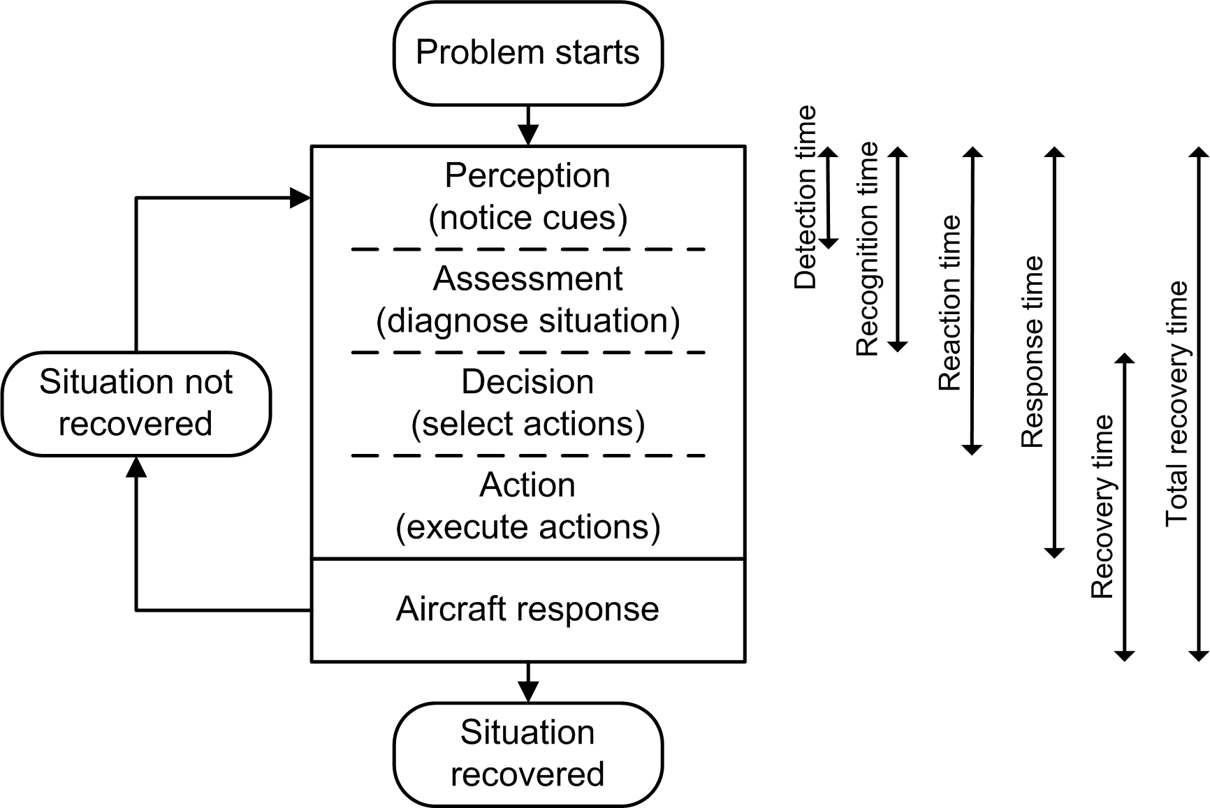Source: ATSB
Total recovery times in real situations will often be much longer due to the time required to detect that there is a problem and diagnose the situation. In many accidents involving SD, the pilot does not detect and correctly diagnose the problem for a significant period of time, if at all, due to a range of factors. Key factors that can influence recognition times are the salience of perceptual cues, workload and distraction, expectancy and instrument flying proficiency. A range of other factors can also influence the likelihood of SD, such as the availability and use of autopilots, pilot interpretation of flight instruments, unusual attitude training and fatigue.

Salience of perceptual cues
The more salient or distinctive a problem or abnormal situation, the more likely and quickly it will be noticed. In this case, the pilot probably expected and perceived that the helicopter was in a gentle right turn at 1,500 ft, although it was actually descending with an increasing bank angle. Many of the potential cues that the helicopter’s flight path was deviating from his perception would not have been salient.
Most importantly, there were no visual cues outside the cockpit to alert the pilot or other passengers of the changing attitude or altitude. Other accidents involving increasing bank angle over a significant time period all occurred in dark night conditions or instrument meteorological conditions (IMC). More broadly, of the fatal general aviation SD accidents in the United States during 1976-1992, 51 per cent occurred at night with another 7 per cent occurring at dawn or dusk, and 80 per cent occurred in IMC, mainly associated with fog, rain or a low cloud ceiling (Collins and Dollar 1996). Of the civil helicopter SD accidents in the United States during 1983-1996, 64 per cent occurred at night, 72 per cent involved restrictions to visibility (such as haze, dust or fog), and 52 per cent occurred in IMC (Mortimer 1997).
In addition to the limited external visual cues, a number of other factors suggested that the pilot would have experienced difficulty detecting the deviation from the intended flight path:
- The flight path analysis and orientation modelling indicated that it was unlikely that there were sufficient vestibular or somatosensory cues to indicate that the helicopter’s attitude was different to what the pilot probably expected. The increasing bank angle was probably below the detection threshold of the semicircular canals. In addition, the most likely flight path would have resulted in a gravito-inertial force (GIF) vector that was about in line with the pilot’s head-to-feet axis. It is also likely that the magnitude of the GIF vector only increased gradually during most of the descent, and was therefore probably not noticed until shortly before impact, particularly if the pilot’s attention was directed elsewhere.
- The lights and the reflections inside the cockpit at night in the pilot’s peripheral vision probably provided a stable visual environment and may have provided a false sense of security, making it less likely that any non-visual indications of a problem were noticed (Gillingham and Previc 1993).
- There would have been an increase in noise associated with increasing airspeed towards the end of the flight. However, this would have been attenuated to some extent by the noise-cancelling headsets been worn by the pilot and passengers.
Overall, the only potentially salient perceptual cues that would have existed for much of the descending turn would have been the flight instruments. However, initially there were only limited deviations in altitude and airspeed and the difference between a gentle right turn and an increasing right bank would not have been that noticeable. As the turn and descent progressed, the pilot was probably directing more attention to one or both of the GPS units than to the flight instruments (see below). Due to the limited options available for instrument layout, the GPS units were not located adjacent to the attitude indicator or altimeter, which may have further reduced the likelihood of the pilot noticing any changes.
The GPS data indicated that when the bank angle reached about 40° it probably stabilised briefly. This occurred at about the time the helicopter was passing through a southerly heading, corresponding to the approximate heading for Muloorina Station, the intended destination. This may indicate that the pilot was attending to the progress of the turn to a limited extent but not sufficiently to recognise the evolving situation.
The helicopter was not fitted or required to be fitted with any effective means of alerting the pilot to the evolving situation. It was fitted with a radar altimeter (RAD ALT), which can provide an indication of passing through a pre-selected altitude. However, the RAD ALT is designed to indicate the distance to the ground directly below the helicopter in level flight. As the bank angle increased during the turn, the RAD ALT would have most likely been over-reading, indicating that the helicopter was higher above ground than it actually was. The ATSB also could not determine the setting of the altitude warning bug on the RAD ALT during the accident flight.
Some aircraft, including larger helicopters, are fitted with bank angle warnings, usually as part of a ground proximity warning system (GPWS). They are usually set to provide an aural alert at varying threshold values depending on the aircraft’s altitude above ground level. However, significant changes in attitude are relatively common in some helicopter operations, and therefore determining an appropriate threshold that does not provide unnecessary warnings would be difficult. Although bank angle warnings increase the chances that a pilot may notice an unexpected attitude, unfortunately they are not always effective in helping crews recover when they are spatially disoriented, as evidenced by some previous accidents (see examples in appendix D).

Workload and distraction
Workload refers to the interaction between a specific individual and the demands associated with the tasks that they are performing. It varies as a function of the number and complexity of task demands and the capacity of the individual to meet those demands. High workload leads to a reduction in the number of information sources an individual will search, and the frequency or amount of time these sources are checked (Staal 2004). It can result in an individual’s performance on some tasks degrading, tasks being performed with simpler or less comprehensive strategies, or tasks being shed completely. In some cases tasks can be shed efficiently by eliminating performance on lower priority tasks or they can be shed inefficiently by abandoning tasks that should be performed (Wickens and Hollands 2000).
Various studies have found that distractions both inside and outside the cockpit were involved in a significant proportion of SD events (Gawron 2004) and such factors were involved in many previous SD accidents involving a gradually increasing bank angle (appendix D). Gillingham and Previc (1996) advised:
Even the most capable instrument pilot is susceptible to spatial disorientation when attention is diverted away from the flight instruments and the primary task of flying the airplane is neglected. This can happen when other duties, such as navigation, communication, … responding to malfunctions, and managing inflight emergencies, place excessive demands on the pilot's attention and lead to "task saturation."
Due to the lack of external visual cues, the pilot would have been flying the departure solely on instruments, which would have involved a high level of workload, particularly until he had established the helicopter in straight and level flight. Workload would also have been increased by the pilot’s limited recent instrument flying experience, and the helicopter not being fitted with an autopilot or automatic stabilisation system.
After levelling off at 1,500 ft, it is likely that the pilot’s attention was significantly diverted by the problem with the initial departure track. The pilot was familiar with the GPS units, and would have been able to reprogram the ‘fly to’ point without difficulty. Nevertheless, reprogramming a GPS is a task that requires several keystrokes and a significant amount of visual attention. As noted in a review of occurrences associated with cockpit distractions in two-crew operations (Dismukes and others 1998):
Periods of head-down activity, such as programming the FMS [Flight Management System], are especially vulnerable because the monitoring pilot’s eyes are diverted from other tasks. Also, activities such as programming, doing paperwork, or reviewing approach plates, demand such high levels of attention that attempting to perform these tasks simultaneously with other tasks substantially increases the risk of error in one task or the other... Some FMC [Flight Management Computer] entries involving one or two keystrokes can be performed quickly and may be interleaved with other cockpit tasks. However, attempting to perform longer programming tasks, such as adding waypoints or inserting approaches during busy segments of flight, can be problematic. It is not possible for the Pilot Not Flying to reliably monitor the Pilot Flying or the aircraft status during longer programming tasks, and it is difficult to suspend the programming in midstream without losing one's place.
As previously noted, the pilot was probably using the Garmin GPS400W as the primary navigation source. ATSB investigators found that it took about 15–25 seconds to reprogram this type of GPS unit with a different fly-to point, even if the user was familiar with the unit.
After reaching 1,500 ft, it would have taken the pilot several seconds to establish the helicopter at the appropriate cruise speed and power settings. The helicopter did not reach cruise speed until after he had commenced the relatively gentle right turn back towards the direction of Muloorina Station. Accordingly, the pilot probably had limited capacity for reprogramming the GPS prior to or during the initial part of the right turn.
As noted earlier, people under high workload do not always prioritise tasks effectively. In addition, many studies have shown that people underestimate time periods when experiencing high workload (Baldouf and others 2009, Block and others 2010), an effect known as time compression or time constriction. Consequently, the pilot may not have realised he was diverting his attention away from the instruments for as long as he did. During some simulator trials to recreate the accident flight path, ATSB investigators also examined the effect of reprogramming the GPS unit during a descending right turn. They noted that the 38-second period appeared to pass much quicker than they anticipated when engaged in the GPS task as well as the flying task.
In summary, it is likely that during the right turn the pilot was reprogramming the GPS unit with the correct destination, which would have required diverting his attention away from the flight instruments for a significant amount of time. There have been many previous accidents and incidents that involved a pilot’s attention being diverted due to operating or programming a GPS (Adams and others 2001, Stański-Pacis and de Voogt 2012). The introduction of GPS units in cars has also been shown to adversely influence a driver’s attention and performance (Fok and others 2011).
Overall, distraction is a common factor in many aviation accidents (ATSB 2007) and pilots need to manage their tasks to minimise the risk of distraction. As noted by Civil Aviation Advisory Publication (CAAP) 5.13-2(0):
During periods of high workload, the ability to prioritise tasks is essential so that important flight safety issues are not overlooked. There are numerous instances of accidents which were caused by pilots fixating on a single task to the exclusion of basic, but important, items such as monitoring aircraft altitude…
Flying single pilot NVFR [night VFR] in a light aircraft is a demanding task requiring the ability to plan ahead (task manage) to avoid periods of activity which could exceed the pilot’s capability…
In this case, the cruise height of 1,500 ft was appropriate for the type of flight and, given the lack of available terrestrial lighting, it was also safer to reprogram the GPS unit in the cruise rather than attempt to land in order to reprogram. However, it would have been more prudent to reprogram the GPS unit in straight and level flight rather than during a turn.

Expectancy
Expectations are based on past experience and other sources of information, and they strongly influence where a person will search for information, what they will search for and their ability to notice and recognise something if it is present (Wickens and McCarley 2008). A substantial body of research has shown that when a person’s attention is focussed on another task, they often do not detect an unexpected object or event, even sometimes when it is salient and the person is looking directly at it (Chabris and Simons 2010).
In this case, the pilot probably had little reason to expect that he would be entering a spiral descent. Unusual attitudes are very rare events for an experienced pilot. His control of the flight up until the right turn had not appeared to be problematic, and it is also possible that he scanned the flight instruments soon after starting the GPS task and noticed no problems. The pilot probably thought he was at a safe height, had sufficient time to attend to the GPS problem, and would be able to detect any deviations that occurred in sufficient time to recover.
It is well known that pilots expect certain types of abnormal events to occur during training or check flights, and they are generally well prepared to notice and respond to them. However, performance will generally be slower when the abnormal event is not expected. For example, although the time to recover from unusual attitudes when they are expected is about 10 seconds, one study showed a longer recovery time of about 26 seconds when the pilots involved were not aware of exactly when the problem would occur (Krause 1959).
A recent study examined air transport pilots’ responses to expected and unexpected events during routine simulator training flights (Casner and others 2013). When an aerodynamic stall event was expected, the average response time was 1.3 seconds and there was little variation between the pilots. When a stall event was unexpected, the average response time was about 10 seconds, there was much more variability between the pilots’ responses, and many of the pilots were unsure about what was happening.

Instrument flying proficiency
When there are no external visual cues, the ability to fly on instruments is essential. Research from the United States has shown that pilots without instrument ratings are five times more likely to have accidents in degraded visual conditions than pilots with instrument ratings (Groff and Price 2006). The United States National Transportation Safety Board (NTSB 1988) also noted that ‘Tests and experience have shown that non-instrument-trained pilots or non-proficient pilots are rarely successful in overcoming spatial disorientation’.
Instrument flying is a complex skill and, once developed, needs to be maintained by frequent practice (Newman 2007a). The Civil Aviation Safety Authority (CASA) has stated that ‘Recent experience is essential to competency in IFR operations because the skills required quickly degrade if not practised regularly’. One study found that commercial helicopter pilots with a command instrument rating (CIR) who did not meet the relevant recency requirements were significantly more likely to lose control (67 per cent) than pilots who did meet the requirements (15 per cent) when inadvertently entering IMC (Wuerz and O’Neal 1997). Another study showed that IFR-rated helicopter pilots’ performance in IMC improves with recent practice (Crognale and Krebs 2011), and other research has found that airline pilots’ instrument flying skills decay due to the lack of manual flying opportunities (Gillen 2010).
The pilot undoubtedly had instrument flying skills, as was evident in the way he flew the helicopter to a stable cruise height and heading. It was also evident in his performance during proficiency checks. However, his last proficiency check was conducted 16 months before the accident. The pilot had not held an instrument rating for over 30 years, and his proficiency checks in recent years were not as thorough as those required to maintain an instrument rating.
It is not clear how much instrument flying the pilot had conducted recently, but it is likely that it was principally during night flight. Based on the available information, he had done little recent night flying, and had had limited night flying experience in recent years. As far as could be determined, much of his night flying would not have been in dark night conditions and he would rarely have had to rely solely on instruments.
A key area where instrument flying skill breaks down is the systematic scanning of the flight instruments. Common mistakes include focussing attention on one instrument too much, or not scanning the key instruments frequently enough (Federal Aviation Administration 2012). Overall, without regular practice and performance feedback from proficiency checks, the pilot’s ability to maintain an appropriate instrument scan when experiencing high workload and distractions would have been diminished.
Although instrument flying proficiency is a very important defence against SD, many studies have shown overall flying experience has little, if any, influence on SD accident rates (Gawron 2004). Newman (2007) noted that SD can affect ‘any pilot, any time, any where, in any aircraft, on any flight, depending on the prevailing circumstances’.

Automatic flight control systems
The helicopter was not fitted with an automatic flight control system, such as an autopilot or automatic stabilisation system. As noted by the NTSB (1988), without such systems:
…pilots will have a difficult time controlling the helicopter if they lose visual reference, since helicopters are unstable in flight and require constant input from the pilot to remain under control.

A recent review conducted for the United Kingdom Civil Aviation Authority (2007) into helicopter accidents in degraded visual conditions stated:
At the heart of the high accident rate is the inherent instability of many small and some medium helicopters which can rapidly lead to excessive pilot workload when attempting to fly in degraded visual conditions.
With a basic autopilot, the pilot can set a helicopter to maintain a desired attitude. With more advanced autopilot systems, the pilot can set the helicopter to maintain flight path parameters such as altitude, heading and airspeed. If the accident helicopter had been fitted with an autopilot, the pilot would probably have engaged it prior to starting to reprogram the GPS, which would have maintained the helicopter’s attitude during this task.
Automatic stabilisation systems (or stability augmentation systems) make helicopters more stable but do not maintain set flight path parameters. Such systems often include rate damping in pitch, roll and yaw axes to aid stability, which reduces the effect of environmental disturbances and the inherent instability characteristics of the helicopter. In addition they generally provide some form of force trim to hold the cyclic control in place and provide an attitude datum for the system, and perform in a similar way as a trim function in an aeroplane. In summary, stabilisation systems reduce pilot workload and can provide more time for a pilot to detect and recover from undesired attitudes.
In this case, a stabilisation system would have reduced the pilot’s workload during the flight. If the force trim function was engaged, the pilot would have also had more tactile feedback from inadvertent cyclic control inputs. However, stabilisation systems can vary significantly in their design and characteristics, and therefore it is difficult to determine the extent to which such a system would have reduced the likelihood of this type of accident.
Despite the considerable safety benefits, automatic flight control systems were not required for helicopter operations under the night VFR in Australia, or in many other countries. Autopilot and/or stabilisation systems are available for most light helicopters, although they are often not fitted due to cost and to some extent, weight considerations. For the AS355, an automatic flight control system includes basic autopilot functions, such as heading hold, altitude hold and airspeed hold. In summary, if the accident helicopter had been fitted with such a system, the likelihood of the accident would have been significantly reduced.

Interpretation of flight instruments
After detecting that an aircraft is at an unexpected or unusual attitude, the pilot needs to overcome their false perceptions and update their mental model of the aircraft’s attitude and motion. This process can require some time, and can sometimes be complicated by a misinterpretation of the aircraft’s attitude indicator (or artificial horizon). As noted by Bramble (2008):
Roll reversal error is defined as an initial roll input made in the wrong direction when faced with an angle of bank requiring immediate correction. It has been theorized that roll reversal errors occur when a pilot confuses the moving horizon bar with the fixed airplane symbol, and attempts to “fly” the horizon bar back to a level attitude as if it were the wings of an airplane. Laboratory studies using ground-based non-motion simulators have documented roll reversal errors among instrument-rated pilots and even among airline transport pilots. Although such errors occur less frequently among highly experienced pilots, experience does not provide complete protection against this type of error.
Roll reversal errors have occurred in several SD accidents involving a gradually increasing bank angle over a significant time period in air transport aircraft (appendix D). It is understandable that in periods of high workload or stress that experienced pilots may revert to trying to control the moving part rather than what they have been trained to do.
For the accident flight, the GPS data did not provide sufficient information to confirm whether roll reversal errors occurred. There was some variation in the continual increase of the estimated bank angle when it reached about 40°, and it is possible that this variation was associated with roll reversal errors. It is also possible such errors occurred after the end of the reliable GPS data and prior to the collision.
Although ‘inside-out’ displays (with a moving horizon and fixed aircraft symbol) are used on almost all Western-built aircraft, some experts believe that ‘outside-in’ displays (with a fixed horizon and moving aircraft symbol) are more effective (Previc and Ercoline 1999). Nevertheless it is generally agreed that attempting to replace inside-out displays is not practical due to their widespread use.
A variety of research has been done to enhance the effectiveness of attitude indicators (Ercoline and others 2004), although not much of this research has led to significant changes in attitude indicator design in most general aviation aircraft. The accident helicopter’s electronic attitude director indicator (EADI) was designed to indicate a high or low pitch situation through the presentation of red chevrons. It could not be determined whether the nose-down pitch attitude of the helicopter during the accident flight would have been enough to trigger this aid.
The ATSB could not determine if the EADI was operating correctly during the accident flight. However, there had been no previous problems reported, and had there been a fault then a red cross would have appeared over the unreliable information to alert the pilot. Regardless of the EADI operation, the standby artificial horizon was operating correctly at the time of the accident and therefore was available for attitude reference information.

Unusual attitude training
If the pilot had recognised the nature of the increasing bank angle problem and descent, his recovery actions should have been to roll wings (or skids) level and then recover the pitch and power as required to arrest the descent and then climb back to a safe altitude. Such actions need to be performed with an effective and rapid scan of relevant flight instruments.
There was no regulatory requirement for the pilot to undergo unusual attitude training in his proficiency checks. The pilot had received unusual attitude training at various times in his flying career, but the last documented time he had done it was in May 2001.
Unusual attitude recovery training is important, and it needs to be conducted regularly in order for recovery actions to be timely and effective. It is also more effectively conducted in simulators, where more extreme attitudes can be safely experienced. Overall, it is difficult to determine if further unusual attitude training would have resulted in a different response on this occasion. As previously discussed, the main reason for the delays in recovery times is usually the time to detect that there is a problem and understand the nature of the problem. Unusual attitude training generally helps more with the proficiency of recovery actions rather than helping to recognise an unusual attitude when it is unexpected. In addition, most unusual attitude training is conducted in an environment where the pilot is expecting the unusual attitude to occur. As noted by Dismukes and others 2007:
Upset attitude situations in actual flight operations typically involve surprise, stress, high workload, ambiguous indications, and/or confusion, which greatly increase the difficulty of quickly and correctly identifying the nature of the upset and executing the correct recovery procedure.

Fatigue and physiological factors
Fatigue can increase the risk of spatial disorientation (Gawron 2004), and it can lead to delayed response times as well as a range of other types of pilot error (Battelle Memorial Institute 1998). The pilot had a reasonably long duty day, but he had not done an extensive amount of flying, and as far as could be determined he had been sleeping normally in recent days. In addition, it is reasonable to expect that the pilot would have been relatively alert at the commencement of the flight, particularly given the short period of high workload during the climb. Overall, it is unlikely that he was experiencing a significant level of fatigue and there were no indications that his performance was being influenced by fatigue.
A range of medical conditions and medications can influence the vestibular system and therefore contribute to spatial disorientation (Newman 2007). However, there was no evidence of any such conditions or medications being involved in this occurrence.

Summary
In summary, the absence of an autopilot increased the likelihood that an unusual attitude would develop during the right turn. The pilot probably did not detect the descent and increasing bank angle for a significant time due to his attention being diverted away from the flight instruments, minimal other perceptual cues, no expectancy of a problem, and limited instrument flying proficiency. He may have detected a problem towards the end of the flight, but not fully recognised the nature of the problem in time to implement effective recovery actions. Spatially disoriented pilots can struggle to comprehend the situations they are in, as evidenced by many previous events where experienced pilots have been alerted to a problem but not been able to either understand or believe what the instruments are telling them.
Although a period of 38 seconds may seem a long time for an experienced pilot to recognise and respond to a developing problem, such events with similar time intervals have happened many times before and the pilot’s performance in this case during the right turn was well within the range of what could be expected given the circumstances. In order to minimise the risk of such accidents, the focus therefore needs to be on what can be done to prevent pilots from being exposed to such situations.

Factors associated with planning the flight
Neither the take-off area nor the intended landing area met the requirements for a standard helicopter landing site (HLS), as would be appropriate for a night flight, and as required by the operator’s operations manual. There were very few visual cues available to the pilot other than the camp fire during the take-off, and there would have been very few cues available during the rest of the flight and limited lighting available at the intended destination. The pilot also had limited recent night flying experience, and the helicopter was not equipped with an autopilot or automatic stabilisation system. Overall, the pilot would have experienced a high workload maintaining control during the flight, and it would have been difficult to manage any abnormal event or significant distraction.
The planned flight did not meet some other requirements. For example, for any VFR flight conducted at night, the pilot was required to provide an alternate aerodrome within 1 hour’s flight time of the destination unless the destination was serviced with a navigation aid or the pilot had approval to use GPS for navigation. In this case the pilot did not have a GPS navigation approval, the destination did not have an aid, and the nearest aerodrome (Leigh Creek) was 255 km away. The helicopter would not have had sufficient fuel to reach the alternate. In addition, there was no evidence that the pilot had left a flight note with a responsible person, which was required for any flight in a designated remote area.
The flight was probably done later than the pilot originally expected, and he had probably not originally intended to conduct a night flight. The investigation could not determine whether the pilot had calculated last light (civil twilight) or obtained information about moon rise at some stage during the day.
There was no indication that the pilot was concerned about being late or having to conduct the flight at night. The tour group reported that they had offered sleeping equipment to the crew if they wanted to stay the night, but it would obviously have been more convenient to have flown back to Muloorina Station where the crew’s luggage was than stay at the camp site. There was also no known pressure from anyone else to conduct the flight, and the pilot was very experienced and well respected by the other members of the crew.
In summary, the pilot did not appear to have adequately planned for the flight. The flight presented a significant risk but there was no evidence to indicate that the pilot was concerned about this risk.

Operator’s processes for managing risk of night flights
The operator did the majority of its flights during day time, and most of its night flights in areas with a significant amount of terrestrial lighting. However, it still occasionally conducted night flights in areas with minimal terrestrial or celestial lighting cues available.
The operator had some risk controls in place for night operations that were in excess of the minimum regulatory requirements. In particular, its proficiency checks included a night flying component, which was not required in order to maintain a night VFR rating. In addition, the operator’s proficiency checks were often conducted more frequently than the minimum requirement of 2 years for VFR pilots. Additional requirements were included in the operator’s operations manual, but these did not appear to be followed (for example, 12-monthly checks at night with a designated pilot and compliance with HLS requirements).
The operator had a charter air operator’s certificate (AOC), and flights such as the accident flight were effectively charter flights. To conduct such flights at night, pilots were required to have a CIR, which would have significantly enhanced the level of safety of the operator’s night operations. There was no indication in the operations manual that the operator was aware that it was meant to be conducting certain types of flights to a charter standard, or to prevent such flights from occurring without the appropriate requirements in place.
The operator had no specific procedures that discussed the risk of dark night operations or required specific risk controls to be used for such operations. The operator’s documented risk management process had not identified any aspect of night operations to be a hazard.
CAAP 5.13-2(0) outlined a number of suggestions for operators that were conducting night operations at low altitudes. Although the operator did not fall into that category, the recommendations apply equally well to any operator that conducts operations in dark night conditions. Accordingly, in addition to CIRs and autopilots or automatic stabilisation systems, risk controls such as formal task approvals for high-risk tasks would have been potentially applicable.
In summary, although some of the operator’s risk controls for the conduct of night VFR flights were in excess of the regulatory requirements, the operator did not effectively manage the risk associated with conducting operations in dark night conditions.

Minimum requirements for night operations
It is widely agreed that flying at night is more problematic than during the day because of the reduction in available visual cues. Most night operations are not conducted in dark night conditions, and the existing minimum regulatory requirements and supporting guidance from CAAP 5.13-2(0) may well be sufficient for most cases.
Compared to situations where there is some ambient illumination and/or ground lighting available, however, there is a significant increase in risk in dark night conditions where no external visual cues are available. In dark night conditions, VMC is effectively the same as IMC. The only real difference is that, if there are lights on the ground, they can be seen in VMC. In remote areas where there are no lights or ambient illumination, there is no difference. Pilots cannot see the ground and have no external cues available to assist with their orientation. In addition, inadvertent entry into cloud is more likely at night because the cloud is harder to see (United Kingdom Civil Aviation Authority 2007), and a significant proportion of VFR into IMC accidents have occurred at night (Transportation Safety Board of Canada 1990).
Although there is no effective difference between IMC and VMC on a dark night in areas with no ground lighting, there was a substantial difference in the minimum requirements for IFR operations compared to night VFR operations. All pilots conducting operations in IMC were required to have an instrument rating. For commercial operations in IMC, pilots were required to hold a CIR, and have their instrument flying ability checked at least every 12 months, as well as meet recency requirements for instrument flying. For private operations in IMC, pilots were required to hold a CIR or a private instrument rating (PIFR), which required a proficiency check every 2 years.
There were also significant differences in required aircraft equipment, such as an autopilot. Charter flights in helicopters at night under the VFR required a pilot to have a CIR, but did not require an IFR-equipped aircraft with an autopilot or similar system. In addition, there are still many other commercial and corporate operations conducted under the VFR, with passengers, where the pilot is not required to have a CIR and the aircraft is not required to have an autopilot.
The ATSB has been concerned about the safety of VFR flights in dark night conditions for many years, and has previously issued recommendations on the issue. CASA subsequently introduced CAAP 5.13-2(0), which provides a significant amount of guidance for operators and pilots conducting night operations. Although the CAAP strongly emphasises the importance of flying with reference to the flight instruments, and that pilots should maintain proficiency on flying on instruments, night VFR is still based on visual procedures. In dark night conditions, a pilot must fly with sole reference to the flight instruments, and should ideally have a demonstrated ability to fly to an IFR standard to ensure an adequate level of safety, particularly for operations where passengers are being carried. In addition the CAAP discusses flight planning issues in depth, but does not discuss the importance of identifying the potential for dark night conditions, or provide guidance on how to identify and assess this potential.
CASA has recently introduced (in February 2013) Civil Aviation Safety Regulation Part 61, which in part requires a pilot with a night VFR rating to be assessed at least every 2 years in night operations to maintain that rating. This will certainly help maintain some pilots’ ability to a higher level than previously, but it will not ensure that the pilots are able to maintain their skills at a CIR standard.
The ATSB contacted several commercial and corporate operators that conduct night operations in helicopters. In general, emergency medical services, police and law enforcement operators stated that they had significantly improved the safety of their night operations in recent years and that they were now operating well above the minimum requirements. Their pilots either had CIRs, were using night vision goggles in an approved manner, or were restricting night operations to well-lit city areas. Most of the operators also had helicopters with autopilots or automatic stabilisation systems. Experienced media work pilots reported that night flights were uncommon and night VFR operations were in general only utilised at the end of a day to return to base. Some media helicopters were equipped with an autopilot.
In summary, the ATSB continues to be concerned that the current minimum requirements for night VFR operations are not sufficient to ensure an adequate level of safety for operations conducted in dark night conditions. Safety relies extensively on the judgement of operators and pilots to ensure their own minimum standards are well in excess of the regulatory requirements. Although some operators have significantly improved their risk controls in recent years, there are still potentially many operations involving passengers being conducted at night that do not have the appropriate level of assurance in place.

Other efforts to reduce the risk of night operations
SD continues to be a significant concern in aviation, whether during IMC or dark night conditions. There have been many efforts by civil and military organisations to reduce the risk. This has included a range of new approaches in training and education (Bramble 2008, Gibbs 2012) and consideration of new types of flight displays as well as auditory and tactile displays (Bramble 2008, Ercoline and others 2004). Many of these developments have some potential to assist in reducing the risk of SD in the future, although the extent to which they can be implemented at all levels of the aviation industry is unclear.
Many of these interventions have been focussed on assisting pilots with recognising and recovering from SD situations. However, the most effective means of reducing the risk of dark night operations is to prevent pilots from operating in such conditions if they do not have the appropriate level of instrument flying skill and proficiency, and the appropriate aircraft systems.
The NTSB recently issued Safety Alert SA-020 Reduced Visual References Require Vigilance. The alert included the following guidance:
Remember that, when flying at night, even visual weather conditions can be challenging. Remote areas with limited ground lighting provide limited visual references cues for pilots, which can be disorienting or render rising terrain visually imperceptible. When planning a night flight, use topographical references to familiarize yourself with surrounding terrain. Consider following instrument procedures if you are rated or avoiding areas with limited ground lighting (such as remote or mountainous areas) if you are not.
The ATSB strongly supports such guidance, and also advises all operators and pilots considering night flights under the VFR to systematically assess the potential for the flight to encounter dark night conditions by considering weather conditions, celestial illumination and available terrain lighting. If there is a likelihood of dark night conditions, the flight should be conducted as an IFR operation, or conducted by a pilot who has an IFR-equivalent level of instrument flying proficiency and with an aircraft that is equipped to a similar standard to that required by the IFR.

Findings
From the evidence available, the following findings are made with respect to the loss of control at night that occurred 145 km north of Marree, South Australia, on 18 August 2011 that involved Aérospatiale AS355F2 helicopter, registered VH-NTV. They should not be read as apportioning blame or liability to any particular organisation or individual.
Safety issues, or system problems, are highlighted in bold to emphasise their importance. A safety issue is an event or condition that increases safety risk and (a) can reasonably be regarded as having the potential to adversely affect the safety of future operations, and (b) is a characteristic of an organisation or a system, rather than a characteristic of a specific individual, or characteristic of an operating environment at a specific point in time.

Contributing factors
- The pilot probably selected an incorrect destination on one or both of the helicopter's global positioning system units prior to departure, which required correction after the flight had commenced.
- The pilot probably became spatially disoriented after initiating a right turn from the cruise height, and did not recognise the descent and increasing bank angle in sufficient time to recover.
- The flight was conducted in dark night conditions, with no visible horizon and minimal celestial and terrestrial lighting.
- The pilot was experiencing a high workload during the right turn, which was associated with establishing the helicopter in cruise flight and probably reprogramming one or both of the helicopter’s global positioning system units.
- The pilot had limited recent night flying experience and at the time probably did not have a level of instrument flying proficiency suitable for dark night conditions.
- The helicopter was used for a night visual flight rules flight in dark night conditions without being equipped with an autopilot.
- Although some of the operator’s risk controls for the conduct of night visual flight rules flights were in excess of the regulatory requirements, the operator did not effectively manage the risk associated with operations in dark night conditions. [Safety issue]
- Helicopter flights were permitted under the visual flight rules in dark night conditions, which are effectively the same as instrument meteorological conditions, but without the same requirements for autopilots and similar systems that are in place for conducting flights under the instrument flight rules. [Safety issue]

Other factors that increase risk
- Aerial work and private flights were permitted under the visual flight rules in dark night conditions, which are effectively the same as instrument meteorological conditions, but without sufficient requirements for proficiency checks and recent experience to enable flight solely by reference to the flight instruments. [Safety issue]
- The helicopter landing site used for the take-off, and the site intended to be used for the landing, were both unsuitable for night operations.

Other findings
- The pilot appeared to conduct a normal take-off, climb and level off at 1,500 ft.
- According to a ruling published by the Civil Aviation Safety Authority in 2004, the flight met the relevant criteria to be considered a charter flight.
- There were no identified mechanical or systems anomalies in the helicopter that might have contributed to the occurrence.

Safety issues and actions
The safety issues identified during this investigation are listed in the Findings and Safety issues and actions sections of this report. The Australian Transport Safety Bureau (ATSB) expects that all safety issues identified by the investigation should be addressed by the relevant organisation(s). In addressing those issues, the ATSB prefers to encourage relevant organisation(s) to proactively initiate safety action, rather than to issue formal safety recommendations or safety advisory notices.
All of the directly involved parties were provided with a draft report and invited to provide submissions. As part of that process, each organisation was asked to communicate what safety actions, if any, they had carried out or were planning to carry out in relation to each safety issue relevant to their organisation.

Operator’s processes for managing operations
Number: | AO-2011-102-SI-01
Issue owner: | The operator of the helicopter
Operation affected: | General aviation – Aerial work
Who it affects: | The operator’s flight crew

Safety issue description:

Although some of the operator’s risk controls for the conduct of night visual flight rules flights were in excess of the regulatory requirements, the operator did not effectively manage the risk associated with operations in dark night conditions.

Response to safety issue by the operator:
Following the accident, the operator ceased conducting flight operations. Consequently no safety action was required to address this safety issue.

Current status of the safety issue:
Issue status: Closed
Justification: The operator has ceased conducting flight operations.

Requirements for visual flight rule flights in dark night conditions
Number: | AO-2011-102-SI-02
Issue owner: | Civil Aviation Safety Authority
Operation affected: | Aviation – All general aviation operations
Who it affects: | All aircraft operating under the night visual flight rules (VFR)

Safety issue description:
Aerial work and private flights were permitted under the visual flight rules in dark night conditions, which are effectively the same as instrument meteorological conditions, but without sufficient requirements for proficiency checks and recent experience to enable flight solely by reference to the flight instruments.

Response to safety issue by: the Civil Aviation Safety Authority
On 18 October 2013, the Civil Aviation Safety Authority (CASA) stated that as part of the new pilot licencing rules (in development prior to August 2011), Civil Aviation Safety Regulation 61.970 will require pilots to demonstrate competency during biennial night visual flight rules assessments, which become effective in December 2013. As noted in Minimum requirements for night operations, this will certainly help maintain some pilots’ ability to a higher level than previously, but it will not ensure that the pilots are able to maintain their skills at an instrument rating standard.
CASA also advised of the following actions:
- CASA will implement a regulatory change project to study the feasibility of rule changes that provide enhanced guidance on NVFR [night VFR] flight planning and other considerations, addressing all categories of operation.
- CASA will clarify the definition of visibility as outlined in CAR [Civil Aviation Regulation] 2 to ensure the primary coincident safety issue above is dealt with. CAR 2 defines visibility as the “ability, as determined by atmospheric conditions and expressed in units of distance, to see and identify prominent unlighted objects by day and prominent lighted objects by night”. CASA will, via regulatory change project, explore the potential to add the requirement that for night visual flight rules the determination of visibility must also include the ability to see a defined natural horizon. This will in effect address the root cause of the matters outlined in the … [safety issues], as pilots will need to have a discernible horizon throughout their flight.
- CASA will provide additional guidance material and advisory notes in Civil Aviation Advisory Publication (CAAP) 5.13-2:
  - distinguishing the difference between NVFR / IFR and instrument conditions;
  - including Certification standards for instrument and non-instrument rotorcraft; and
  - emphasising the authority given by a NVFR rating.
The proposed changes project will be subject to CASA’s normal consultation requirements.
ATSB comment/action in response:
The ATSB welcomes the intent of the action proposed by CASA in response to this safety issue. In particular, the ATSB agrees that expanding what is meant by the term ‘visibility’ at night to include the requirement for a visual horizon will help ensure that pilots operating under the night VFR will have sufficient visual cues. However, given the importance of the safety issue, the ATSB is concerned about the indefinite nature of the proposed evaluation and other exploratory activities.
As a result, the ATSB has issued the following safety recommendation.

ATSB safety recommendation to: the Civil Aviation Safety Authority
Action number: AO-2011-102-SR-59
Action status: Safety action pending

The Australian Transport Safety Bureau recommends that the Civil Aviation Safety Authority prioritise its efforts to address the safety risk associated with aerial work and private flights as permitted under the visual flight rules in dark night conditions, which are effectively the same as instrument meteorological conditions, but without sufficient requirements for proficiency checks and recent experience to enable flight solely by reference to the flight instruments.

Requirements for autopilots in dark night conditions
Number: | AO-2011-102-SI-03
Issue owner: | Civil Aviation Safety Authority
Operation affected: | Aviation – All general aviation helicopter operations
Who it affects: | All helicopters operating under the night VFR

Safety issue description:

Helicopter flights were permitted under the visual flight rules in dark night conditions, which are effectively the same as instrument meteorological conditions, but without the same requirements for autopilots and similar systems that are in place for conducting flights under the instrument flight rules.

Response to safety issue by: the Civil Aviation Safety Authority
On 18 October 2013, the Civil Aviation Safety Authority (CASA) advised that it would work towards promulgating Part 133 (Australian air transport operations – rotorcraft) of the Civil Aviation Safety Regulations 1998, which will include the following regulation:
133.571 Autopilot—night VFR flights on which passengers are carried
(1) This regulation applies if:
(a) the flight is a VFR flight at night; and
(b) a passenger is carried in the flight; and
(c) the rotorcraft is not carrying a 2-pilot crew each of whom is authorised under [Part 61] to conduct an IFR flight in a rotorcraft.
(2) The operator and the pilot in command each commit an offence if, when the rotorcraft begins the flight, the rotorcraft is not fitted with an autopilot.
In addition, as previously stated, CASA advised of further action proposed to address safety issue AO-2011-102-SI-02. This included:
CASA will clarify the definition of visibility as outlined in CAR [Civil Aviation Regulation] 2 to ensure the primary coincident safety issue above is dealt with. CAR 2 defines visibility as the “ability, as determined by atmospheric conditions and expressed in units of distance, to see and identify prominent unlighted objects by day and prominent lighted objects by night”. CASA will, via regulatory change project, explore the potential to add the requirement that for night visual flight rules the determination of visibility must also include the ability to see a defined natural horizon. This will in effect address the root cause of the matters outlined in the … [safety issues], as pilots will need to have a discernible horizon throughout their flight.
Subsequently, CASA advised on 30 October 2013 that Part 133 is planned to be made (or become law) in the last quarter of calendar year 2013 or first quarter of 2014 and come into effect from the first quarter of 2015. This will align with the normal Aeronautical Information Regulation and Control cycle for the notification of aeronautical information changes. The period between the Part being made and having effect will allow for implementation planning and education programs.
ATSB comment/action in response:
The ATSB notes that the introduction of Civil Aviation Safety Regulation (CASR) 133.571 will require all air transport flights in helicopters with passengers at night to be in helicopters equipped with an autopilot or with a two-pilot crew. This extends the range of operations required to have such risk controls. Although it does not directly address the situation for other helicopter operations, effective risk controls for such operations will be potentially addressed in any safety action taken by CASA to address the safety recommendation AO-2011-102-SR-59. The ATSB will monitor the progress of that safety action.

Current status of the safety issue:
Issue status: Adequately addressed.
Justification: The ATSB is satisfied that the work by CASA to finalise and make CASR 133.571 will, when implemented, reduce the risk of helicopter operations at night involving commercial passenger transport. In the case of non-passenger-transport operations under the night VFR, the lack of a requirement for an autopilot or alternately a two-pilot crew increases the residual risk of aerial work and private flights. This reinforces the importance of ATSB safety recommendation AO-2011-102-SR-59 above (see the discussion titled Requirements for visual flight rule flights in dark night conditions).

General details

Occurrence details
Date and time: | 18 August 2011 – 1902 CST
Occurrence category: | Accident
Primary occurrence type: | Loss of control
Type of operation: | Charter
Location: | 145 km north of Marree, South Australia
 | Latitude: 28° 22.63’ S | Longitude: 137° 42.83’ E

Aircraft details
Manufacturer and model: | Aérospatiale AS355F2
Registration: | VH-NTV
Operator: | Australian Broadcasting Corporation
Serial number: | 5380
Type of operation: | Charter
Persons on board: | Crew – 1 | Passengers – 2
Injuries: | Crew – 1 (Fatal) | Passengers – 2 (Fatal)
Damage: | Destroyed

Sources and submissions

Sources of information
The sources of information during the investigation included:
- the operator of the helicopter
- previous flight crew of the helicopter
- the owner of the helicopter
- the maintainer of the helicopter
- the helicopter manufacturer
- South Australia Police
- the South Australia State Coroner
- the Australian Maritime Safety Authority (AMSA)
- the Bureau of Meteorology (BoM)
- the Civil Aviation Safety Authority (CASA)
- the United States Army Aeromedical Research Laboratory (USAARL)
- the Bureau d'Enquêtes et d'Analyses pour la sécurité de l'aviation civile (BEA).

References
Adams, CA, Hwoschinsky, PV & Adams, RJ 2001, Analysis of adverse events in identifying GPS human factors issues, Proceedings of the 11th International Symposium on Aviation Psychology.
Australian Transport Safety Bureau, 2005, Dangerous distraction: An examination of accidents and incidents involving pilot distraction in Australia between 1997 and 2004, Aviation Research Investigation Report B2004/0324. Available from www.atsb.gov.au.
Baldau, D Burgard, E & Wittmann, M 2009, ‘Time perception as a workload measure in simulated car driving’, Applied Ergonomics, vol. 40, pp. 929-935.
Battelle Memorial Institute 1998, An overview of the scientific literature concerning fatigue, sleep, and the circadian cycle, Report prepared for the Office of the Chief Scientific and Technical Advisor for Human Factors, United States Federal Aviation Administration.
Benson, AJ Hutt, EC & Brown, SF 1989, ‘Thresholds for the perception of whole body angular movement about a vertical axis’, Aviation, Space, and Environmental Medicine, vol. 60, pp. 205-213.
Benson, AJ 1999a, ‘Spatial disorientation – general aspects’, in J Ernsting, AN Nicholson & DJ Rainford (Eds.), Aviation Medicine (3rd ed.), Oxford, England, Butterworth Heinemann, pp. 419-436.
Benson, AJ 1999b, Spatial disorientation – common illusions, in J Ernsting, AN Nicholson & DJ Rainford (Eds.), Aviation Medicine (3rd ed.), Oxford, England, Butterworth Heinemann, pp. 437-454.
Beringer, DB & Ball, JD, 2005, Comparison of a typical electronic attitude-direction indicator with terrain-depicting primary flight displays for performing recoveries from unknown attitudes: Using difference and equivalence tests, Office of Airspace Medicine, Federal Aviation Administration, report DOT/FAA/AM-05/23.
Beringer, DB Williges, RC & Roscoe, SN 1975, ‘The transition of experienced pilots to a frequency-separated aircraft attitude display’, Human Factors, vol. 17, pp. 401-414.
Block, RA Hancock, PA & Zackay, D 2010, How cognitive load affects duration judgments: A meta-analytic review, Acta Psychologica, vol. 134, pp. 330-343.
Booze, CF Pidkowicz JK, Davis AW, & Bolding FA 1980, ‘Postmortem coronary atherosclerosis findings in general aviation accident pilot fatalities: 1975-1977’, Aviation, Space, and Environmental Medicine, vol. 52, pp. 24-27.
Booze, CF & Staggs, CM 1986, ‘A comparison of postmortem coronary atherosclerosis findings in general aviation pilot fatalities’, Aviation, Space, and Environmental Medicine, vol. 58, pp. 297-300.
Bramble, WJ, 2008, Spatial disorientation accidents in large commercial airplanes: Case studies and countermeasures, paper presented at the Flight Safety Foundation’s 61st International Air Safety Summit, Honolulu, Hawaii.
Casner, SM Geven, RW & Williams, RT 2013, ‘The effectiveness of airline pilot training for abnormal events’, Human Factors: The Journal of the Human Factors and Ergonomics Society, vol. 55, pp.477-485.
Chabris, C., & Simons, D. 2010, The invisible gorilla and other ways our intuition deceives us, HarperCollins, Hammersmith UK.
Cheung, B 2004, ‘Nonvisual spatial orientation mechanisms’, in FH Previc & WR Ercoline (Eds.) Spatial disorientation in aviation, Lexington MA, American Institute of Aeronautics and Astronautics, Inc, pp. 37-94.
Collins, WD & Dollar, CS 1996, Fatal general aviation accidents involving spatial disorientation: 1976-1992, Office of Airspace Medicine, Federal Aviation Administration, report DOT/FAA/AM-96/21.
Corrigan, PA & Cook, CB 2008, ‘Endocrine system and nephrology’, in JR Davies, R Johnson, J Stepanek & JA Fogarty (Eds.), Fundamentals of aerospace medicine (4th edition), Lippincott, Williams and Williams, Philadelphia PA.
Crognale, MA & Krebs, WK 2011, ‘Performance of helicopter pilots during inadvertent flight into instrument meteorological conditions’, The International Journal of Aviation Psychology, vol. 21, pp. 235-253.
Dismukes, RK Berman, BA & Loukopoulos, LD 2007, The limits of expertise: Rethinking pilot error and the causes of airline accidents, Ashgate, Aldershot UK.
Dismukes, K Young, G & Sumwalt, R 1998, ‘Cockpit interruptions and distractions: Effective management requires a careful balancing act’, ASRS Directline, issue 10, pp. 4-9.
Ercoline, WR DeVilbiss, CA & Evans, RH 2004, Flight displays I: Head-down display topics for spatial disorientation, in FH Previc & WR Ercoline (Eds.) Spatial disorientation in aviation, Lexington MA, American Institute of Aeronautics and Astronautics, Inc, pp. 379-449.
Federal Aviation Administration 2008, Pilot’s handbook of aeronautical knowledge, Chapter 16: ‘Aeromedical facts’, United States Department of Transportation.
Federal Aviation Administration 2012, Instrument flying handbook, Chapter 8: ‘Helicopter attitude instrument flying’, United States Department of Transportation.
Fok, AW Frischmann, TB Sawyer, B Robin, M & Mouloua M 2011, ‘The impact of GPS interface design on driving and distraction’, Proceedings of the Human Factors and Ergonomics Society 55th Annual Meeting, pp. 1755-1759.
Gawron, V 2004, ‘Psychological factors’, in FH Previc & WR Ercoline (Eds.) Spatial disorientation in aviation, Lexington MA, American Institute of Aeronautics and Astronautics, Inc, pp. 145-195.
Gaydos, SJ, Harrigan MJ & Bushby, AJR, 2012, ‘Ten years of spatial disorientation in U.S. Army rotary-wing operations’, Aviation, Space, and Environmental Medicine, vol. 83, pp. 739–45.
Gibb, R Ercoline, & Scharff, L 2012, ‘Spatial disorientation: Decades of pilot fatalities’, Aviation, Space, and Environmental Medicine, vol. 82, pp 1-8.
Groff, LS & Price, JM 2006, ‘General aviation accidents in degraded visibility: A case control study of 72 accidents’, Aviation, Space, and Environmental Medicine, vol. 77, pp. 1062–7.
Gillingham, KK & Previc, FP 1993, Spatial orientation in flight, United States Air Force, Armstrong Laboratory technical report AL-TR-1993-0022.
Hancock, PA & Weaver, JL 2004, ‘On time distortion under stress’, Theoretical issues in Ergonomics Science, vol. 6, pp. 193-211.
Hiremath, V Proctor, RW Fanjoy, RO Feyen, RG & Yo, JP 2009, ‘Comparison of pilot recovery and response times in two types of cockpits’, in MJ Smith & G Salvendy (Eds.) Human Interface, Part II, HCII 2009, LNCS 5618, Berlin: Springer-Verlag, pp. 766–775.
Huber, SW 2006, ‘Recovery from unusual attitudes: HUD vs. back-up display in a static F/A-18 simulator’, Aviation, Space, and Environmental Medicine, vol. 77, pp. 444-448.
Kalloniatis, M & Luu, C 2007, ‘Light and dark adaptation’, in H Kolb, R Nelson, E Fernandez & B Jones (Eds.) Webvision: The organization of the retina and visual system, on-line textbook hosted by WordPress, available from webvision.med.utah.edu.
Lindo, RS Deaton, JE Cain, JH & Lang, C 2012, ‘Methods of instrument training and effects on pilots’ performance with different types of flight instrument displays’, Aviation Psychology and Applied Human Factors, vol. 2, pp. 62-71.
Lyons, T Ercoline, W O’Toole, K & Grayson, K. 2006, ‘Aircraft and related factors in crashes involving spatial disorientation: 15 years of U.S. Air Force data’, Aviation, Space, and Environmental Medicine, vol. 77, pp. 720-723.
McGrath, BJ Rupert, AH & Guedry, FE 2003, ‘Analysis of spatial disorientation accidents in the US navy’, Spatial disorientation in military vehicles: Causes, consequences and cures, RTO-MP-086, pp. 10-1 to 10-12.
Mortimer, RG, 1995, ‘General aviation airplane accidents involving spatial disorientation’, Proceedings of the Human Factors and Ergonomics Society 39th Annual Meeting, pp. 25-29.
Mortimer, RG 1997, Spatial disorientation in U.S. civil aviation helicopter accidents, Proceedings of the 9th International Symposium on Aviation Psychology, pp. 16-20.
Newman, DG, 2007a, An overview of spatial disorientation as a factor in aviation accidents and incidents, Australian Transport Safety Bureau, Aviation Research and Analysis Report B2007/0063. Available from www.atsb.gov.au.
Newman, DG 2007b, Pilot incapacitation: Analysis of medical conditions affecting pilots involved in accidents and incidents 1 January 1975 to 31 March 2006, Australian Transport Safety Bureau, Aviation Research and Analysis Report B2006/0170. Available from www.atsb.gov.au.
National Transportation Safety Board 2010, Introduction of glass cockpit avionics into light aircraft, Safety Study NTSB/SS-01/10.
National Transportation Safety Board 1988, Commercial emergency medical service helicopter operations, Safety Study NTSB/SS-88-01.
Previc, FH & Ercoline, WR 1999, ‘The `Outside-In' attitude display concept revisited’, The International Journal of Aviation Psychology, vol. 9, pp. 377-401.

Previc, FH & Ercoline, WR 2004, ‘Spatial disorientation in aviation: Historical background, concepts and terminology’, in FH Previc & WR Ercoline (Eds.) Spatial disorientation in aviation, Lexington MA, American Institute of Aeronautics and Astronautics, Inc, pp. 1-36.
Staal, M. A. 2004, Stress, cognition, and human performance: A literature review and conceptual framework, National Aeronautics and Space Administration Technical Memorandum NASA/TM-2004-212824.
Stański-Pacis, G & de Voogt, A 2012, ‘The role of GPS in aviation incidents and accidents’, in A de Voogt & TC D’Oliveira, Mechanisms in the chain of safety: Research and operational experiences in aviation psychology, Farnham UK, Ashgate, pp. 117-130.
Transport Canada, 1997, A study into the safety of flight in marginal visibility.
Transportation Safety Board of Canada, 1990, Report of a safety study on VFR flight into adverse weather, Aviation Safety Study 90-SP002.
United Kingdom Civil Aviation Authority 2007, Helicopter flight in degraded visual conditions, Paper 2007/03, Safety Regulation Group.
Wickens, CD & Hollands, JG, 2000, Engineering psychology and human performance, 3rd edition, Prentice-Hall International, Upper Saddle River, NJ.
Wickens, CD & McCarley, JS 2008, Applied attention theory, CRC Press, Boca Raton, FL.
Wuerz, RC & O’Neal, R 1997, ‘Role of pilot instrument proficiency in the safety of helicopter emergency medical services’, Academic Emergency Medicine vol. 4, pp. 972-975.
Wynn, T Howarth, P & Kunze, B 2010, Dark adaptation and lookout duties, Health and Safety Laboratory, Harpur Hill, Derbyshire, UK.
Zipes, DP 2005, ‘Epidemiology and mechanisms of sudden cardiac death’, Canadian Journal of Cardiology, vol. 21 (supplement A), pp. 37A-40A.

Submissions
Under Part 4, Division 2 (Investigation Reports), Section 26 of the Transport Safety Investigation Act 2003 (the Act), the Australian Transport Safety Bureau (ATSB) may provide a draft report, on a confidential basis, to any person whom the ATSB considers appropriate. Section 26 (1) (a) of the Act allows a person receiving a draft report to make submissions to the ATSB about the draft report.
A draft of this report was provided to the helicopter operator, previous helicopter flight crew, the helicopter owner, the helicopter maintainer, the helicopter manufacturer, CASA, the USAARL, and the BEA. Submissions were received from previous helicopter flight crew, the helicopter owner,, CASA, the USAARL, and the BEA. The submissions were reviewed and, where considered appropriate, the text of the report was amended accordingly.

Appendices

Appendix A – Garmin GPSMAP 495 examination

Introduction
During the on-site phase of the investigation into an accident involving AS355F2 helicopter VH-NTV, a GPSMAP 495 GPS unit (Figure A1) was recovered and subsequently examined and downloaded by the Australian Transport Safety Bureau (ATSB). This appendix details the results of the recovery and analysis of information from the GPS unit.
Figure A1: Typical Garmin GPSMAP 495
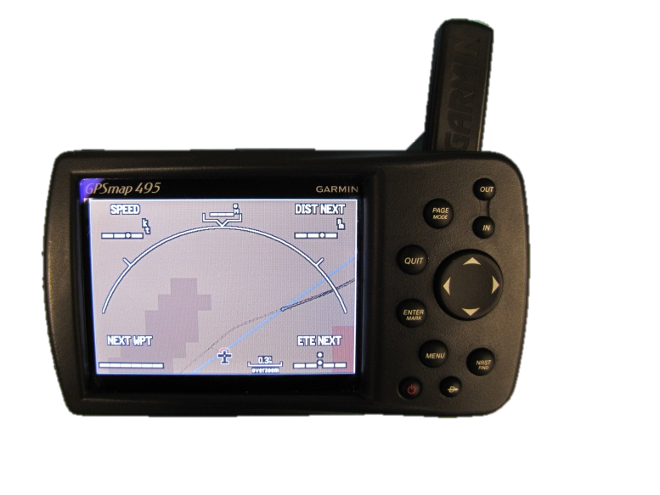
Source: ATSB

Garmin GPSMAP 495
The Garmin GPSMAP 495 was capable of recording the aircraft’s flight path on non-volatile memory and featured a built-in Jeppesen database. A copy of the user manual was obtained from the manufacturer’s website.
The GPS manufacturer provided a schematic of the circuit board and a FBGA memory chip was identified as the memory used to store flight track logs. When the chip became full, depending on the recording mode selected, the unit would either record over the oldest flight track logs or stop recording. A TSOP memory chip stored user transferred flight track logs to prevent them from being overwritten when the FBGA device became full. The TSOP and FBGA memory chip details are presented in Table A1.
Table A1: Memory Chip Information
Device | TSOP | FBGA
Manufacturer | Samsung | ST Microelectronics
Part Number | K9K8G08U0B | M58LR128KB85ZB5
Memory Size | 1GB | 16MB

Physical examination
The recovered unit was damaged (Figure A2).
Figure A2: Recovered VH-NTV Garmin GPSMAP 495
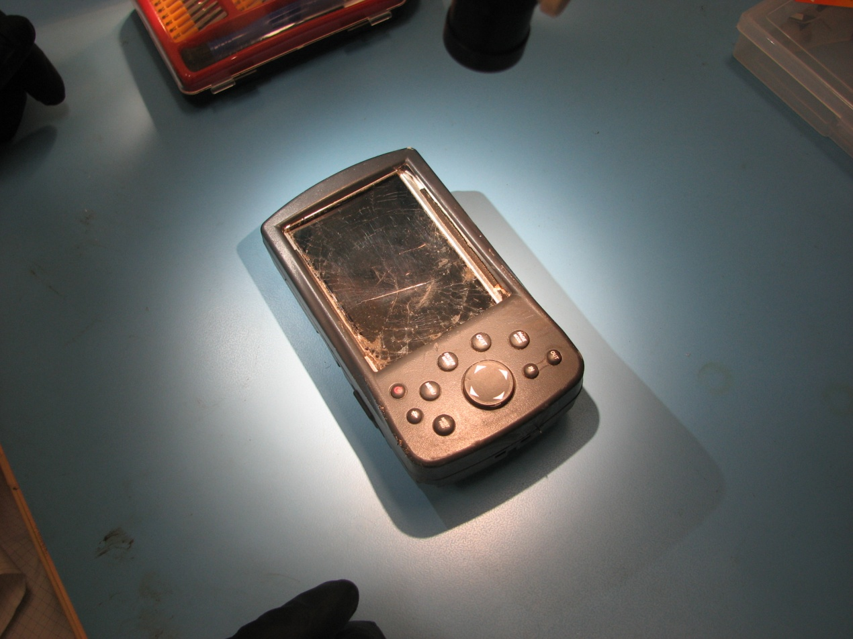
Source: ATSB
Disassembly and examination of the unit revealed that the FBGA chip was undamaged but the TSOP memory chip (Figure A3) was cracked through the outer casing (Figure A4 and Figure A5) with the pins crushed by the protective surrounding.
Figure A3: FBGA (blue) and TSOP (red) chips on VH-NTV GPSMAP 495 circuit board
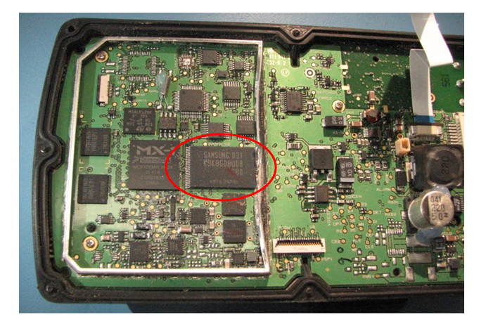
Source: ATSB
Figure A4: Location of damage to TSOP chip
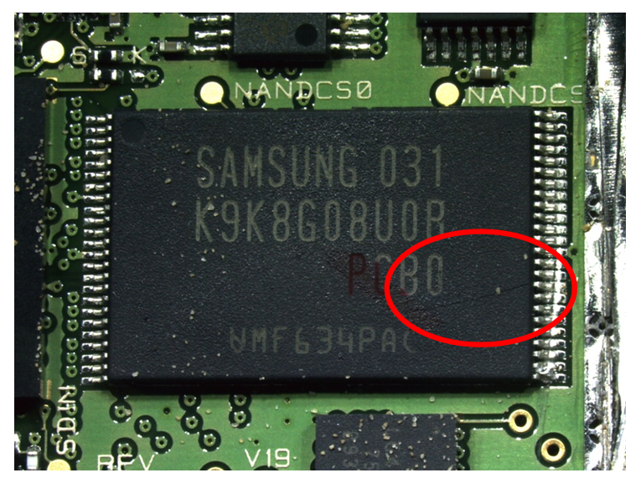
Source: ATSB
Figure A5: Damage to TSOP chip
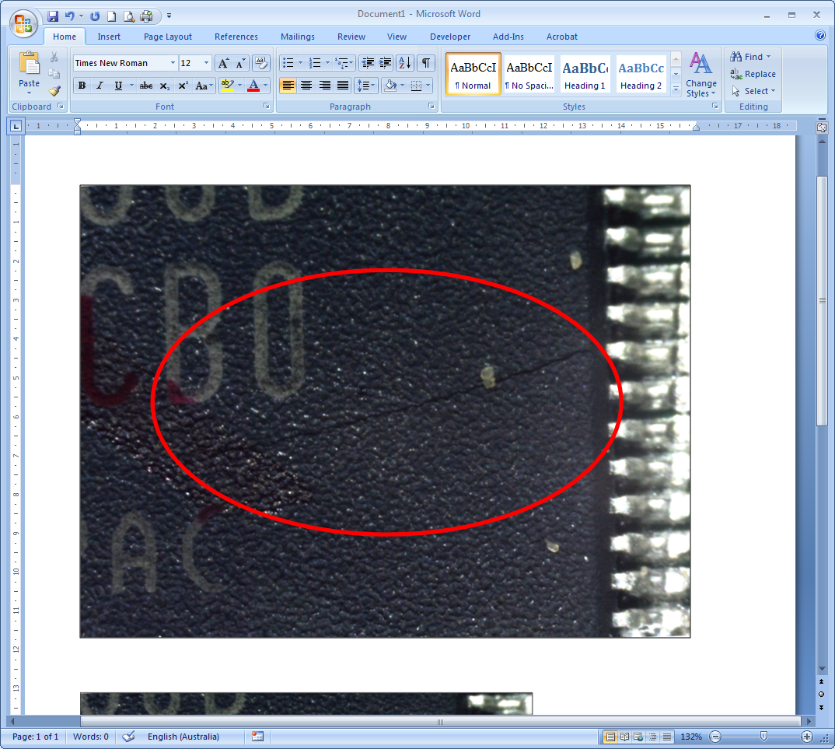
Source: ATSB
X-ray examinations showed no damage to the metallic connections in either the TSOP or FBGA memory devices (Figure A6 and Figure A7). The examination was unable to determine the extent of damage to any silicon-based connections.
Figure A6: X-ray of the TSOP memory chip
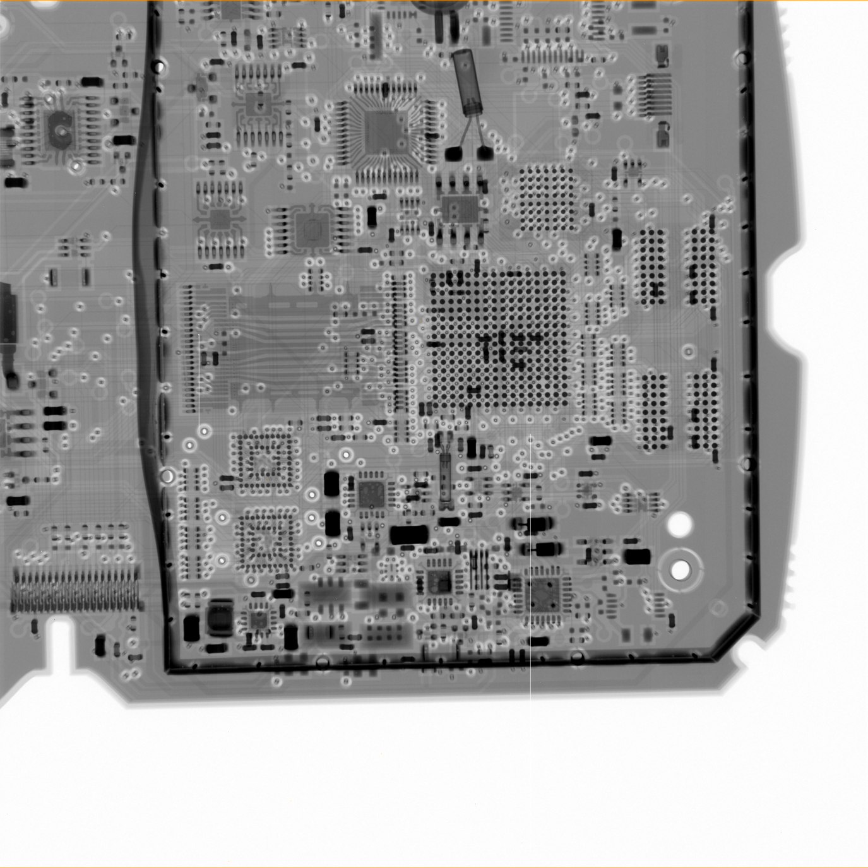
Source: ATSB
Figure A7: X-ray of the FBGA memory chip
Source: ATSB

Memory chip removal and rework
A cyanoacrylate-based adhesive (commonly known as ‘super glue’) was applied to the TSOP chip damage to minimise the possibility of crack propagation during the chip removal process.
A Hakko FR-803B rework station (Figure A8) was used for the removal of the FBGA and TSOP memory chips from the accident unit circuit board.
Figure A8: FBGA chip removal
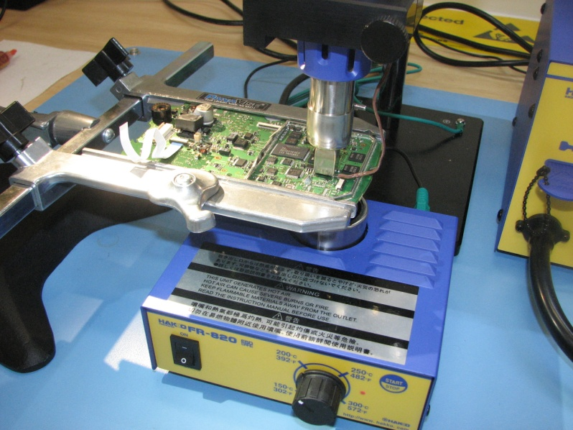
Source: ATSB
The TSOP memory chip was removed and found to have two significant cracks in the outer casing on the underside of the chip.
The FBGA memory chip was removed and then cleaned before solder balls were re-affixed to each of the 56 individual pads using a microscope (Figure A9).
Figure A9: FBGA memory chip after re-balling
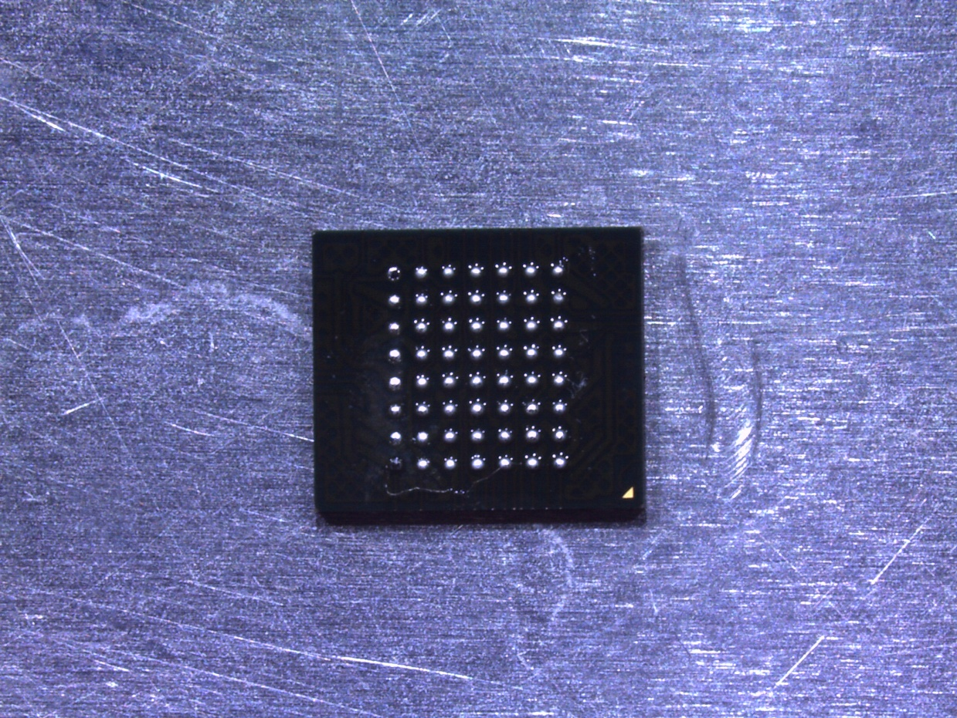
Source: ATSB

Memory chip download
A Xeltek SuperPro 5000 programmer and appropriate algorithm and adapter were used for the download of both the FBGA and TSOP memory chips.
A complete 16 MB raw binary data file was recovered from the FBGA memory chip. The download of the TSOP memory chip was not successful with a manufacturer and device ID error displayed during the pre-download checks. The data recovered contained 0xF1 in all byte locations. The compromised memory chip casing had likely allowed air and moisture into the critical regions of the chip, reducing the likelihood of a successful data recovery.
A hexadecimal editor program, Hex Workshop, was used to view the FBGA raw data. The flight data was located using decoding information provided by the Bureau d'Enquêtes et d'Analyses pour la sécurité de l'aviation civile (BEA).

Overview of recorded flight data
A total of 22,962 track points were recovered. The earliest track point was recorded on 29 May 2011 at 1156:31 Central Standard Time and the last track point recorded was from the accident flight on 18 August 2011. The GPSMAP 495 had three recording interval:
- Interval-Distance, track point recorded after a specified distance has been travelled.
- Time, track point recorded after a specified time has elapsed.
- Resolution track point recorded based on an entered resolution. The higher the resolution entered, the more points the unit creates to make the track.
The default recording interval setting was ‘resolution’, with a default value of 82 ft. The recovered flight data did not contain a consistent time or distance interval between recorded track points. Consequently, it was considered that the unit was recording track points at the default recording interval of 82ft.

Accident flight data
The recording of the previous flight ended at 1748:04. The unit resumed recording at 1856:41 and continued recording for 308 seconds on the last recorded flight, ending at 1901:49. Thirty-two data points were recorded.
The first data point was when the unit was powered on and obtained its first valid GPS fix. The second data point occurred 142 seconds later, and subsequent data points included increasing altitude. Therefore, the best estimate of the start of the flight was considered to be 1859:03, 142 seconds after the first data point, and all subsequent descriptions of the data are based on the flight starting at this time. The unit recorded time and position at generally decreasing intervals of between 1 and 13 seconds. As discussed under GPS data error sources below, the relative error between two data points was considered to be low.
Other investigation agencies advised the ATSB that the GPSMAP 495 would not record valid data for a period of time preceding a power interruption (such as at ground impact). Experience had indicated that there may be several data points ‘missing’ from the last part of the flight, and some of the final points recorded would not be consistent with the helicopter’s actual flight path.
Another Garmin GPSMAP 495 was used to estimate the time between the last recorded data point and a power disruption. The maximum time between the unit recording a point and power disruption was found to be 14 seconds. Consequently, the last two recorded points were considered invalid due to their inconsistency with the preceding flight path, the accident site location and the projected time to impact.
The recovered track points were analysed to determine approximate flight parameter values throughout the descent (Table A2). The data used in the ATSB analysis fell into one of three main categories: recorded data, derived data, and estimated data based on certain assumptions or simplifications.
Table A2: Data used in flight path analysis
Data | Derivation method
Position (comprising latitude, longitude, and height) | Obtained directly from GPS recording.
Time | Obtained directly from GPS recording.
3-dimensional distance travelled | 3-dimensional distance between two recorded data points.
3-dimensional speed | 3-dimensional distance travelled, divided by time interval.
Groundspeed | 2-dimensional distance travelled, divided by time interval.
Ground track | 2-dimensional angle between recorded data points.
Ground track rate of change | Difference between two consecutive ground track estimates, divided by time interval.
Ground track acceleration | Difference between two consecutive ground track rate of change estimates, divided by time interval.
Vertical speed | Difference between two consecutive height data points, divided by time interval.
Vertical acceleration | Difference between two consecutive vertical speed estimates, divided by time interval.
Turn radius | 2-dimensional arc passing through three consecutive positions.
Centripetal acceleration | Two standard methods used:  1. Uniform circular motion estimate using estimated speed and turn radius.  2. Uniform circular motion estimate using estimated speed and track rate of change.
Total acceleration (magnitude of the gravito-inertial force) | Vector sum of accelerations acting on a point inside the helicopter: vertical acceleration (including gravity and helicopter vertical movement), and centripetal acceleration.
Bank angle | Two standard methods used:  1. Estimate using estimated speed and turn radius.  2. Estimate using estimated speed and track rate of change.
Roll rate | Difference between two consecutive bank angle estimates, divided by time interval.
Roll acceleration | Difference between two consecutive roll rate estimates, divided by time interval.

Recorded data
Figure A10 and Figure A11 show the recorded position and altitude of the downloaded data. The recorded position showed a relatively smooth tightening spiral. The recorded altitude showed that the helicopter reached a cruising height of about 1,500 ft before descending.
Figure A10: Recorded GPS ground track
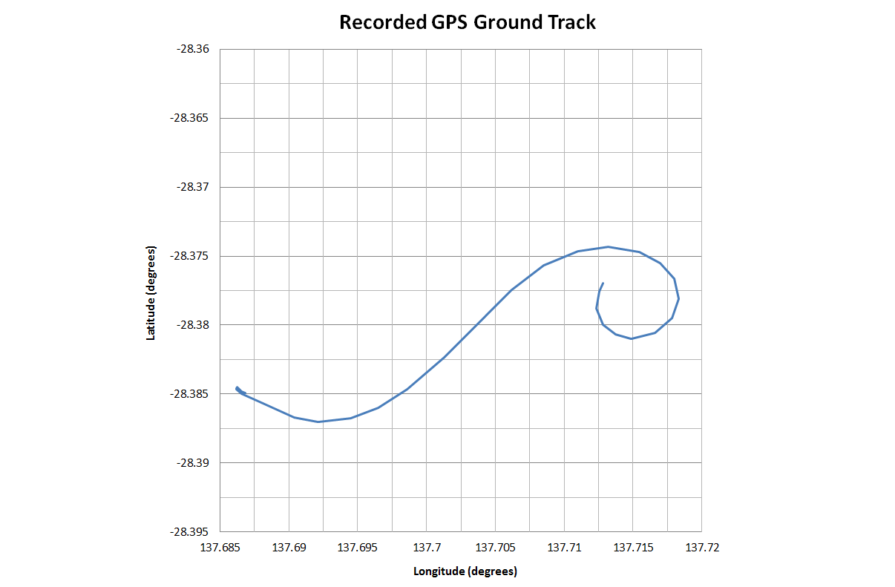Source: ATSB
Figure A11: Recorded GPS altitude
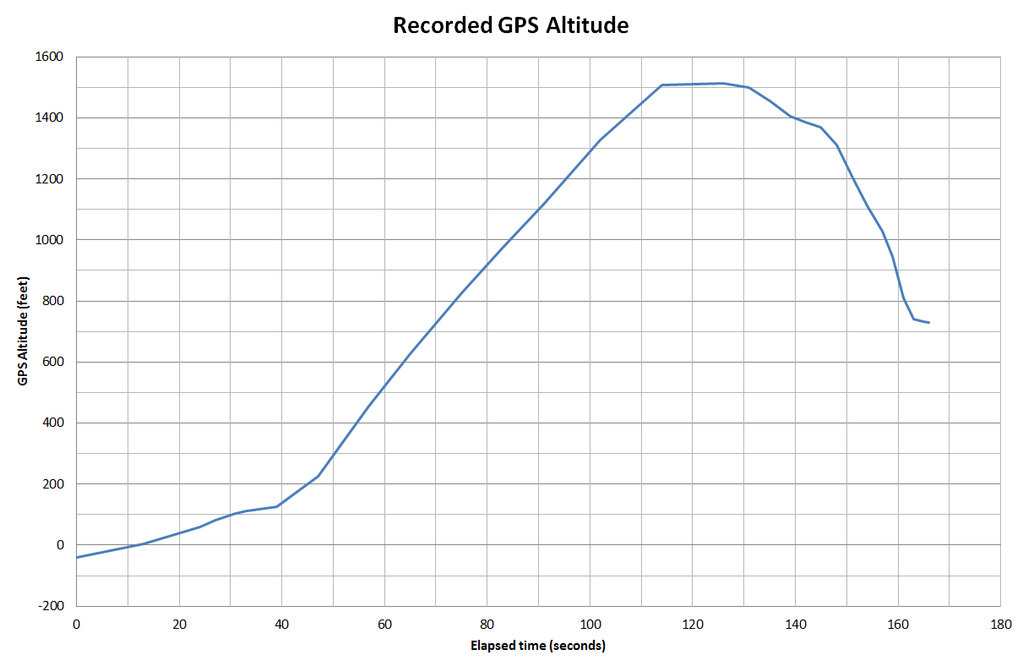Source: ATSB

Derived data
Using the position, altitude and time recorded data, several parameters such as distance, track (Figure A12), groundspeed (Figure A13), turn radius (Figure A14), and track rate (Figure A15) were derived using simple mathematical formulae. The derived data was subject to any errors in the recorded position, altitude, and time information, as well as the limitations of the method used to derive the data. Specifically, the derived values were based on discrete (non-continuous) data points, whereas the helicopter’s motion was continuous. As a result, the derived data may be considered slightly ‘smoothed’ or simplified, but also the most likely representation of the helicopter’s actual motion. The values were derived making no other assumptions about the operation of the helicopter.
Figure A12: Derived track
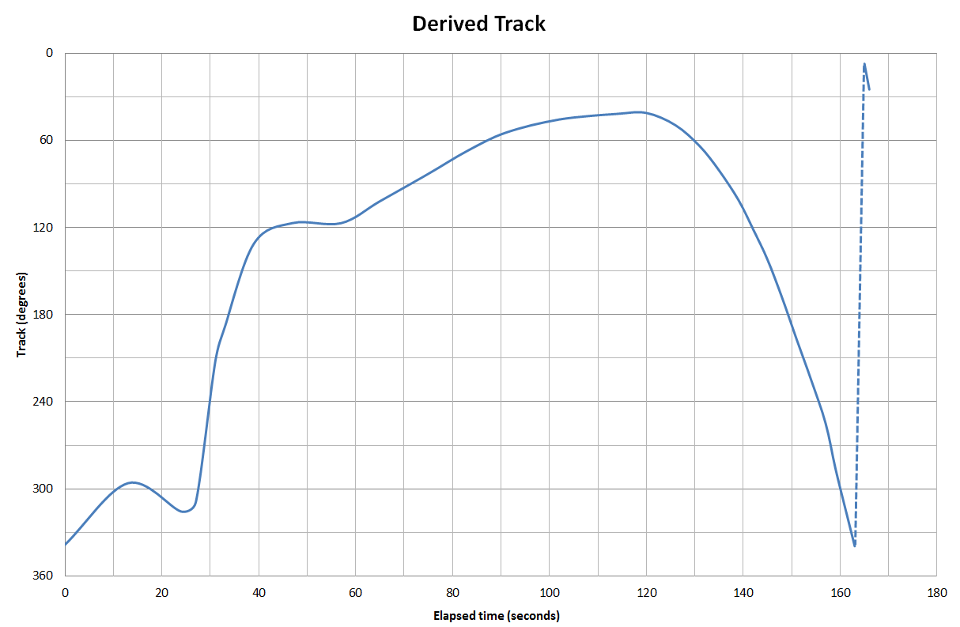Source: ATSB
Figure A13: Derived groundspeed
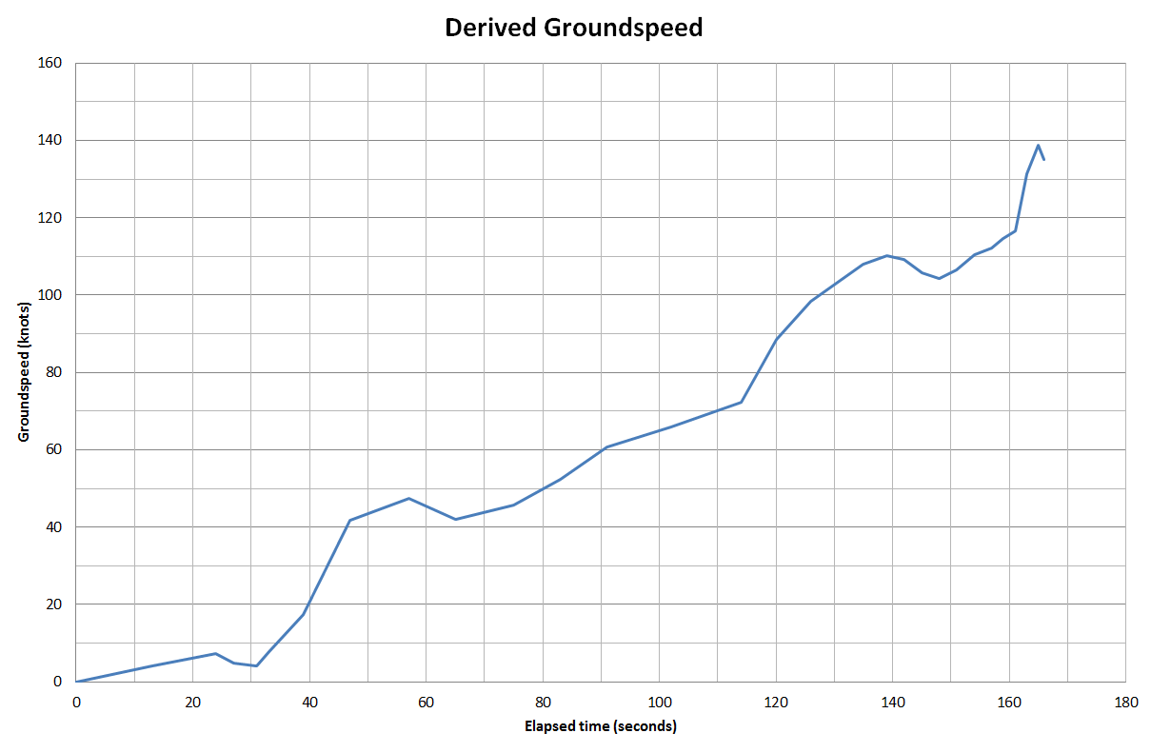Source: ATSB
Figure A14: Derived turn radius
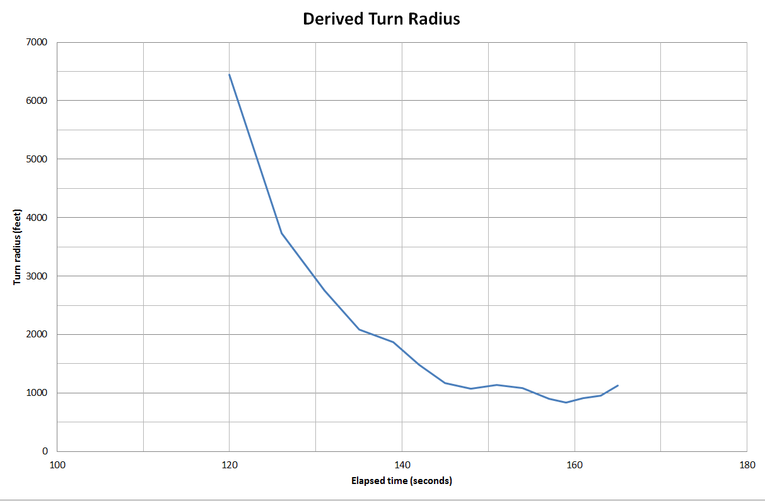Source: ATSB
Figure A15: Derived track rate
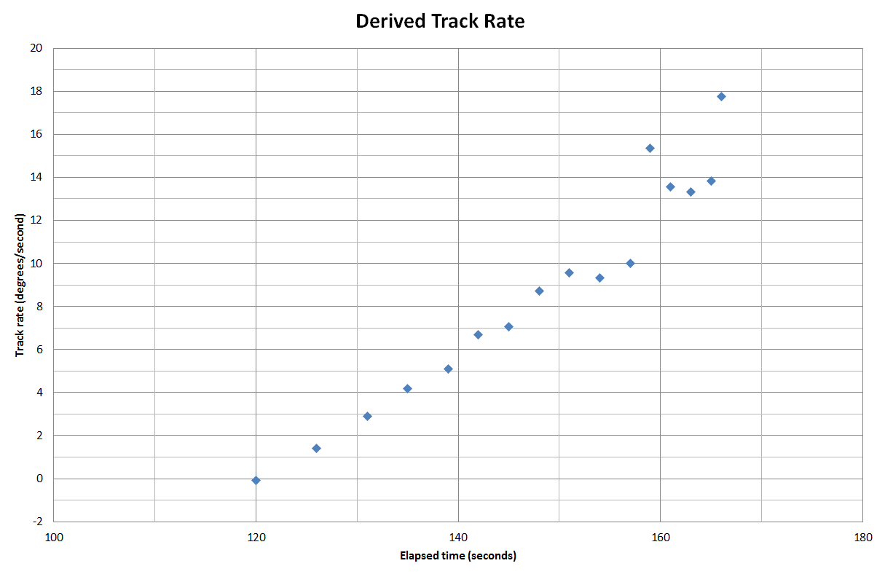Source: ATSB

Estimated additional data
The ATSB estimated additional data used in the flight path analysis. The method used to estimate each type of data is described in Table 2. Centripetal acceleration, bank angle, roll rate and roll acceleration were calculated using these derived parameters and making assumptions about the operation of the aircraft. These assumptions included that the helicopter remained oriented in the direction of travel and that the vertical speed of the aircraft did not significantly affect bank angle. Although the resulting data was likely to be less accurate than the more directly derived data, it was considered to be representative of a helicopter following the recorded flight path.
The total acceleration, as would be felt by the pilot, and bank angle were calculated using two methods. The first method used the estimated rate of turn and groundspeed. The second method used the estimated turn radius and groundspeed. Both methods produced comparable results. The estimated bank angle is shown in Figure A16.
The ATSB also estimated the time of impact by extrapolating various parameters. Using rate of descent, the time of impact was estimated to be 7 to 14 seconds after the last reliable data point (163 seconds after take-off). Using distance to run from the last reliable data point to the accident site, the time of impact was estimated to be 4 to 9 seconds after the last reliable data point. The overlap of 7 to 9 seconds was consistent with the results of ATSB simulator trials, which provided an estimate of 7 to 9 seconds. The time of impact was therefore concluded to be about 171 seconds after take-off.
Figure A16: Estimated bank angle
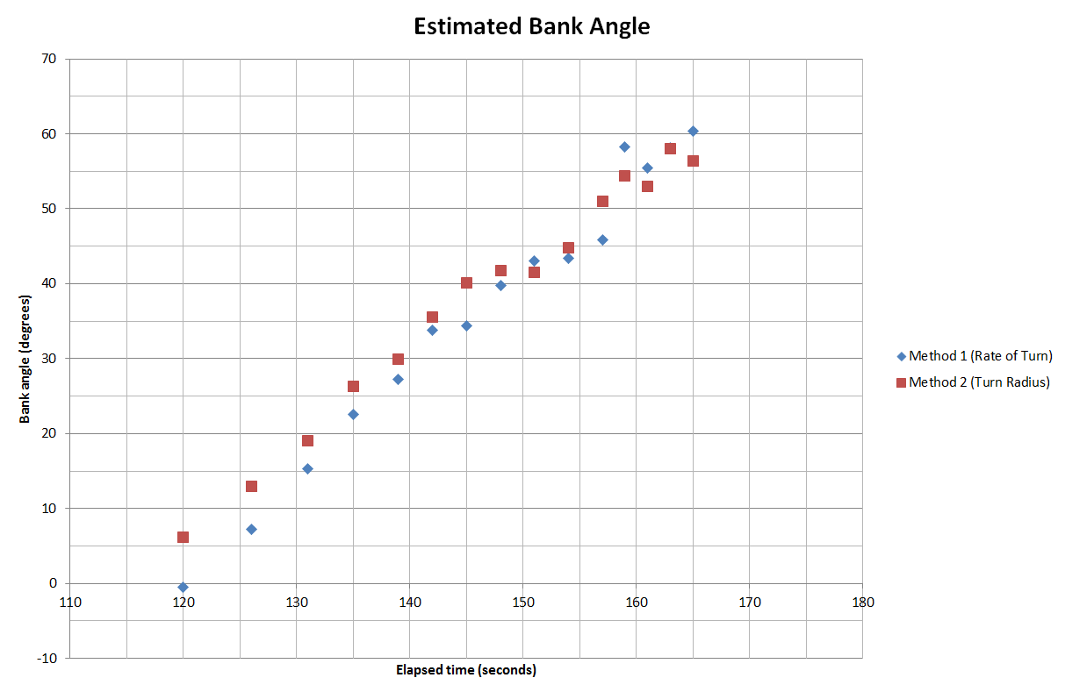Source: ATSB

GPS data error sources
GPS data is subject to errors from multiple sources. These include:
- Ephemeris data: orbital and clock correction data for each satellite vehicle. Broadcast individually for each satellite vehicle, data is valid for about 30 minutes and broadcast about every 30 seconds.
- Satellite clock error: each satellite is equipped with multiple, very accurate atomic clocks which assist in providing positional information. The atomic clocks are not synchronised between satellites. As such, corrections need to be made.
- Ionospheric effects: the ionosphere contains a large number of electrons and positively charged ions. These ions refract the electromagnetic waves from the satellites, resulting in elongated paths of the signals.
- Tropospheric effects: troposphere effects are mainly related to the varying concentrations in water vapour which affect the refraction of electromagnetic waves to a lesser extent than in the troposphere
- Multipath effects: caused by the reflection of satellite signals from objects.
- Receiver errors: caused by the GPS receiver processing the GPS signal; an example is the rounding of values.
The first three errors noted above can lead to a significant positional determination error. Ephemeris and satellite clock errors remain fixed between signals within a small time frame. Similarly, ionospheric effects will not differ significantly in a small time frame unless there is significant solar activity during that time frame. Although the cumulative error from these effects may result in an offset of the recorded path from the true path, the magnitude of the error between recorded points over a small timeframe will remain relatively constant.
GPS units receiving GPS data can also affect the accuracy of the recorded data as a result of the following:
- GPS units require a minimum of four satellites in view to resolve positional information. An increased number of satellites available for positional resolution results in an increased level of accuracy.
- GPS units can experience a loss of signal when an aircraft’s attitude results in the aircraft structure obscuring the antenna from some of the GPS satellites.
- The accuracy of the GPS position can degrade as an aircraft undergoes higher than normal acceleration.
- Consumer GPS units have been known to use predictive algorithms (such as Kalman filters) to smooth data sets and reduce erroneous values. This has the potential to affect the reliability of recorded points in unusual flight conditions. Some GPS units also use proprietary recording algorithms; these algorithms attempt to maintain the accuracy of the recorded flight track whilst minimising the amount of points recorded.
At the time of the accident (1902:01), the unit was considered to have had 10 satellites in view (Figure A17). GPS time recorded on the unit was retrieved from the navigation message sent from the GPS satellites, which used atomic clocks to maintain highly accurate timekeeping. The GPSMAP 495 owner’s manual lists the GPS accuracy as ‘15 metres (49 feet) RMS 95% typical’.
In the case of the data recovered from the unit fitted to VH-NTV, the errors that may occur in GPS data are unlikely to have had a material effect on the accident flight recorded data.
Figure A17: GPS satellite visibility
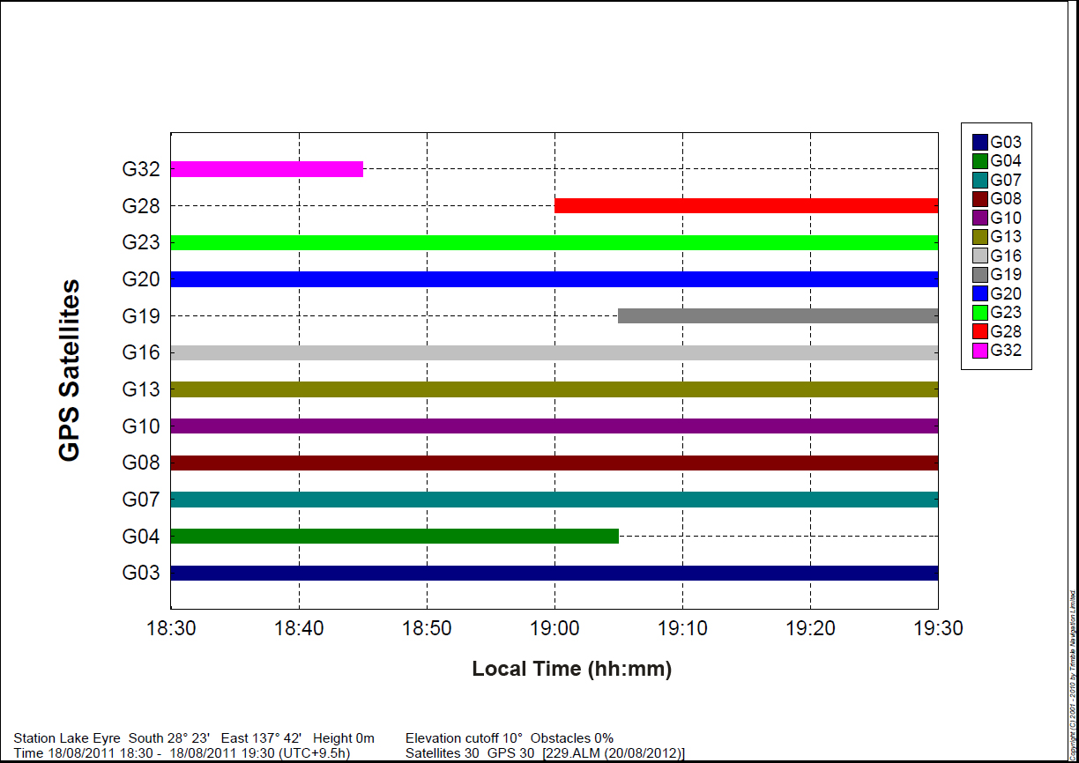Source: ATSB

Additional data points
The following is an extract from the GPSMAP 495 owner’s manual:
The GPSMAP 495 stores up to 3,000 alphanumeric waypoints with a user-defined icon, category, comment, altitude, depth and temperature available for each waypoint. Waypoints can be created using three basic methods:
Enter/Mark- allows you to quickly Mark your present location.
Graphically- allows you to define a new waypoint location from the map show using the rocker.
Text Entry- allows you to enter new waypoints location coordinates manually.
Examination of the FBGA memory chip data showed that a hexadecimal ‘flag’ 0x32C04210 was located 475 times within the binary file, followed by latitude and longitude information. The points recovered were consistent with some other known destinations of the helicopter. It was considered that these points were waypoints stored on the unit. The last latitude and longitude information following the hexadecimal flag matched the destination of the previous flight.

Appendix B – P2 memory cards examination

Introduction
During the on-site phase, 17 Panasonic P2 video camera memory cards were recovered. The film crew had been conducting video recording operations throughout the day prior to the accident and the cards were recovered for examination to determine if they may contain imagery or audio relevant to the accident. The video camera being used on the journey was a Panasonic AJ-HPX2100E capable of holding five Panasonic P2 memory cards.

Panasonic P2 cards
A Panasonic P2 card (Figure B1) was a PCMCIA format memory card that contained multiple solid-state flash memory chips in proprietary array architecture. Each card contained two memory modules, with each module consisting of four memory chips. The video camera on board the helicopter recorded sequentially to each installed Panasonic P2 card. The video imagery was stored in a material exchange (MXF) file format; an open (non-proprietary) file format established for the exchange of audio visual material and capable of storing data and metadata. Audio and video files can be stored separately, with only the file names linking the two files together.
Figure B1: Exemplar Panasonic P2 card


Physical examination
Damage to the recovered video cards ranged from no visible effects, to severe heat and fire damage. Three of the cards were recovered installed within a circuit assembly.
After consultation with the manufacturer’s Australian representatives, one of the installed cards was identified as a video encoder card which did not store recorded imagery. Of the ‘loose’ cards, four presented with damage that was characteristic of them having been installed in the video camera during the accident. One card contained header pins consistent with the video camera connection (Figure B2).
Figure B2: Header pins removed from one P2 card

Source: ATSB

Data recovery
The cards were taken to the manufacturer’s facilities in Melbourne for identification of the memory modules and data recovery under the oversight of an ATSB investigator. Recovery attempts were unsuccessful and the manufacturer recommended that the cards be sent to their international headquarters in Osaka, Japan. An officer from the Japan Transport Safety Board (JTSB) was appointed as an accredited representative to the investigation and subsequently organised and managed the data recovery process.
The cards were sent to the JTSB and an initial recovery attempt was made on 10 November 2011. One card (card 1) was successfully downloaded during this process. The manufacturer was unable to recover any further data from the P2 cards and recommended replacing components on some of the P2 cards to increase the likelihood of recovery.
Approval to proceed with component replacement allowed for the recovery of one module from two cards (card 2 and card 3). Due to the proprietary array architecture, file names and metadata were visible, but inaccessible without the successful recovery of both modules from each card.

Data analysis
The last location of video footage on card 1 was at the Cooper Creek ferry crossing. Using the time stamp from this video footage and correlating it with eye witness reports, it is estimated that the time stamp recorded by the camera was indicative of Eastern Standard Time being used as a time base. Card 1 was full, suggesting that another card had been used after this time.
Card 2 was last recorded to at 1915 EST on 18 August 2011, approximately 15 minutes before the accident flight (1930 EST or 1900 Central Standard Time). Card 3 contained recordings from 17 August 2011 to 1000 on 18 August 2011 and was not relevant to the accident flight.

Appendix C – Engines examination
The engines were removed from the accident site and taken to a Rolls-Royce M250-approved workshop for detailed examination under the supervision of the Australian Transport Safety Bureau (ATSB).
The left engine was externally fire damaged. There was no significant fire damage on the right engine. Both engines were completely disassembled and examined, and found to contain a quantity of oil. Fuel was identified in several fuel pipes on the right engine, including the fuel pipe from the fuel control unit to the fuel nozzle check valve. No fuel was evident in the left engine fuel components or pipes, most likely due to fire exposure.
One of the left engine compressor casing halves had a hole in about the 3 o’clock position (looking from the rear), indicating that at least one of the compressor blades had been liberated and breached the compressor housing. The front support for the compressor had been severely disrupted, most likely as a result of the impact sequence. This compromised the rotational area for the compressor rotor pack, resulting in an overload failure of the compressor blades and subsequent breach of the compressor case half.
The left engine compressor rotor pack and case halves were taken to the ATSB facility in Canberra for further examination regarding the blade release (Figure C1). It was concluded that the blade release was most likely as a result of the impact disruption to the compressor, not a fatigue issue.
Rotational scoring was identified throughout the left engine from contact between the compressor and turbine discs and their associated shrouds (Figure C2). Foreign object damage (FOD) was also observed on the compressor, and sand had been ingested into the turbine module gas path.
During the disassembly and examination of the right engine, similar evidence of rotational scoring and sand ingestion was identified (Figure C3 and Figure C4).
There were similarities between the engines noted throughout the examination regarding signatures of operation. It was likely that at the time of the impact, the gas generator and power turbine sections of both engines were operating at a level of power; however, this level could not be determined.
The fuel components were removed from both engines and taken to a Honeywell-approved workshop for detailed examination under the supervision of the ATSB. The left engine components were unable to be bench tested due to the fire damage, however they were disassembled and no internal defects were identified. The right engine components were bench tested and then disassembled. The components performed correctly under test except for two test points on the governor, indicating that it may have been slow to respond to power change demand. The pilot who had flown the helicopter in the period between the last scheduled maintenance, and the Lake Eyre journey, confirmed that the engines were well matched and were performing well together. No defects were identified when disassembled.
Figure C1: Left engine rotor pack with hole in casing and typical stage 1 blade overload failure
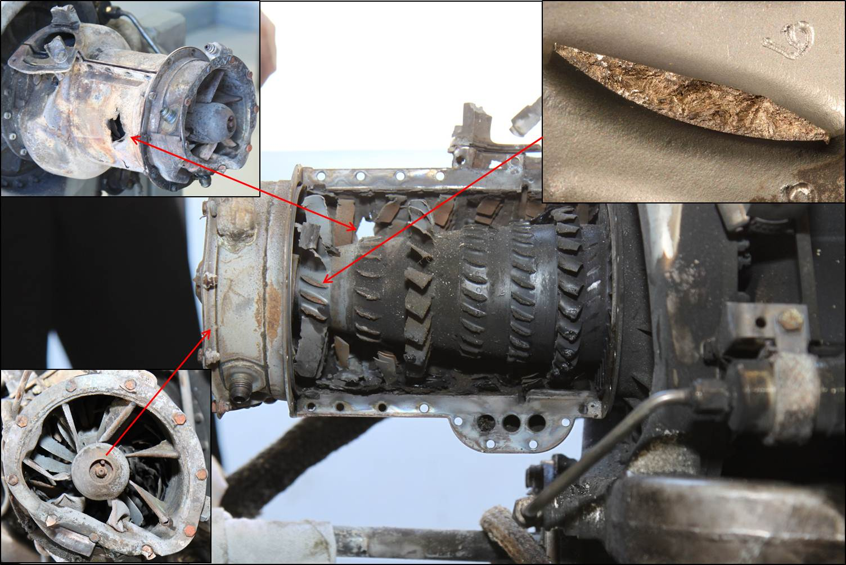Source: ATSB
Figure C2: Left compressor displaying evidence of rotation
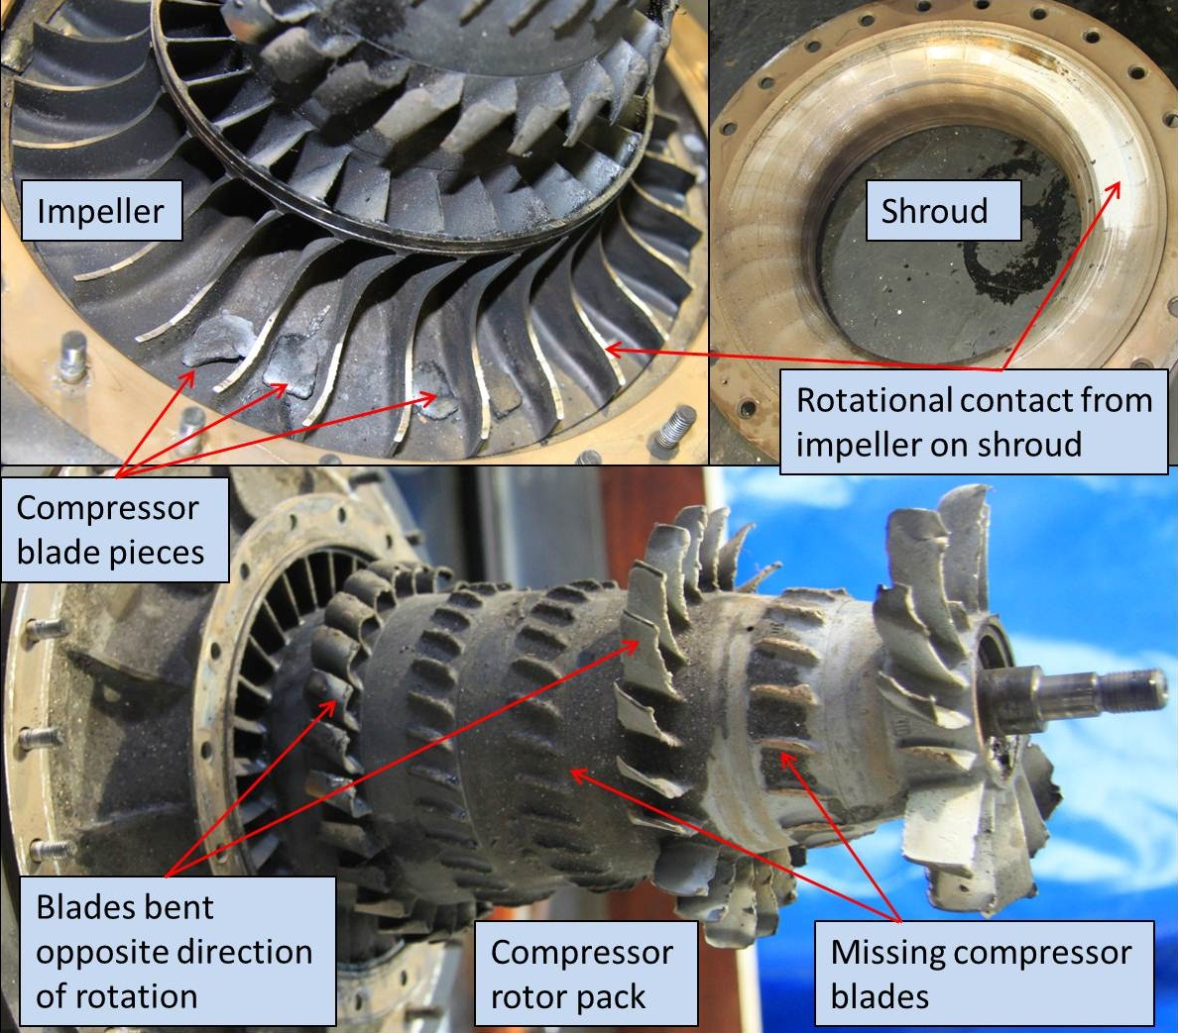Source: ATSB
Figure C3: Right compressor case half displaying evidence of rotation
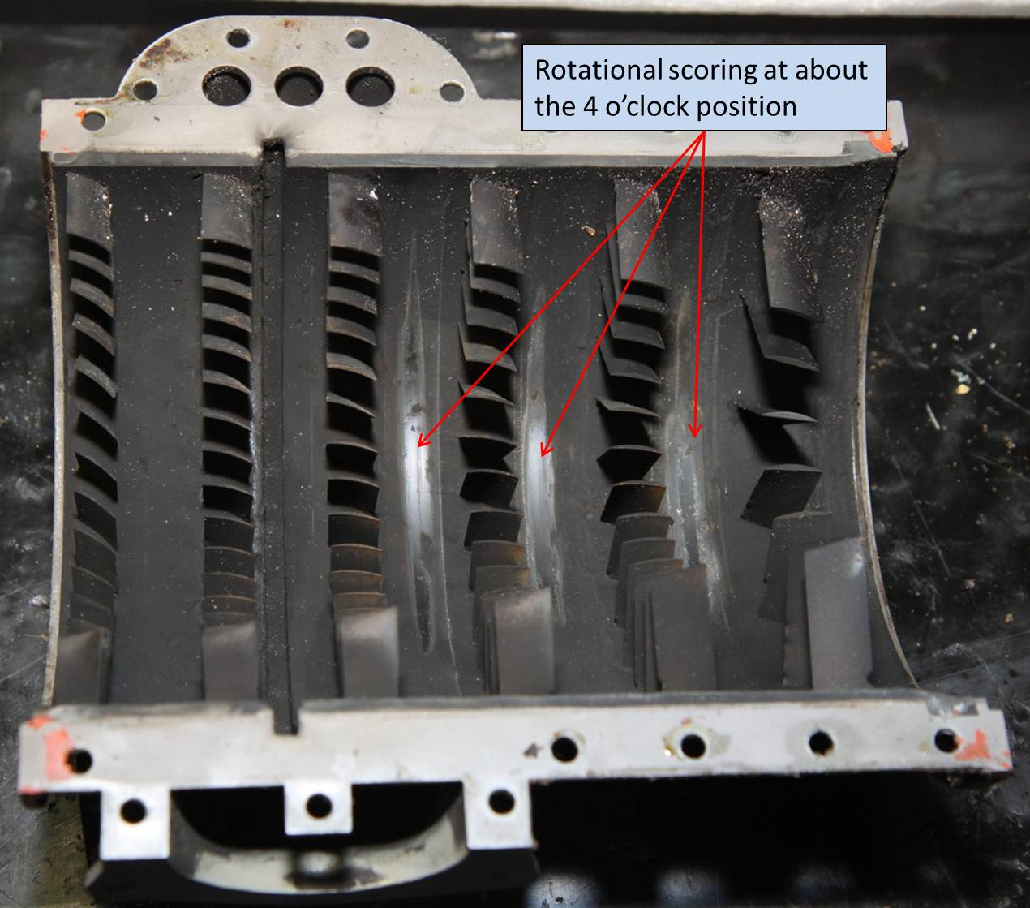Source: ATSB
Figure C4: Right compressor rotor pack showing debris and rotational damage
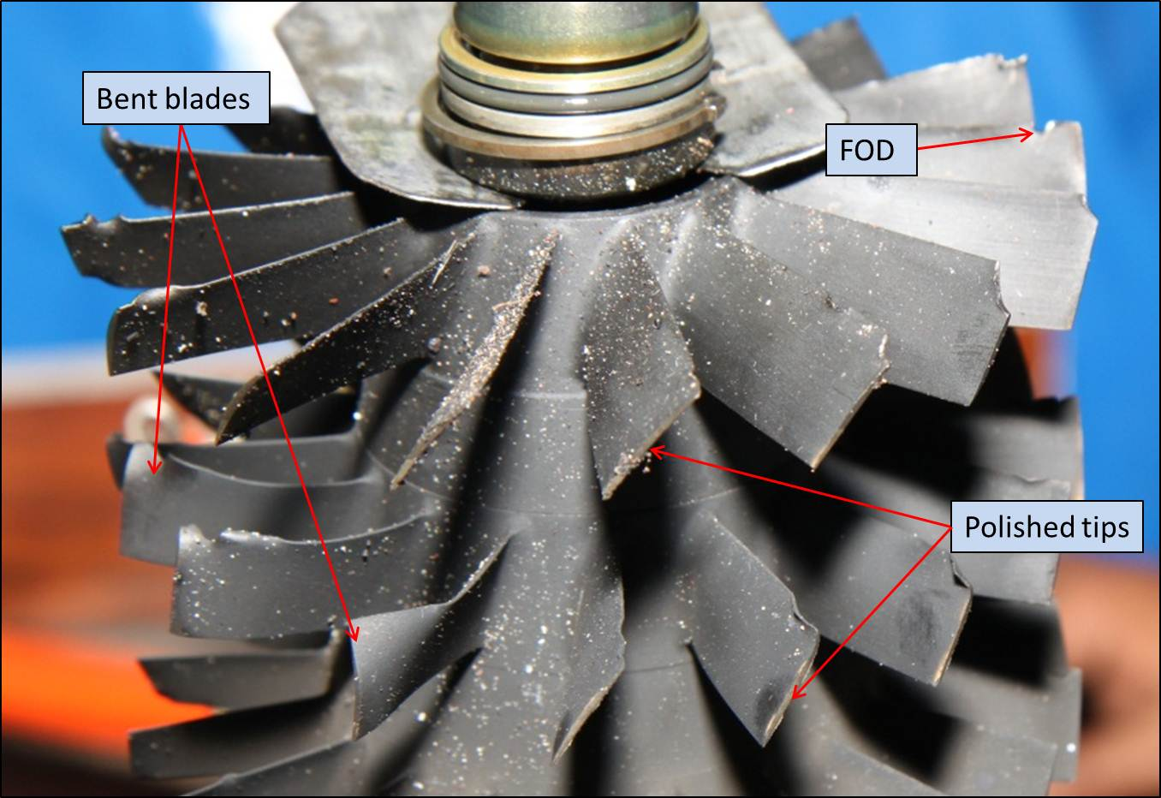Source: ATSB

Appendix D – Accidents involving gradually increasing bank angle

Air India Boeing 747, 1 January 1978
On 1 January 1978, a Boeing 747-200, operated as Air India flight 855, departed Mumbai, India in dark night conditions with 213 people on board. The captain had over 17,000 hours experience and was the pilot flying.
Soon after take-off, the aircraft was climbing in a gentle right turn. The aircraft levelled off and then commenced a roll to the left. The aircraft reached a maximum altitude of 1,500 ft before it began to descend, and it impacted the water with more than 90° left bank and a 35 to 40° nose-down attitude. The cockpit voice recorder indicated that the captain’s attitude indicator was providing incorrect roll indications, which the captain had noticed. The flight engineer also advised the captain to use a different attitude indicator when the bank angle was passing 40°.
The Court of Inquiry found that the probable cause of the accident was ‘irrational control wheel inputs given by the Captain following complete unawareness of the attitude of the aircraft on his part after Attitude Director Indicator (ADI) had malfunctioned’.
In reviewing the flight data, Gillingham and Previc (1986) noted that:
… the resultant G force which the pilot created by his control inputs allowed him to perceive his desired 10° to 12° climb angle and a net G force between 0.9 and 1.1 G for virtually the whole flight, even though he actually levelled off and then descended in an accelerating spiral until the aircraft crashed nearly inverted… The fact that the desired flight profile (a straight climb) would have yielded the same gravitoinertial force environment as was actually generated is strong evidence that the pilot was spatially disoriented.

Korean Air B747, 22 December 1999
On 22 December 1999, a Boeing 747-2B5F freighter, operated as Korean Air flight 8509, departed London Stansted airport, United Kingdom, in instrument meteorological conditions (IMC) at night, with four crew on board. The captain had about 13,500 hours experience and was the pilot flying.
On the aircraft’s flight to Stansted, the crew were alerted to a fault with captain’s ADI being unreliable in the roll attitude. On the ground at Stansted, maintenance crew identified what they thought was the fault and carried out a repair and system check, which tested serviceable.
At about 1836 the crew was cleared for take-off. The tower controller reported that the take-off appeared to be normal, and the aircraft disappeared from view at about 400 ft when it entered cloud. The first of three comparator warnings, indicating a disparity between the displayed information on the crew’s ADI’s, sounded 16.7 seconds after take-off. The flight engineer became aware of the ADI failure and warned the flight crew 26 seconds after take-off. The control wheel was moved to initiate a left turn at 29 seconds after take-off, and the last comparator warning sounded at 32.7 seconds, which was most likely cancelled by the flight crew. The data ended 55 seconds after take-off, descending through 1,950 ft above ground level, with a pitch attitude of 35.5° nose-down, and at a derived left bank angle of 80.6°. About 2 minutes later, tower personnel saw an explosion to the south of the airport.
The investigation revealed that throughout the accident flight, the captain's ADI indicated the correct pitch attitude but that the roll attitude remained at a wings-level indication. Radar and flight recorder data showed that the aircraft commenced a turn to the left but that this turn was continuous until impact with the ground. At impact, the aircraft was in a 40° nose-down attitude, banked at about 90° to the left, and with a speed of about 250 to 300 kt.
The investigation concluded that, despite comparator warnings for the crew’s ADIs, along with prompts from the flight engineer, the captain maintained a left roll input to impact. The investigation was uncertain why the first officer did not notice, or did not alert the captain to the unsafe attitude.

Crossair Saab 340B, 10 January 2000
On 10 January 2000, a Saab 340B aircraft, operated as Crossair flight 498, departed Zurich, Switzerland in instrument meteorological conditions (IMC) at night with 10 people on board. The captain had over 8,400 hours flight experience and was the pilot flying.
Air traffic control instructed the crew to turn left at the first waypoint, and the captain rolled the aircraft to a 16° left bank. The crew were busy with various routine actions after take-off. The first officer entered the ATC clearance into the aircraft’s flight management system but did not specify a direction of turn. As the shortest direction was to the right, the flight director provided guidance to the captain for a right turn. The captain started banking the aircraft to the right and reached 31° right bank after 13 seconds. The bank was then briefly stabilised at about 40°, with the pitch attitude decreasing. After another 10 seconds, there was a 9-second period of uncoordinated roll inputs both left and right, resulting a right bank angle of about 80° and a pitch-down attitude of 25°. The first officer made the captain aware that they should be turning left during this period. The aircraft entered a spiral dive, reaching a maximum bank angle of 137° right. The last recorded bank angle was 67° right.
The investigation report concluded that the captain had lost spatial orientation. It also noted that the captain was experiencing a high workload due to not selecting the autopilot on, and that he had significant previous experience with Russian-built aircraft, which have a different type of attitude indicator (inside-out) than was fitted to western-built aircraft such as the Saab 340B (outside-in).

Flash Air B737, 3 January 2004
On 3 January 2004, a Boeing 737-300, operated as Flash Airlines flight 604, departed Sharm el-Sheikh International Airport in Egypt in dark night conditions with 148 people on board. The captain had over 7,400 hours flight experience and was the pilot flying.
After taking off from runway 22 Right, the captain initiated a climbing left turn to establish a heading of 306° in accordance with the flight crew’s clearance from air traffic control. During the climb, the aircraft’s bank angle was initially 20° left. Soon after passing 3,000 ft the crew selected the autopilot on and then disengaged it, and then performed and discussed other autoflight mode changes. Approaching 4,000 ft, the wings were level and the aircraft was heading 140°. From about this time, the captain’s aileron inputs oscillated both ways but were predominantly to the right and the aircraft gradually started banking to the right. The first officer advised the captain that the aircraft was turning to the right, and subsequently stated ‘overbank’ several times, but the captain still did not appear to realise the situation. About 50 seconds after starting the right bank, the aircraft reached a bank angle of 110° before action was taken to level the wings. At that stage, the aircraft was pitching 43° nose-down and the recovery actions started too late to prevent the aircraft colliding with the water.
As part of the investigation, spatial orientation modelling studies showed that the angular roll rates were in the range of 1 to 2° per second, which were ‘within the range of thresholds for detection of angular motion published in the literature’. The modelling also showed that the gravito-inertial force vector remained at zero during most of the increasing bank angle.

Adam Airlines B737, 1 January 2007
On 1 January 2007, a Boeing 737-400, operating as Adam Airlines Flight 574, was cruising at 35,000 ft during the day in marginal visual meteorological conditions in Indonesia with 102 people on board. The captain had over 13,000 hours flight experience and was the pilot flying.
The crew became preoccupied with troubleshooting a problem with one of the aircraft’s two inertial reference systems. After changing the mode of the faulty system, the autopilot disconnected and the aircraft began a slow roll to the right of about 1° per second.
During the increasing right bank angle, there were variations in aileron inputs and the roll rate briefly ceased on several occasions before continuing. After 34 seconds, the bank reached 35° and the BANK ANGLE aural alert sounded. After about 64 seconds, with a bank of 100° and approaching a pitch attitude of 60° nose-down, the pilots realised their critical situation and attempted recovery actions. However, these were inappropriate and ineffective, and the aircraft broke up in flight.

Kenya Airways B737, 5 May 2007
On 5 May 2007, a B737-800 aircraft, operating as Kenya Airways Flight 507, departed Douala Airport, Cameroon in dark-night conditions with 114 people on board. The captain had over 8,600 hours flight experience and was the pilot flying.
As soon as the aircraft became airborne, it had a net tendency to roll slightly to the right, which was easily controlled by the captain to maintain a wings-level attitude. Soon after passing 1,000 ft, the crew provided no flight control inputs for 55 seconds and the aircraft gradually rolled to the right. During this period the crew discussed and made minor heading changes to avoid adverse weather ahead. In addition, the captain attempted to engage the autopilot but it was not actually engaged and this error was not detected by the crew.
After the 55-second period, the aircraft was at 2,700 ft with a bank angle of 35°. The BANK ANGLE aural alert sounded and the captain responded with a series of significant roll inputs to both the right and left, resulting in a rapidly increasing roll to the right. The bank angle was briefly stabilised at 50° when the autopilot was engaged, but it increased again after further control inputs by the captain, which disconnected the autopilot. The aircraft entered a spiral dive and the bank angle reached 115° before decreasing. Eight-five seconds after starting the right bank, the aircraft crashed with a bank angle of 60° right and a pitch-down attitude of 48°.
The final report into the accident concluded that:
The airplane crashed after loss of control by the crew as a result of spatial disorientation (non recognized or subtle type transitioning to recognized spatial disorientation), after a long slow roll, during which no instrument scanning was done, and in the absence of external visual references in a dark night.

Aeroflot-Nord B737, 13 September 2008
On 13 September 2008, a B737-500, operating as Aeroflot-Nord flight 821, was on approach to Perm, Russia with 88 people on board. The flight was conducted at night and there was a relatively low cloud base in the area. The first officer, who was the pilot flying initially, had over 8,900 hours flight experience and the captain had over 3,900 hours.
During the approach, there was a difference between the thrust levels of the engines creating a significant yawing moment to the left, which led to a constant left banking. The autopilot's ability to counteract the left banking tendency was eventually saturated, and the aircraft started banking left at 2° per second. After the bank reached 32°, the first officer corrected the situation. However, he was experiencing difficulties in maintaining speed and altitude control, and during this period the autopilot disconnected. The captain was engaged in communications with air traffic control during this period.
At 2308:25, the aircraft started banking left again at 1° per second. After it reached a bank angle of 30° with airspeed reducing, the first officer asked the captain to take over. The captain provided abrupt left inputs and the bank angle reached 76° before the first officer told the captain to bank in the opposite direction, decreasing the left bank to 30°. The captain then applied abrupt inputs in both directions before applying full left wheel input, resulting in a roll rate of over 35° per second at impact.
The final investigation reported stated:
The immediate cause of the accident was spatial disorientation of the crew, especially the Captain who was the pilot flying at the final stage of the flight, which led to the left flip-over, a steep descent and the crash of the aircraft. The spatial disorientation was experienced during the night time operation in clouds, with both autopilot and autothrottle disengaged. Contributing to the development of the spatial disorientation and failure to recover from it was a lack of proficiency in aircraft handling, crew resource management and of skills associated with upset recovery using "western"-type attitude indications that are found on foreign and modern Russian-made aircraft.

United States military helicopter accident
The United States Army Aeromedical Research Laboratory advised the ATSB of a United States military helicopter accident that had some very similar flight characteristics to the accident involving VH-NTV. The accident occurred in 2005 when two large military helicopters were conducting a medical evacuation mission. Soon after take-off, the helicopters were travelling at 1,000 ft in degraded visual conditions during the day over desert terrain.
The pilot flying the trailing helicopter was turning slightly to the left to change their position from the right side of the lead helicopter to the left side. The pilot unknowingly initiated a gradual left turn which continued until the helicopter was at about 100° left bank with a very steep, nose-low descent at an altitude where a successful recovery was not possible. The time from departing straight and level flight until impact was about 50 seconds.
Both of the crew had valid instrument ratings but limited recent instrument flying time. The crew were both wearing night vision goggles, and their attention was probably focussed on maintaining visual contact with the lead helicopter.
As part of the investigation, spatial orientation modelling studies showed that the crew would not have had any perception of abnormal roll or pitch during most of the increasing bank angle. The modelling also showed that the gravito-inertial force during most of the increasing bank was similar to normal straight and level flight.

Appendix E – Spatial orientation modelling
Several groups of specialists have developed perceptual modelling tools to estimate a pilot’s perception of their spatial orientation. The ATSB asked the United States Army Aeromedical Research Laboratory (USAARL) to conduct an analysis of the accident involving VH-NTV. This group previously performed many analyses for military and civil aircraft accident investigations, particularly in the United States military.
The nature of the USAARL spatial disorientation (SD) analysis tool is described in detail by McGrath and others (2003) and Newman and others (2012). The tool, originally developed by the United States Naval Aerospace Medical Research Laboratory (NAMRL), is based on an observer theory model adapted from the work of Merfeld and a classical systems model adapted from the work of Grissett. Both of these spatial orientation models are developed from existing vestibular models and 40 years of additional data obtained through centrifuge and aircraft experiments, as well as aircraft accidents. The spatial orientation models assume that the pilot is not using outside visual horizon cues or the aircraft instruments, and do not include somatosensory inputs.
The basic steps taken to conduct the spatial orientation analysis using the tool were:
- The ATSB mathematically estimated the helicopter’s accelerations and bank angle to build a model of the helicopter’s most likely motion matching the recorded GPS data (appendix A). The estimated values were the simplest ones that could be derived to accurately match the helicopter’s flight path. Although there could have been some variation from these estimations, it was considered unlikely that there would have been significant roll accelerations occurring during the flight while still producing a relatively smooth and consistent flight path at cruising speed.
- Using the data provided by the ATSB, estimates of the roll position, roll velocity, and linear acceleration experienced by the pilot of the accident aircraft were calculated using the mathematical analysis software package MatLabTM (The MathWorks, Inc.).
- The estimates of the roll position, roll velocity, and linear acceleration of the helicopter were input into the spatial orientation models to produce an estimate of perceived pilot orientation using the modelling analysis software package SimulinkTM (The MathWorks, Inc.).
- To determine the accuracy and validity of the perceived pilot orientation, the perception results were evaluated using available sources of information regarding the context and purpose of the flight.
Further details of the general methodology used in such analyses are provided by the following:
- McGrath, BJ Rupert & AH Guedry, FE 2003, Analysis of spatial disorientation accidents in the US Navy, Spatial disorientation in military vehicles: Causes, consequences and cures, RTO-MP-086, pp. 10-1 to 10-12.
- Newman, MC Lawson, BD Rupert, AH & McGrath, BJ 2012, The role of perceptual modeling in the understanding of spatial disorientation during flight and ground-based simulator training, paper presented at the American Institute of Aeronautics and Astronautics Conference, AIAA Modeling and Simulation Technologies Conference, 13 - 16 August 2012, Minneapolis, Minnesota.

Appendix F – Accidents involving night VFR operations
The ATSB reviewed its occurrence database for accidents in Australia from 1993 to 2012 that met the following criteria:
- occurred at night
- conducted under the visual flight rules (VFR)
- occurred in visual meteorological conditions (VMC) or probable VMC
- involved a pilot that had either a night VFR rating or a command instrument rating (CIR)
- involved an aircraft equipped for night VFR flight or instrument flight rules (IFR) flight
- involved either controlled flight into terrain (CFIT) or a loss of aircraft control in flight, and the loss of control did not appear to be related to any technical problem with engines, flight controls or primary flight instruments.
Table F1 lists 13 accidents that met these criteria. Another five accidents that occurred during agricultural spraying operations also met the criteria. In addition, there were other accidents that may have met the criteria but there was insufficient information available to determine the nature of the accident or whether the conditions were VMC or IMC. At least six other accidents probably involved VFR flights entering IMC at night during the same period.
Of the 13 accidents in Table F1, the following was noted:
- 11 occurred in dark night conditions
- none occurred immediately after take-off, one occurred on final approach, three occurred during flight at low level, and the remainder occurred during climb or en route
- in only one case did the pilot in command have a relevant CIR
- in four cases there were passengers on board but the pilot had probably not met the relevant recency requirements for carrying passengers at night
- five accidents involved helicopters, three of which were CFITs and two involved loss of control (including VH-NTV on 18 August 2011)
- 10 accidents resulted in fatalities, with the only non-fatal accidents being three helicopter accidents involving CFIT at low speed from low level or during climb.
During 1993 to 2012 there were also eight accidents involving IFR flights at night that otherwise met the same criteria. Three occurred very soon after take-off and four were CFITs during approach. All occurred in dark night conditions. The rate of IFR versus night VFR accidents could not be determined due to very limited information available on the amount of night flying under the two types of rules. However, it would be expected that significantly more flying at night is conducted under the IFR than the VFR.

Table F1: Australian accidents on night VFR flights from 1993 to 2012
Date | Investigation | Details
9 Apr 1993 | 199300822 | PA-28RT, VH-IWJ, private flight from Coolangatta, Qld, to Maitland, NSW. Loss of control en route. Dark night conditions. 2 persons on board (POB), both fatally injured.
9 Apr 1994 | 199400871 | Bell 206L-3 helicopter, VH-LIA, search and rescue practice flight over water near Point Nepean, Vic. Collision with water during low-level and low speed operations (dropping buoys). Terrain lighting on horizon visible. 4 POB, no serious injuries.
8 Jul 1994 | 199401771 | PA-28R, VH-JEG, night training flight from Bankstown, NSW, to Canberra, ACT. Loss of control en route. Dark night conditions. Instructor had CIR. 3 POB, all fatally injured.
10 Oct 1995 | 199503369 | Cessna 182R, VH-XTK, private flight from Warrnambool to Moorabbin, Vic. Loss of control during climb. Dark night conditions. 2 POB, both fatally injured.
26 Feb 1998 | 199800604 | Cessna 210N, VH-SJP, private business flight transporting passengers from Windorah to Osborne Mine, Qld. Loss of control during circuit. Dark night conditions. Pilot did not meet recency requirements to carry passengers at night. 3 POB, all fatally injured.
10 Apr 1998 | 199801298 | Bell 206B helicopter, VH-WCQ, charter flight, returning from ship to Dampier, WA. Collision with water during climb. Dark night conditions. 1 POB, no serious injuries.
27 Apr 2001 | 200102083 | Bell 407 helicopter, VH-WOQ, aerial work north-east of Rockhampton, Qld. Collision with water during low-level and low speed operations (dropping life raft). Dark night conditions. 2 POB, no serious injuries.
17 Oct 2003 | 200304282 | Bell 407 helicopter, VH-HTD, aerial work (emergency medical services) en route from Mackay to Hamilton Island, Qld. Loss of control en route. Dark night conditions. 3 POB, all fatally injured.
15 Aug 2004 | 200403006 | Mooney M20K, VH-DXZ, private flight from Cobar, NSW, to Caloundra, Qld. Loss of control during approach. Dark night conditions. 1 POB, fatally injured.
8 Sep 2004 | 200403351 | Robinson R44 helicopter, VH-AWX, private flight returning to homestead west of Roma, Qld. Loss of control en route. Dark night conditions. Pilot probably did not meet recency requirements to carry passengers in a helicopter at night. Pilot also held CIR for fixed-wing aircraft. 2 POB, both fatally injured.
9 Dec 2006 | AO-2006-002 | Air Tractor AT802A, VH-CJZ, agricultural flight, returning to landing strip near Collarenebri, NSW. Collision with terrain from low level. Dark night conditions. 1 POB, fatally injured.
30 Mar 2011 | AO-2011-043 | Piper PA-32R, VH-LTI, private flight from Brewarrina to Moree, NSW. Collision with terrain on final approach. Terrain lighting available during approach. Pilot did not meet recency requirements to carry passengers at night. 6 POB, 4 fatally injured and 2 seriously injured.
18 Aug 2011 | AO-2011-102 | Aérospatiale AS355F2 helicopter, VH-NTV, passenger charter flight near Lake Eyre, SA. Loss of control after reaching cruise level. Dark night conditions. Pilot probably did not meet recency requirements to carry passengers at night. 3 POB, all fatally injured.

Australian Transport Safety Bureau
The Australian Transport Safety Bureau (ATSB) is an independent Commonwealth Government statutory agency. The ATSB is governed by a Commission and is entirely separate from transport regulators, policy makers and service providers. The ATSB’s function is to improve safety and public confidence in the aviation, marine and rail modes of transport through excellence in: independent investigation of transport accidents and other safety occurrences; safety data recording, analysis and research; fostering safety awareness, knowledge and action.
The ATSB is responsible for investigating accidents and other transport safety matters involving civil aviation, marine and rail operations in Australia that fall within Commonwealth jurisdiction, as well as participating in overseas investigations involving Australian registered aircraft and ships. A primary concern is the safety of commercial transport, with particular regard to fare-paying passenger operations.
The ATSB performs its functions in accordance with the provisions of the Transport Safety Investigation Act 2003 and Regulations and, where applicable, relevant international agreements.

Purpose of safety investigations
The object of a safety investigation is to identify and reduce safety-related risk. ATSB investigations determine and communicate the factors related to the transport safety matter being investigated.
It is not a function of the ATSB to apportion blame or determine liability. At the same time, an investigation report must include factual material of sufficient weight to support the analysis and findings. At all times the ATSB endeavours to balance the use of material that could imply adverse comment with the need to properly explain what happened, and why, in a fair and unbiased manner.

Developing safety action
Central to the ATSB’s investigation of transport safety matters is the early identification of safety issues in the transport environment. The ATSB prefers to encourage the relevant organisation(s) to initiate proactive safety action that addresses safety issues. Nevertheless, the ATSB may use its power to make a formal safety recommendation either during or at the end of an investigation, depending on the level of risk associated with a safety issue and the extent of corrective action undertaken by the relevant organisation.
When safety recommendations are issued, they focus on clearly describing the safety issue of concern, rather than providing instructions or opinions on a preferred method of corrective action. As with equivalent overseas organisations, the ATSB has no power to enforce the implementation of its recommendations. It is a matter for the body to which an ATSB recommendation is directed to assess the costs and benefits of any particular means of addressing a safety issue.
When the ATSB issues a safety recommendation to a person, organisation or agency, they must provide a written response within 90 days. That response must indicate whether they accept the recommendation, any reasons for not accepting part or all of the recommendation, and details of any proposed safety action to give effect to the recommendation.
The ATSB can also issue safety advisory notices suggesting that an organisation or an industry sector consider a safety issue and take action where it believes it appropriate. There is no requirement for a formal response to an advisory notice, although the ATSB will publish any response it receives.

Central Standard Time was Coordinated Universal Time (UTC) + 9.5 hours.
A non-directional (radio) beacon (NDB) is a radio transmitter at a known location, used as a navigational aid. The signal transmitted does not include inherent directional information.
Very high frequency omnidirectional radio range (VOR). A ground-based navigation aid that emits a signal that can be received by appropriately-equipped aircraft and represented as the aircraft’s bearing (called a 'radial') to or from that aid.
Alternatively, the flight was permitted if the helicopter was fitted with dual controls and the operating crew also included another qualified pilot.
Circadian dysrhythmia occurs when the body’s biological clock is disrupted by a sudden shift in daily rhythm. It is commonly referred to as jet lag and is usually the result of either travel across multiple time zones or shift work.
Renal colic could lead to pilot incapacitation if the pilot does not land the aircraft soon after the onset of pain. Corrigan and Cook (2008) noted that reviews had found several reported cases of renal colic leading to pilot incapacitation. Most of these cases occurred in multi-crew environments, although one case on a single-pilot flight also did not result in an accident. An ATSB research study found no cases of renal colic in a review of Australian pilot incapacitation occurrences (Newman 2007b).
CASA-developed maintenance schedule.
An accumulator is a device for storing energy in a hydraulic system which can act as an emergency source of pressure of fluid.
Data is lost when power is removed from the memory device.
Data is retained when power is removed from the memory device.
Cloud cover is normally reported using expressions that denote the extent of the cover. The expression Scattered indicates that cloud was covering between a quarter and a half of the sky.
Defined as the instant in the evening, when the centre of the sun is at a depression angle of 6° below an ideal horizon. At this time in the absence of moonlight, artificial lighting or adverse atmospheric conditions, the illumination is such that large objects may be seen but no detail is discernible.
Defined as the instant in the evening, when the centre of the sun is at a depression angle of 12° below an ideal horizon. At this time in the absence of moonlight, artificial lighting or adverse atmospheric conditions, it is dark for normal practical purposes. For navigation purposes at sea, the sea horizon is not normally visible.
Defined as the instant in the evening, when the centre of the sun is at a depression angle of 18° below an ideal horizon. At this time the illumination due to scattered light from the Sun is less than that from starlight and other natural light sources in the sky.
Astronomical information was obtained from Geoscience Australia (www.ga.gov.au/geodesy/astro).
Civil Aviation Advisory Publication 5.13-2(0) Night Visual Flight Rules Rating stated that ‘helicopters with extensive areas of Perspex are particularly prone to disorienting reflections on the inside of the cockpit canopy’.
Pilot-adjustable pointer (bug) that will provide an aural and visual warning when the aircraft descends through the selected height.
Red warning light indicating a fire in the respective engine compartment.
Amber caution light indicating excessive aerodynamic loading and the main servo-unit stall point has been reached, or that the left hydraulic system is not pressurised.
Amber caution light indicating that the pitot heating system is turned off.
Amber caution light indicating that a door is ajar.
An international satellite-based search and rescue (SAR), distress alert and detection system.
For further information see: http://www.mnh.si.edu/highlight/feathers/
For further details see https://www.flyelite.com/faa-certified/helicopter-devices/th-100/.
For further details see http://www.eurocopterusa.com/training/AS350-simulator.asp .
Although implied by the definition, errors of geographical orientation, or incorrectly perceiving an aircraft’s distance or bearing from a fixed location, are generally not considered as examples of SD.
Some researchers state that the vestibular and somatosensory systems together produce the ‘seat of the pants’ perceptions.
Examples include ATSB investigation 200304282 (Bell 407, VH-HTD, Cape Hillsborough, Qld, 17 October 2003) and the UK Air Accidents Investigation Branch investigation 4/1997 (Report on the accident to Aerospatiale AS355F1 Twin Squirrel, G-CFLT, near Middlewich, Cheshire on 22 October 1996).
For example, see ATSB investigation AO-2011-017, Controlled flight into terrain – Cessna Aircraft Company 310R VH-XGX, near Bathurst Island Aerodrome, Northern Territory, 5 February 2011.
Where the pilot’s flight controls are used to avoid slip or skid throughout the turn.
Under CAR 2, visibility was defined as ‘the ability, as determined by atmospheric conditions and expressed in units of distance, to see and identify prominent unlighted objects by day and prominent lighted objects by night.’
CAR 174B limited operations at night under the VFR in single engine aircraft to private and aerial work flights, and charter flights in limited circumstances (if no passengers were carried or the aircraft was a turbine-powered aeroplane and CASA had provided approval in writing).
For private and aerial work flights in an aeroplane, or marine pilot transfers in a helicopter, the aircraft’s maximum take-off weight was required to be 5,700 kg or less. To conduct marine pilot transfers, the pilot had to also hold a commercial or air transport pilot licence.
To conduct a flight at night, the holder of a CIR also needed to meet the night flying experience requirements associated with a night VFR rating.
Automatic stabilisation systems help reduce pilot workload by reducing the inherent instability of helicopters (see Automatic flight control systems).
CASA advised that the term ‘VFR’ was meant to be ‘VMC’ and ‘altitude’ was meant to be ‘attitude’.
The visit to the tour group was originally meant to occur 5 days later. However, the itinerary was not fixed and visits could vary as required.
Data retrieved from the GPSMAP 495 showed that, compared to Muloorina Station, Cowarie was the second closest user-defined location to the departure point. The locations with the most similar distance to Muloorina Station (96.8 km) were a point near Mulka (97.9 km on a heading of 092°), Cowarie Station (98.3 km on a heading of 034°) and Kalamurina (92.42 km on a heading of 031°). Mulka and Kalamurina were not listed on the crew’s itinerary, and may not have been loaded as waypoints in the GPS400W.
Reviews of post-mortem examinations of general aviation pilots involved in fatal accidents in the United States found that between 3 to 5 per cent had ‘severe’ coronary atherosclerosis (Booze and others 1980, Booze and Staggs 1986). The rate for pilots aged over 50 was 7 to 9 per cent. However, in only a small proportion of cases was there sufficient information available to conclude that the condition led to incapacitation or was a factor in the associated accident.
Total recovery times will vary significantly depending on many factors, such as the attitude, aircraft type, airspeed, pilot experience and recency of practice. Many research studies have compared recovery times to different types of attitude indicators, but their results are difficult to compare as they used different methods. A time of 10 seconds for attitudes involving about a 45° bank angle is a broad generalisation and is based on several studies (Beringer and others 1975, Beringer and Ball 2005, Guttman 1986, Hasbrook and Rasmussen 1973, and Huber 2006).
Time constriction occurs when duration judgements are being done at the same time as other tasks are being performed, which is relevant to this situation. The opposite effect, time expansion, has been shown to occur when people make duration judgements retrospectively. Time expansion can also occur in cases of significant stress when an individual is waiting for something to occur (Hancock and Weaver 2005).
In this study, the pilots were looking at and following another aircraft. When external visual cues were removed, their task was to switch to flying with reference to the instruments, change heading 30° and establish the aircraft in straight and level flight. In effect it was measuring the time required to switch from visual flight to instrument flight without knowing beforehand when the switch was required to occur.
Civil Aviation Advisory Publication 5.13.1 (0), Private IFR rating, September 2000.
See the Aeronautical Information Publication, ENR section, for these requirements.
The pilot had not met other requirements for proficiency checks to be conducted every 12 months due to his age and in order to conduct low-flying operations, but these checks did not relate directly to night or instrument flying.
The first version of this report was published in 1986. Adaptations of this report have also been published as a chapter in different editions of the text by Davies and others 2008.
The global positioning system (GPS) is a space-based global navigation satellite system (GNSS) that provides location and time information in all weather, anywhere on or near the Earth, where there is an unobstructed line of sight to four or more GPS satellites.
A Jeppesen database is an electronic database containing navigational information such as airport, VOR, NDB and runway information.
A fine ball grid array (FBGA) is a surface mount electronic device characterised by small connection pads on the base of the device.
A thin small outline package (TSOP) is a surface mount electronic device characterised by connection pins on two sides of device.
A track point is a recorded point of an aircraft’s flight path. It comprises latitude, longitude, altitude above MSL and time information.
Aircraft Accident Investigations Second Edition, Richard H. Wood, Robert W. Sweginnis
The track data in this figure is presented in degrees T, whereas the data presented in The Occurrence section of the report has been adjusted to be degrees M.
Personal Computer Memory Card International Association.
Eastern Standard Time (EST) was Coordinated Universal Time (UTC) + 10 hours.
Set-up of the governor on each engine, and their ability to maintain power demands evenly between the two engines to the main rotor gearbox in a helicopter installation.
Information obtained from: Government of India, Civil Aviation Department Accidents Summary, 1978; and Gero, D 1993, Aviation disasters, Patrick Stephens, Sparkford Somerset UK.
Final report, accident, Boeing 747-2B5F, HL-7451 (Korea), near London Stansted Airport, UK, 22 December 1999. Report produced by the UK Air Accidents Investigation Branch.
Final Report of the Aircraft Accident Investigation Bureau on the accident to the Saab 340B aircraft, registration HB-AKK of Crossair flight CRX 498 on 10 January 2000 near Nassenwil/ZH. Report produced by the Federal Department of the Environment, Transport, Energy and Communications in Switzerland, 2001.
Final report of the aircraft accident investigation, Flash Airlines flight 604, January 3, 2004, Boeing 737-300, SU-ZCF, Red Sea off Sharm el-Sheikh, Egypt. Report produced by the Egyptian Ministry of Civil Aviation, 2006.
Aircraft accident investigation report KNKT/07.01/08.01.36, Boeing 737–4Q8, PK–KKW, Makassar Strait, Sulawesi, Republic of Indonesia, 1 January 2007. National Transportation Safety Committee, Ministry of Transportation, Republic of Indonesia , 2008.
Technical investigation into the accident of the B737-800 registration 5Y-KYA operated by Kenya Airways that occurred on the 5th of May 2007 in Douala. Ministry of Transport, Republic of Cameroon.
Final report, accident, Boeing 737-505, VP-BKO (Bermuda), Aeroflot-Nord Airline, Russian Federation, near Bolshoye Savino Airport, Perm, 14 September 2008. Interstate Aviation Committee, Air Accident Investigation Commission.
Merfeld, DM Young, LR Oman, CM & Shelhamer, MJ 1993, ‘A multidimensional model of the effect of gravity on the spatial orientation of the monkey’, Journal of Vestibular Research, vol. 3, pp. 141-161.
Grissett, JD 1993, Mathematical model for interaction of canals and otoliths in perception of orientation, translation, and rotation, NAMRL Special Report 93-5, Naval Aerospace Medical Research Laboratory, Pensacola, FL.

